Preparatory Committee OEA/Ser.P
AG/CP/doc.819/12
26 January 2012
Original: textual

NOTE FROM THE SECRETARY GENERAL TRANSMITTING THE OFFER OF THE GOVERNMENT OF GUATEMALA TO HOST THE FORTY-THIRD REGULAR SESSION
OF THE GENERAL ASSEMBLY

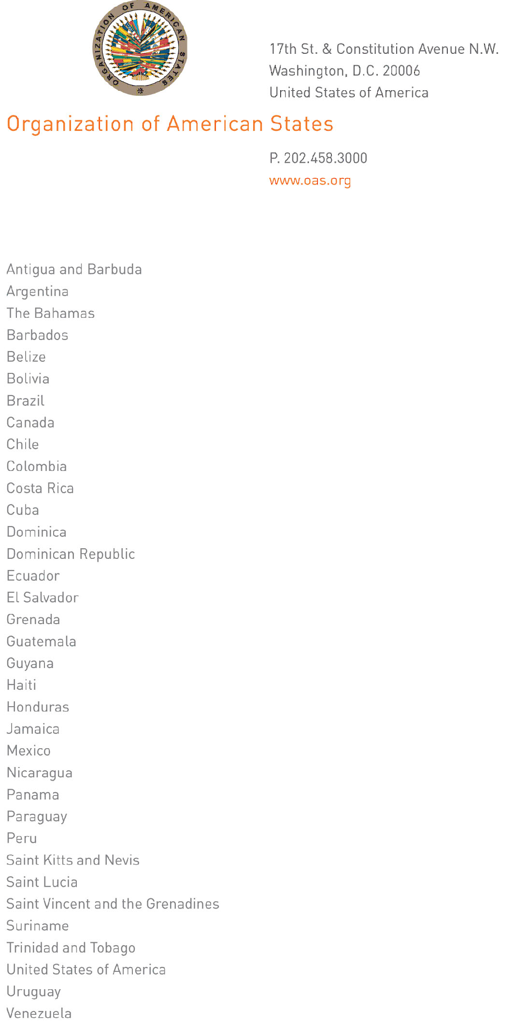

January 25, 2012

His Excellency
Ambassador Duly Brutus
Permanent Representative of Haiti
to the Organization of American States
Chair of the Permanent Council
Washington, D.C.

Excellency:

I have the honor of writing to enclose herewith a note dated January 24 of this year from His Excellency, Mr. Harold Caballeros, Minister of Foreign Affairs of Guatemala, confirming the offer of his government to host the forty-third regular session of the General Assembly in 2013.

Accept, Excellency, renewed assurances of my highest consideration.

José Miguel Insulza
Secretary General

Ministry of Foreign Affairs
Guatemala

January 24, 2012

Excellency:

It gives me great pleasure to write in order to formalize the offer of my country to host the regular session of the General Assembly of the Organization of American States to be held in June 2013.

In that regard, I would like to say that the Government of Guatemala feels honored to be able to host such an important event.

Accordingly, I would like to extend an invitation to the Assistant Secretary General, Ambassador Albert Ramdin, to visit Guatemala soon in order to begin to address the logistical arrangements that the Assembly would entail.
input.doc

Accept, Excellency, assurances of my highest and most distinguished consideration.

Harold Caballeros
Minister of Foreign Affairs

The Honorable
José Miguel Insulza
Secretary General
Organization of American States

