PREPARATORY COMMITTEE OEA/Ser.P
AG/CP/doc.822/12
Forty-second regular session 12 April 2012
Original: Spanish

NOTE FROM THE SECRETARY GENERAL
REQUESTING INCLUSION OF THE TOPIC “FOLLOW-UP OF THE RECOMMENDATIONS OF THE REPORT OF THE SPECIAL WORKING GROUP TO REFLECT ON THE WORKINGS OF THE IACHR WITH A VIEW TO STRENGTHENING THE IAHRS” ON THE PRELIMINARY
DRAFT AGENDA OF THE FORTY-SECOND REGULAR SESSION
OF THE GENERAL ASSEMBLY
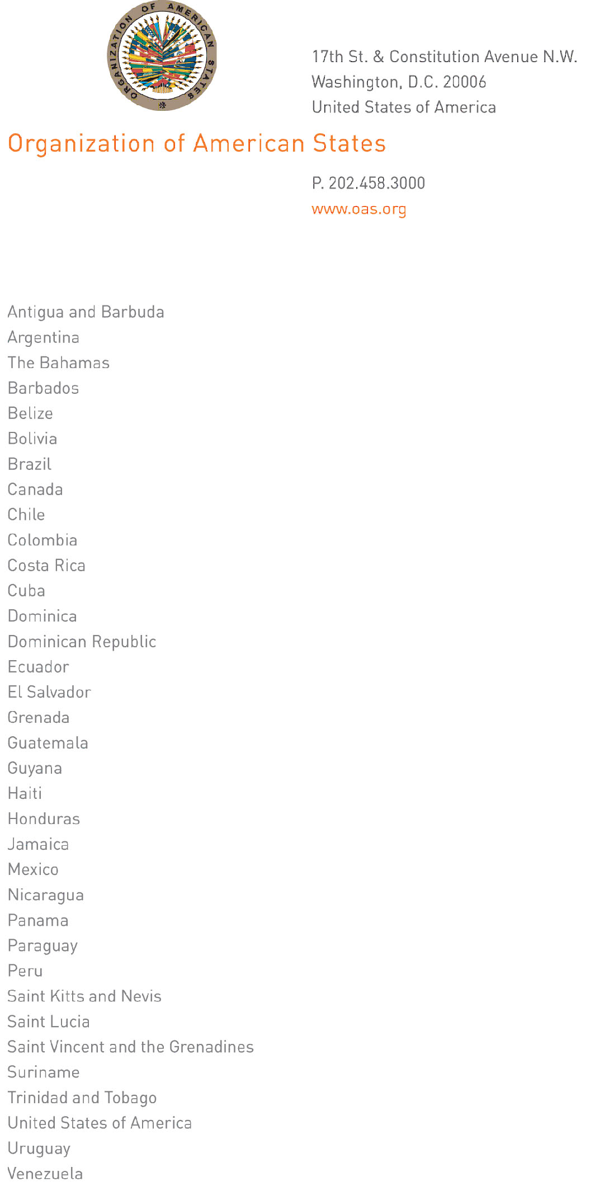
April 12, 2012

Excellency:

I have the honor to address Your Excellency with reference to the mandate I received from the Permanent Council, on January 25, 2012, concerning follow-up of the recommendations contained in the “Report of the Special Working Group to Reflect on the Workings of the IACHR with a View to Strengthening the IAHRS.”

Pursuant to the aforementioned mandate, I should be grateful for the Preparatory Committee to consider including the topic “Follow-up of the recommendations of the Report of the Special Working Group to Reflect on the Workings of the IACHR with a View to Strengthening the IAHRS” on the draft agenda of the forty-second regular session of the General Assembly, to be held in Cochabamba, Bolivia, next June.

Thank you in advance for your attention to this request.

Accept, Excellency, renewed assurances of my highest consideration.

José Miguel Insulza
Secretary General

His Excellency
Ambassador Leonidas Rosa Bautista
Permanent Representative of Honduras
to the Organization of American States
Chair of the Preparatory Committee of the
General Assembly
Washington, D.C.

input.doc

