PREPARATORY COMMITTEE OEA/Ser.P
AG/CP/doc.847/13
Forty-third regular session 16 May 2013
Original: Spanish

REQUEST FROM THE SECRETARY GENERAL TO INCLUDE

THE PARTICIPATION OF THE PRESIDENT OF THE UNITED NATIONS
GENERAL ASSEMBLY, MR. VUK JEREMIC, IN THE PLENARY OF THE FORTY-THIRD REGULAR SESSION OF THE OAS GENERAL ASSEMBLY
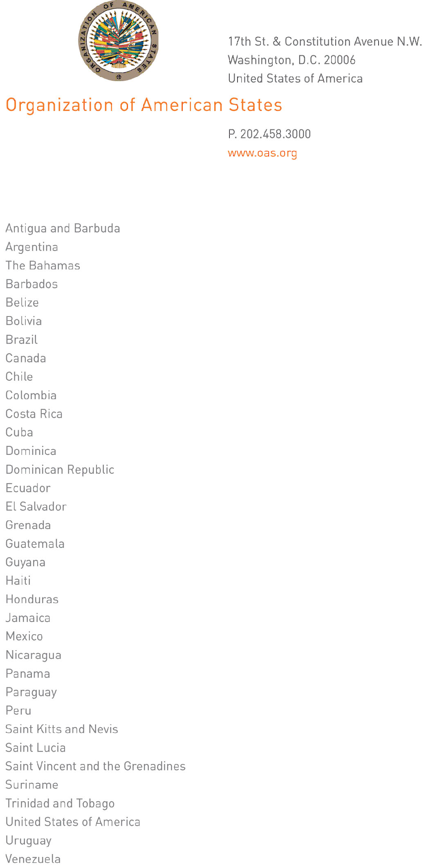

May 15, 2013

His Excellency
Ambassador Arturo Vallarino
Permanent Representative of Panama to the OAS
Chair of the Permanent Council and of the
Preparatory Committee of the forty-third regular
session of the General Assembly
Washington, D.C.

Excellency:

I have the honor to request that, in your capacity as Chair of the Preparatory Committee of the OAS General Assembly, you forward to said Committee the interest expressed by the President of the United Nations General Assembly, Mr. Vuk Jeremic, to address the plenary of the OAS General Assembly at its forty-third regular session, which will be held from June 4 to 6, 2013 in La Antigua, Guatemala. I should be most grateful, Excellency, if you would refer this expression of interest to the Committee for consideration.

Accept, Excellency, the renewed assurances of my highest consideration.

José Miguel Insulza
Secretary General

input.doc

