PERMANENT COUNCIL OF THE OEA/Ser.G
ORGANIZATION OF AMERICAN STATES CP/CAJP/INF-269/15
22 October 2015
COMMITTEE ON JURIDICAL AND POLITICAL AFFAIRS Original: Spanish/English

INVITATION TO THE SPECIAL MEETING TO REVIEW THE STATUS OF IMPLEMENTATION OF THE INTER-AMERICAN PROGRAM FOR UNIVERSAL CIVIL REGISTRY AND THE “RIGHT TO IDENTITY”

NOVEMBER 12TH, 2015
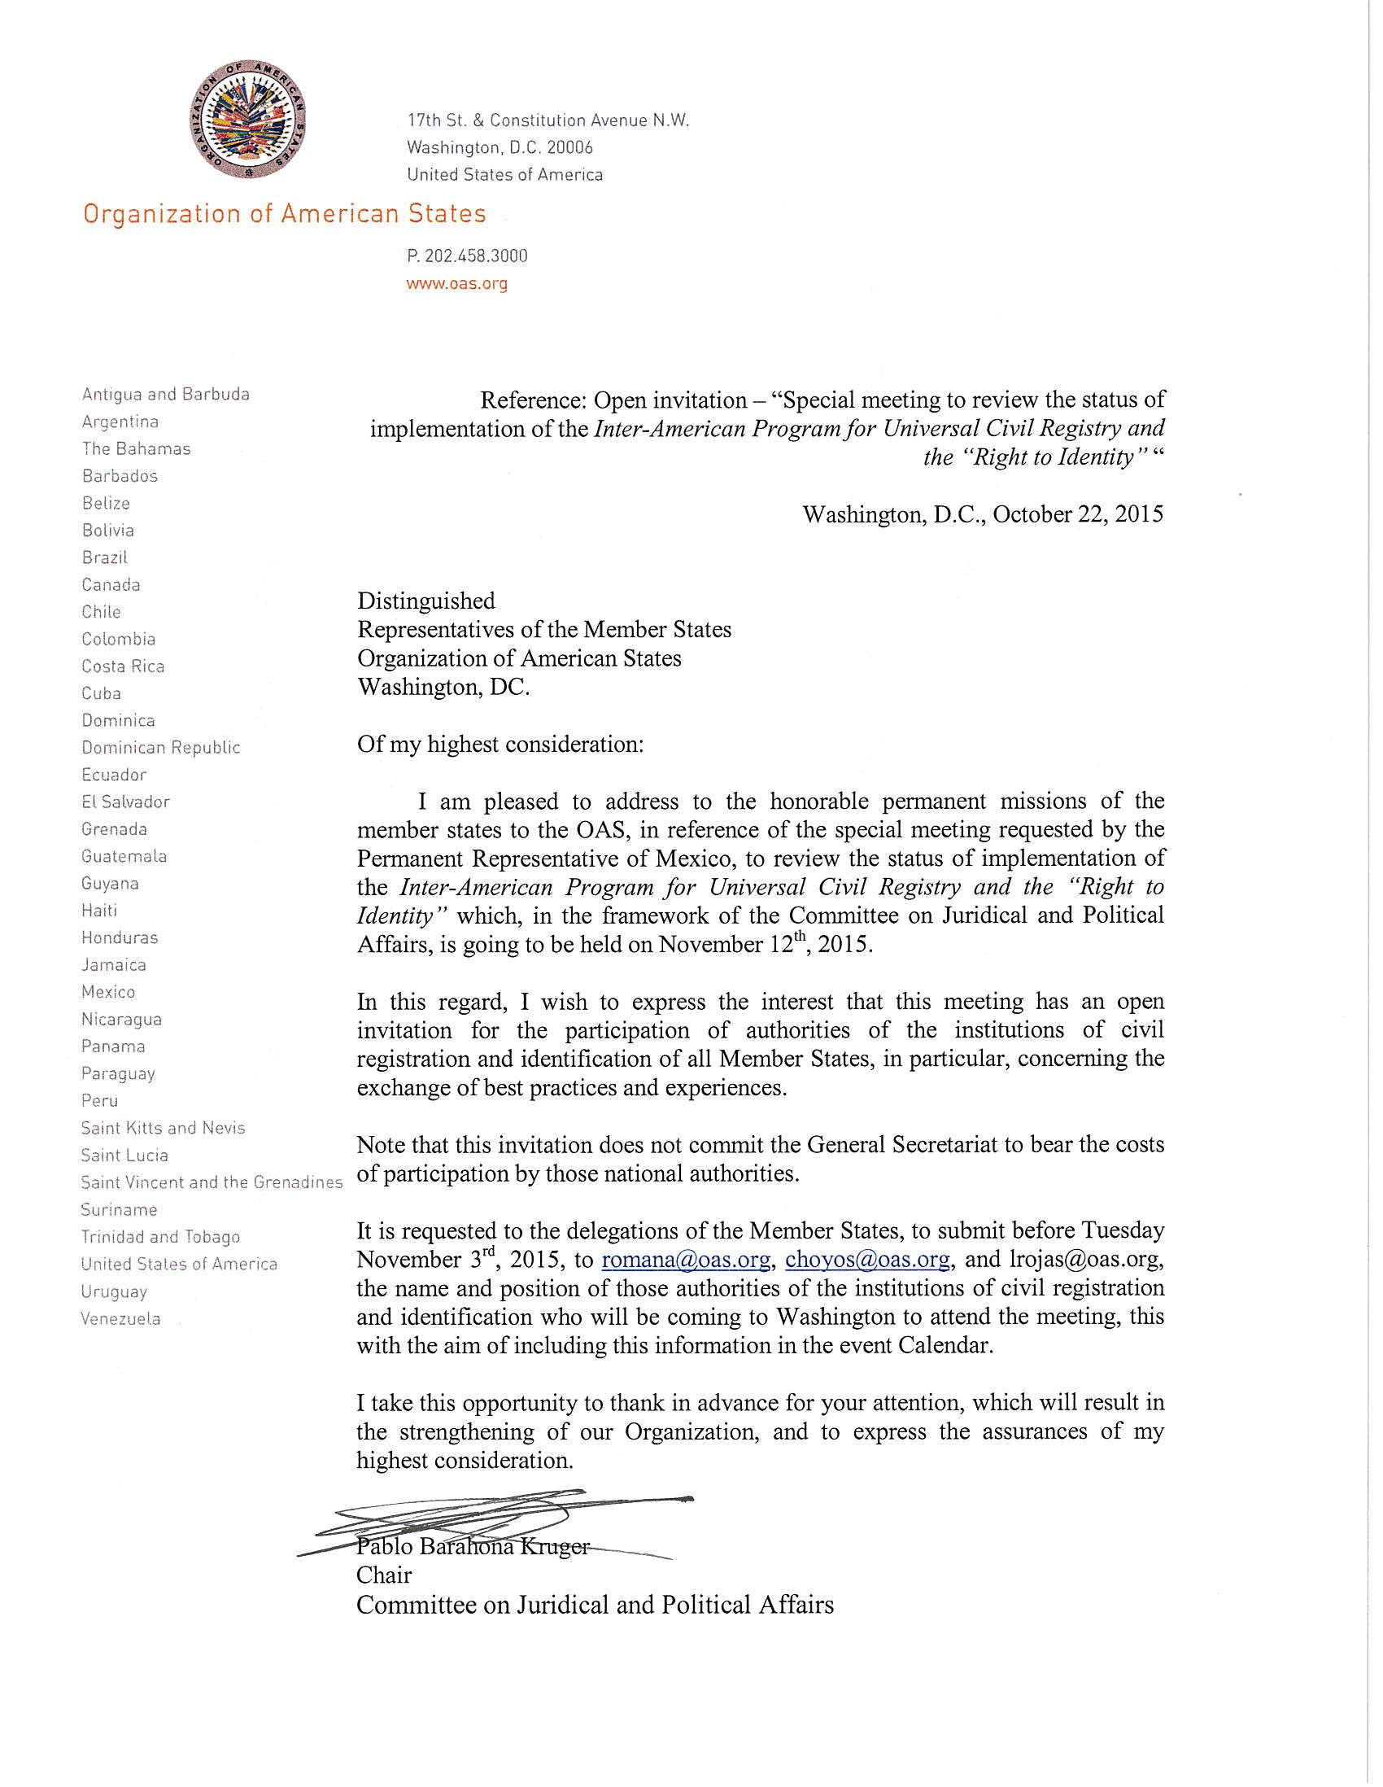
input.doc

