OEA/Ser.G
CP/INF.6265/11
6 July 2011
Original: Spanish

NOTICE

The Secretariat of the Permanent Council of the Organization of American States presents its compliments to the permanent missions and has the honor to transmit a copy of the letter from the Secretary General to the Chair of the Permanent Council in which he advises that he will be away from headquarters from July 6-8, 2011.

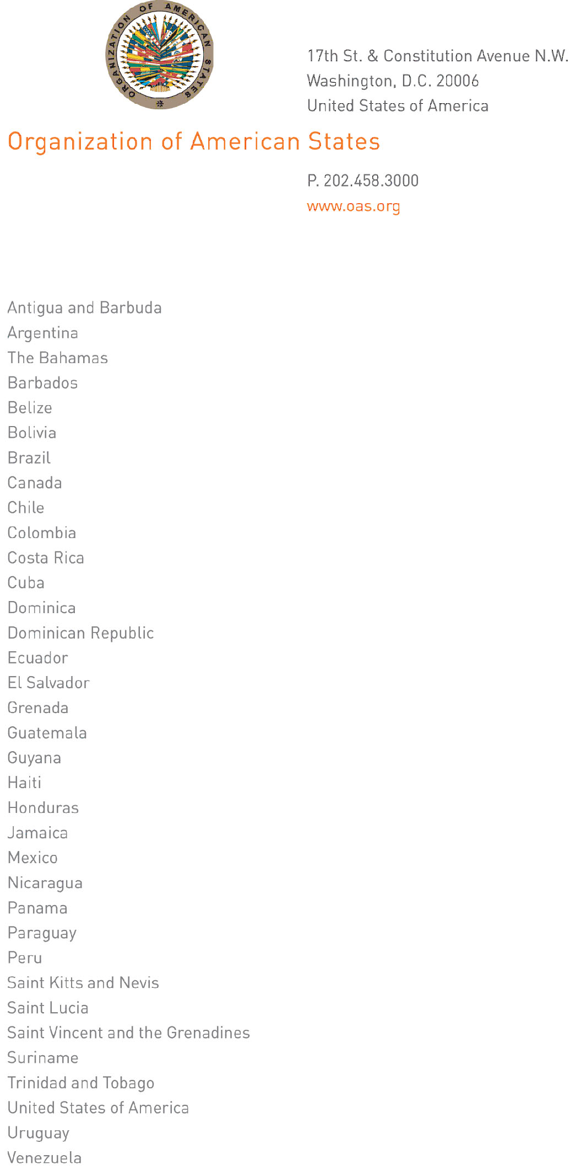

July 5, 2011

His Excellency
Ambassador Jorge Skinner-Kee
Permanent Representative of Guatemala
to the Organization of American States
Washington, D.C.

Excellency:
input.doc
I have the honor to address Your Excellency to advise that I will be away from headquarters from July 6 at midday to July 8, 2011.

During my absence, Ambassador Albert Ramdin, Assistant Secretary General, will be in charge of the General Secretariat.

Accept, Excellency, renewed assurances of my highest and most distinguished consideration.

José Miguel Insulza
Secretary General

