OEA/Ser.G
CP/INF.6275/11
21 July 2011
Original: Spanish

N O T I C E

The Secretariat of the Permanent Council of the Organization of American States presents its compliments to the permanent missions and has the honor of enclosing a copy of the letter from the Secretary General to the Chair of the Permanent Council informing him that he will be absent from headquarters from July 21 to 29, 2011.
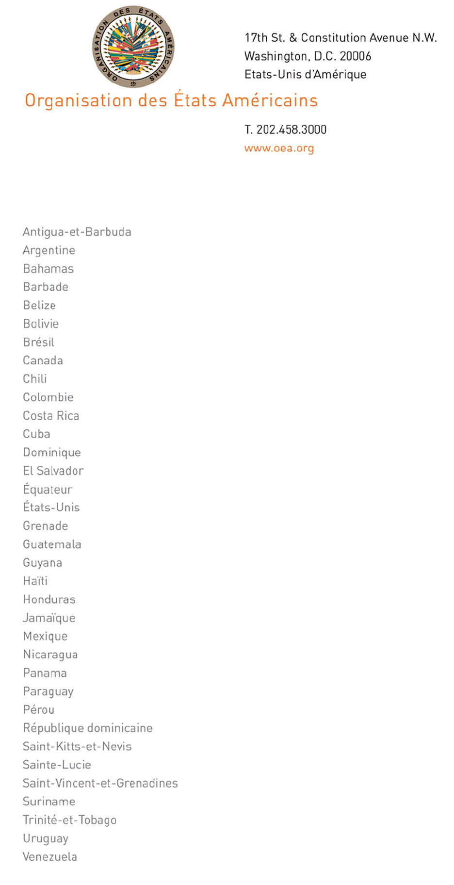
July 20, 2011

His Excellency
Jorge Skinner-Klee
Ambassador, Permanent Representative of Guatemala
to the Organization of American States
Chair of the Permanent Council
Washington, D.C.

Excellency,

I have the honor of writing to advise you that I will be away from headquarters from July 21 to 29, 2011.
input.doc
In my absence, the following officials will be in charge of the General Secretariat:

- Ambassador Albert Ramdin, Assistant Secretary General, on Monday, July 25.

- Ambassador Alfonso Quiñonez, Secretary for External Relations, July 21, 22, and 26 to 29

Accept, Excellency, renewed assurances of my highest and most distinguished consideration.

José Miguel Insulza
Secretary General

