OEA/Ser.G
CP/INF.6284/11
15 August 2011
Original: Spanish

NOTICE

The Secretariat of the Permanent Council of the Organization of American States presents its compliments to the permanent missions and has the honor to forward a copy of the letter from the Secretary General to the Chair of the Permanent Council informing him that he will be away from Headquarters from August 15 to 19, 2011.
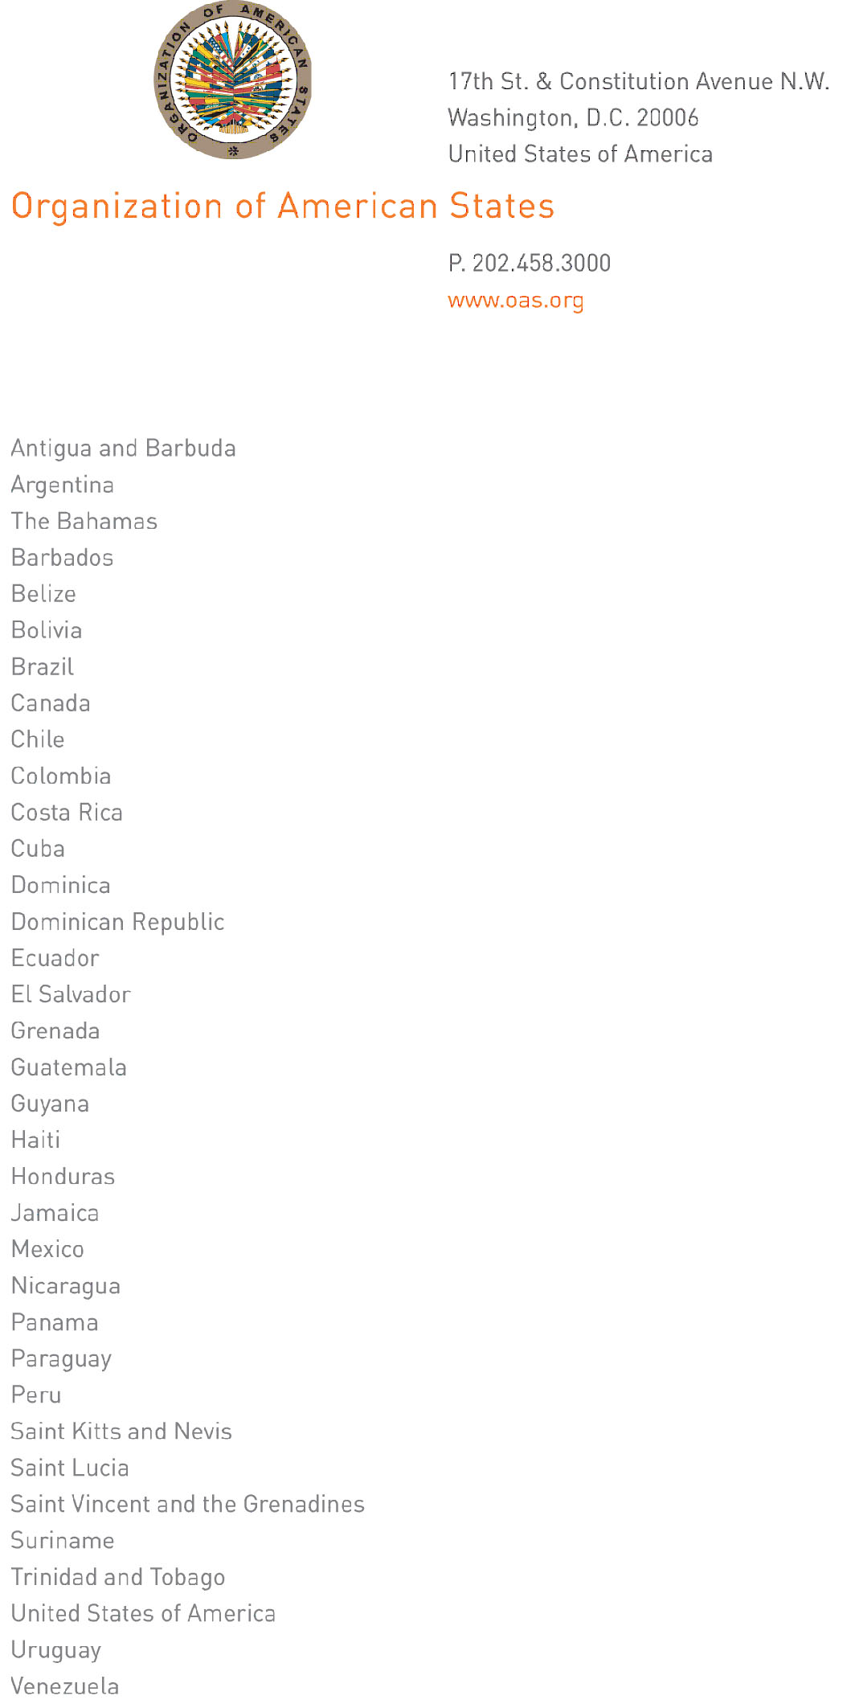
August 12, 2011
input.doc

His Excellency
Jorge Skinner-Klee,
Ambassador, Permanent Representative of Guatemala
to the Organization of American States,
Chair of the Permanent Council,
Washington, D.C.

Excellency:

I have the honor to address Your Excellency to inform you that I will be away from headquarters from August 15 to 19, 2011.

During my absence, the following will be in charge of the General Secretariat:

- Ambassador Albert Ramdin, Assistant Secretary General, on August 15 and 16;

- Ambassador Alfonso Quiñónez, Secretary for External Relations, from August 17 to 19.

Accept, Excellency, renewed assurances of my highest consideration.

José Miguel Insulza
Secretary General

