OEA/Ser.G
CP/INF.6300/11
16 September 2011
Original: Spanish

NOTICE

The Secretariat of the Permanent Council of the Organization of American States presents its compliments to the permanent missions and has the honor to forward a copy of a letter from the Secretary General to the Chair of the Permanent Council, informing the latter that he will be away from headquarters from September 19 to 20, 2011.
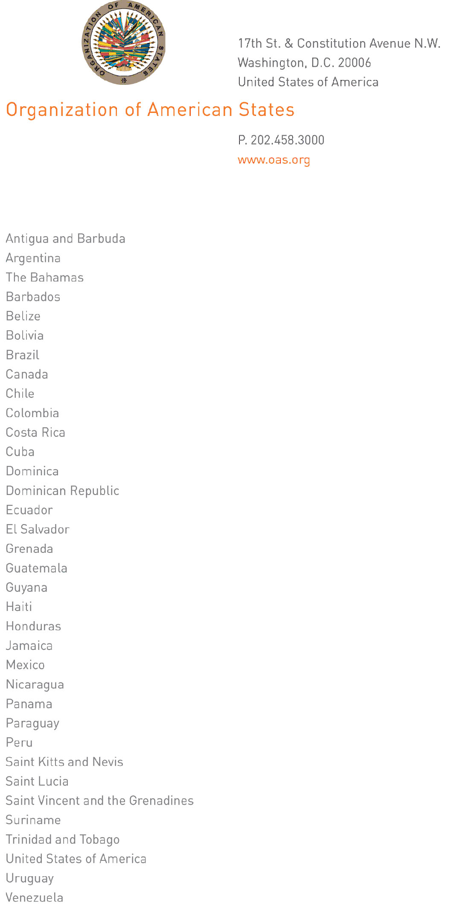
September 16, 2011

His Excellency
Jorge Skinner-Klee
Ambassador, Permanent Representative of Guatemala
to the Organization of American States
Chair of the Permanent Council
Washington, D.C.

Excellency:
input.doc

I have the honor to address Your Excellency to inform you that I will be away from headquarters from September 19 to 20, 2011.

During my absence Ambassador Alfonso Quiñónez, Secretary for External Relations, will be in charge of the General Secretariat.

Accept, Excellency, renewed assurances of my highest consideration.

José Miguel Insulza
Secretary General

