OEA/Ser.G
CP/INF.6443/12
13 June 2012
Original: Spanish

N O T I C E

The Secretariat of the Permanent Council of the Organization of American States presents its compliments to the permanent missions and has the pleasure of forwarding a copy of a letter from the Secretary General to the Chair of the Permanent Council, informing him that he will be away from headquarters on June 14 and 15, 2012.
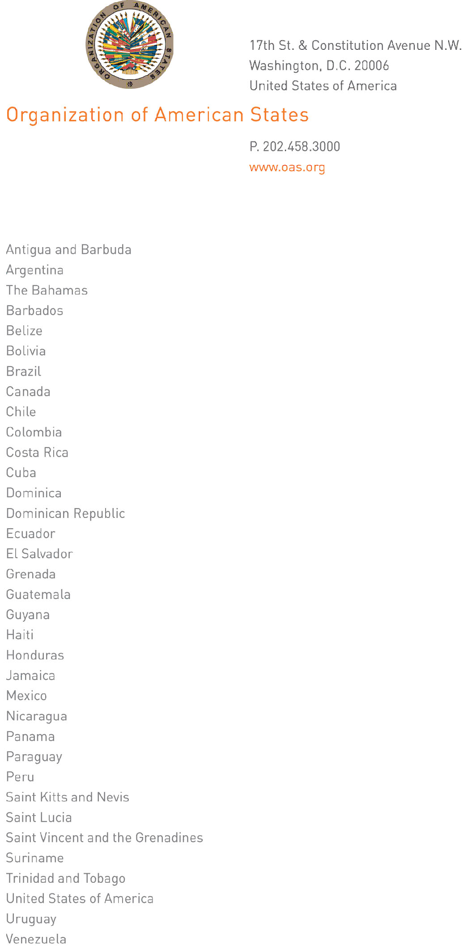
June 13, 2012

His Excellency
Leonidas Rosa Bautista
Ambassador, Permanent Representative of Honduras
to the Organization of American States
Chair of the Permanent Council
Washington, D.C.

Excellency:

I have the honor of writing to advise you that I will be away from headquarters on June 14 and 15 2012.

In my absence, Ambassador Hugo de Zela, Chief of Staff, will be in charge of the General Secretariat.
input.doc
Accept, Excellency, renewed assurances of my highest and most distinguished consideration.

José Miguel Insulza
Secretary General

