OEA/Ser.G
CP/INF.6538/12
22 October 2012
Original: Spanish

NOTICE

The Secretariat of the Permanent Council of the Organization of American States presents its compliments to the permanent missions and has the honor to forward a copy of a letter from the Secretary General to the Chair of the Permanent Council, informing the latter that he will be away from headquarters from October 22 to 29, 2012.
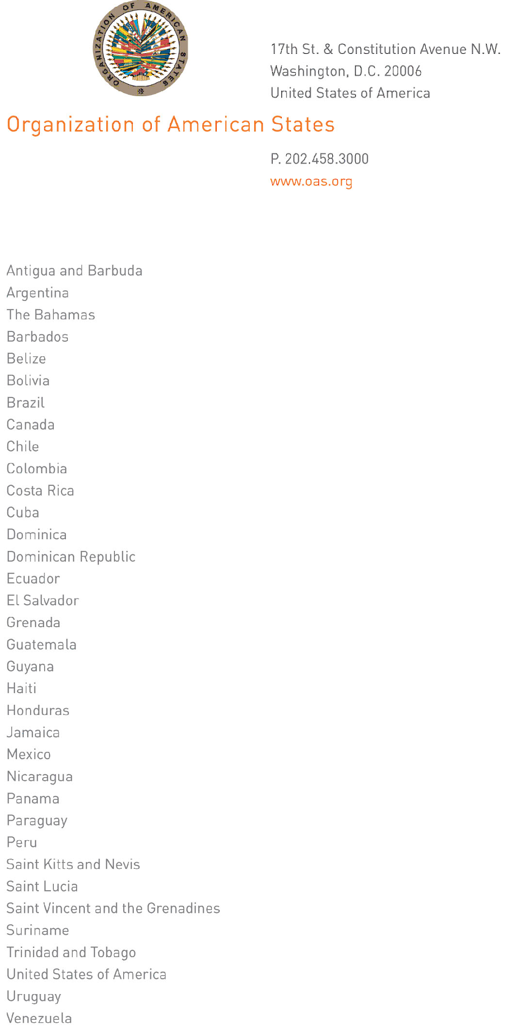

October 19, 2012

His Excellency
Joel Hernández
Ambassador, Permanent Representative of Mexico
to the Organization of American States
Chair of the Permanent Council
Washington, D.C.

Excellency:
input.doc
I have the honor to address Your Excellency to inform you that I will be away from headquarters from October 22 to 29, 2012.

During my absence, the following will be in charge of the General Secretariat:

- Ambassador Albert Ramdin, Assistant Secretary General, on October 22, 23, and 26;
- Ambassador Hugo de Zela, Chief of Staff, on October 24, 25, and 29.

Accept, Excellency, renewed assurances of my highest consideration.

José Miguel Insulza
Secretary General

