OEA/Ser.G
CP/INF.6598/12
28 November 2012
Original: Spanish

N O T I C E

The Secretariat of the Permanent Council of the Organization of American States presents its compliments to the permanent missions and has the honor to forward herewith a letter from the Secretary General to the Chair of the Permanent Council, advising him that he would be away from headquarters from November 28 to 30, 2012.
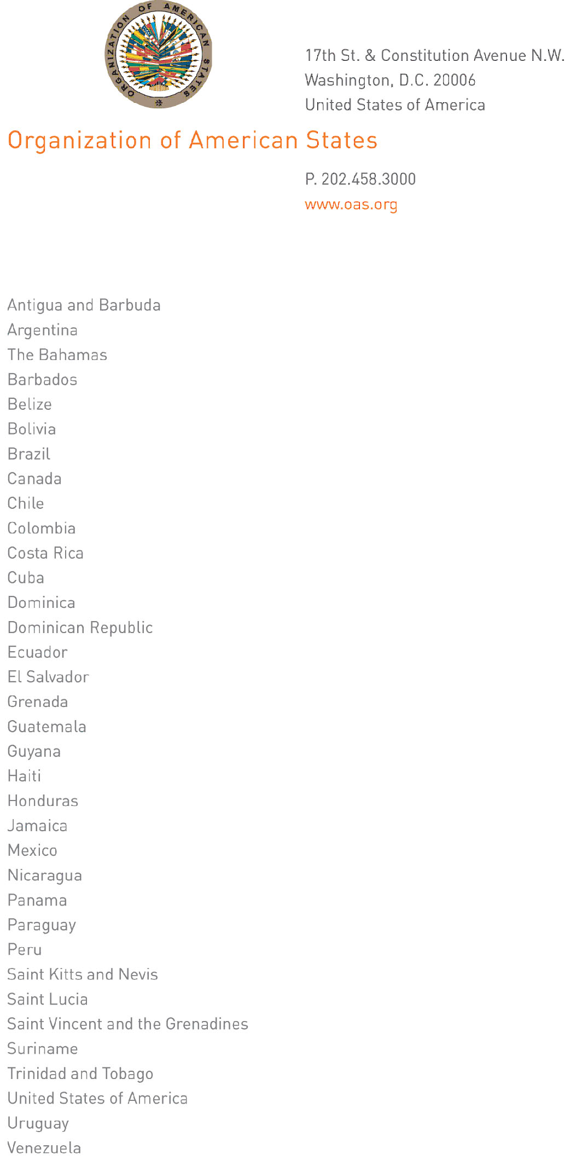
November 27, 2012

His Excellency Joel Hernández
Ambassador, Permanent Representative of Mexico
to the Organization of American States
Chair of the Permanent Council
Washington, D.C.

Excellency:
input.doc
I have the honor to address Your Excellency to advise you that I will be away from headquarters from November 28 to 30, 2012.

During my absence, the following officials will be in charge of the General Secretariat:

- Ambassador Albert Ramdin, Assistant Secretary General, November 28
- Ambassador Hugo de Zela, Chief of Staff, November 29 and 30.

Accept, Excellency, renewed assurances of my highest consideration.

José Miguel Insulza
Secretary General

