OEA/Ser.G
CP/INF.6613/12
20 December 2012
Original: Spanish

NOTICE

The Secretariat of the Permanent Council of the Organization of American States presents its compliments to the permanent missions and has the honor to forward a copy of a letter from the Secretary General to the Chair of the Permanent Council, informing the latter that he will be away from headquarters from December 21, 2012 to January 10, 2013.
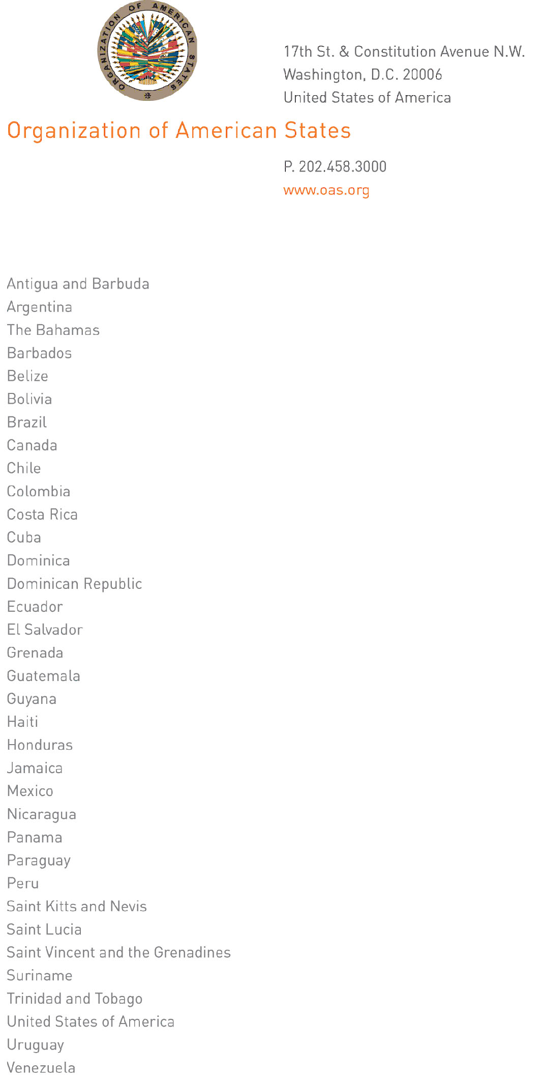

December 20, 2012

His Excellency
Joel Hernández
Ambassador, Permanent Representative of Mexico
to the Organization of American States
Chair of the Permanent Council
Washington, D.C.

Excellency:
CP29924E04
I have the honor to address Your Excellency to inform you that I will be away from Headquarters from December 21, 2012 to January 10, 2013.

During my absence, Ambassador Albert Ramdin, Assistant Secretary General, will be in charge of the General Secretariat:

Accept, Excellency, renewed assurances of my highest consideration.

José Miguel Insulza
Secretary General

