OEA/Ser.G
CP/INF.6623/13
24 January 2013
Original: Spanish

NOTICE

The Secretariat of the Permanent Council of the Organization of American States presents its compliments to the permanent missions and has the honor of forwarding a copy of a letter from the Secretary General to the Chair of the Permanent Council, informing the latter that he will be away from headquarters from January 24 to 29, 2013.
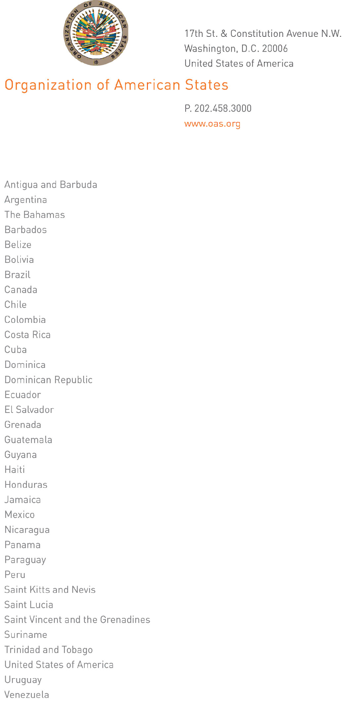
January 23, 2013

His Excellency
Denis Moncada Colindres
Ambassador, Permanent Representative of Nicaragua
to the Organization of American States
Chair of the Permanent Council
Washington, D.C.

Excellency:

I have the honor of writing to advise that I will be away from headquarters from January 24 to 29, 2013.

In my absence, the following officers will be in charge of the General Secretariat.

- Dr. Jean Michel Arrighi, Secretary for Legal Affairs, on January 24 and 25;

- Ambassador Albert Ramdin, Assistant Secretary General, on January 28 and 29.

Accept, Excellency, the renewed assurances of my highest consideration.

José Miguel Insulza
Secretary General
input.doc

