OEA/Ser.G
CP/INF.6691/13
18 March 2013
Original: Spanish

NOTICE

The Secretariat of the Permanent Council of the Organization of American States presents its compliments to the permanent missions and has the honor to forward a copy of a letter from the Secretary General to the Chair of the Permanent Council, informing the latter that he will be away from headquarters from March 18 to 20, 2013.
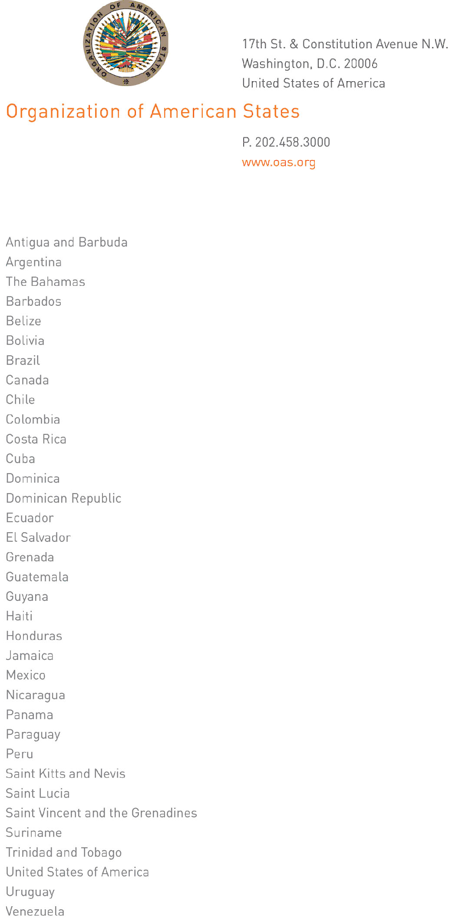
March 17, 2013

His Excellency
Denis Moncada Colindres
Ambassador, Permanent Representative of Nicaragua
to the Organization of American States
Chair of the Permanent Council
Washington, D.C.

Excellency:

I have the honor of writing to advise that I will be away from headquarters from March 18 to 20, 2013.

In my absence, Ambassador Hugo de Zela, Chief of Staff, will be in charge of the General Secretariat.

Accept, Excellency, the renewed assurances of my highest consideration.

José Miguel Insulza
Secretary General
input.doc

