OEA/Ser.G
CP/INF.6724/13
9 May 2013
Original: Spanish

N O T I C E

The Secretariat of the Permanent Council of the Organization of American States presents its compliments to the permanent missions and has the honor of conveying to them a copy of the letter from the Secretary General to the Chair of the Permanent Council, in which he indicates he will be absent from headquarters on May 9 and 10, 2013.
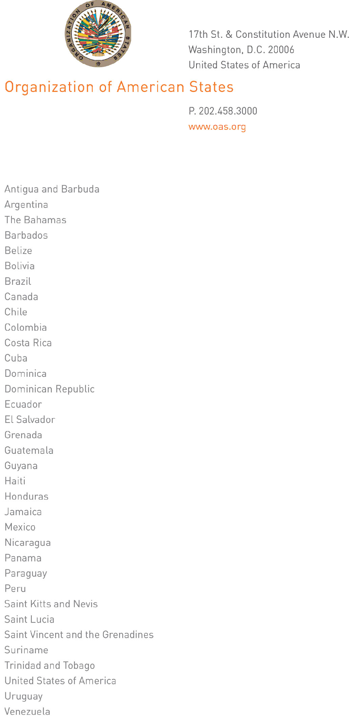

May 8, 2013

His Excellency Arturo Vallarino
Ambassador, Permanent Representative of Panama
to the Organization of American States
Chair of the Permanent Council
Washington, D.C.

Excellency:
input.doc
I have the honor of addressing Your Excellency to report that I shall be absent from headquarters on May 9 and 10, 2013.

During my absence, Ambassador Hugo de Zela, Chief of Staff, will be in charge of the General Secretariat.

Accept, Excellency, the renewed assurances of my highest consideration.

José Miguel Insulza
Secretary General

