OEA/Ser.G
CP/INF.5672/08
9 April 2008
Original: English

FIFTH SUMMIT OF THE AMERICAS

PORT OF SPAIN, 2009

‘SECURING OUR CITIZENS’ FUTURE BY PROMOTING HUMAN PROSPERITY, ENERGY SECURITY AND ENVIRONMENTAL SUSTAINABILITY’

CONCEPT PAPER

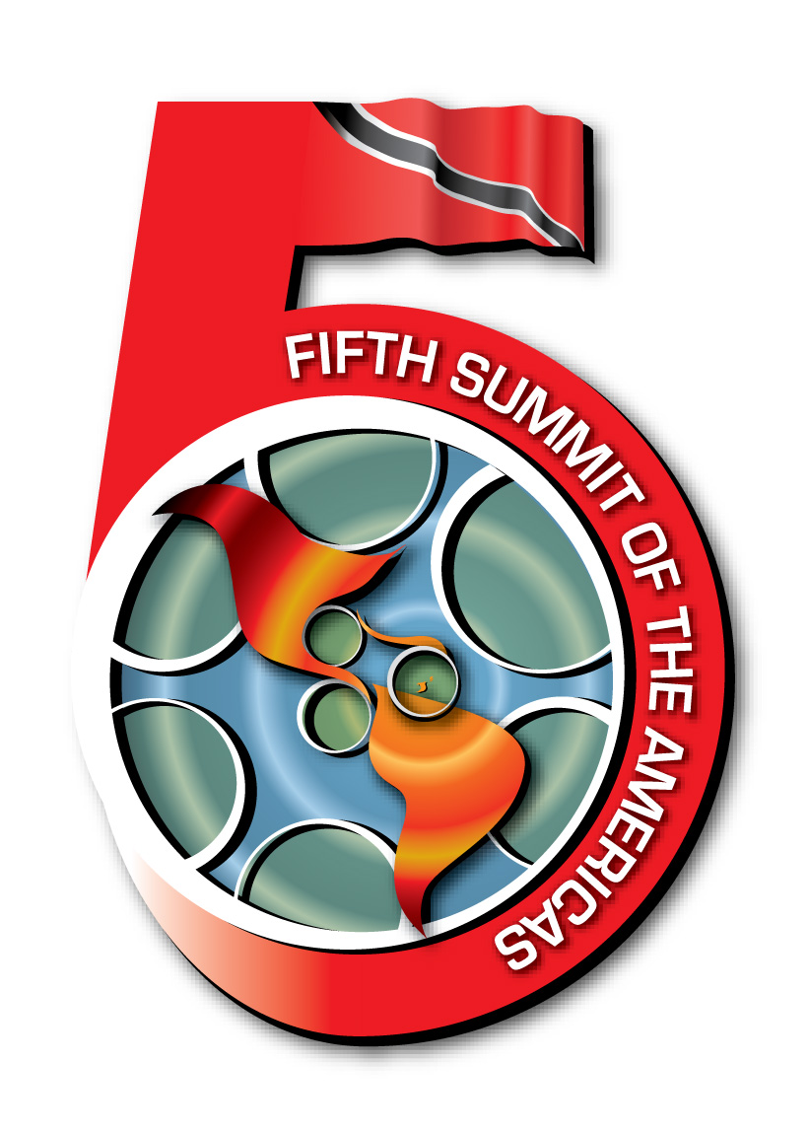


SIRG/GRIC doc.1/08
9 April, 2008
Original: English

Fifth Summit of the Americas

Port of Spain, 2009

‘Securing Our Citizens’ Future by Promoting Human Prosperity, Energy Security and Environmental Sustainability’

Concept Paper

The leaders of the democratic nations of the Hemisphere will meet in 2009 in Port of Spain, Trinidad and Tobago at the Fifth Summit of the Americas to consider the most important issues facing the region and to advance collective solutions in pursuit of a higher quality of life for all citizens.

After several decades of reforms, the Americas today are showing encouraging signs of progress. The emergence of positive political, economic and social trends has renewed expectations among our citizens for a better future of equal opportunity, greater security and increased prosperity.

Meeting these expectations will require stronger and deeper regional cooperation and more effective programmes of action to accelerate the momentum of economic growth, build stronger democratic systems and combat the persistent and pervasive problems of poverty, hunger, exclusion and inequality, objectives which have been at the heart of the Summit Process since 1994. There is also an urgent need to address the new threats to regional security, in a world that is being rapidly transformed by technological advance, geo-political change and an emerging pattern of increasing energy constraints and environmental impacts.

The Port of Spain Summit will focus on developing feasible solutions to the challenges facing the Hemisphere and delivering tangible and measurable outcomes for all citizens. The emphasis will be on building our people’s ability to improve their lives and circumstances.

The progress made at the previous four Summits of the Americas and the two Special Summits provide a solid basis for developing a focused, integrated and results-oriented Inter-American Agenda that encourages the effective engagement of civil society, the private sector, indigenous peoples, afro-descendants, women, youth and regional institutions in the Summit Process.

Securing Our Citizens’ Future by Promoting Human Prosperity, Energy Security and Environmental Sustainability focuses on reducing critical vulnerabilities and improving the well-being and safety of the peoples of the Americas through an integrated and mutually reinforcing set of social, economic and environmental policies. It addresses a collective regional agenda for achieving accelerated human development and poverty reduction, social and cultural inclusion, and a transition to greater energy security and more sustainable communities.

This integrated agenda will only succeed if it is supported by strong democratic values, good governance, respect for human rights, the rule of law, a renewed fight against corruption, gang violence, organized crime and terrorism, and a reaffirmation of the principles of the Inter-American Democratic Charter.

Overcoming poverty continues to be a major challenge for most of our countries. Deep and persistent inequalities exist in education, health, nutritional status, income and access to basic services such as water, sanitation, housing and electricity. Across the region, more than 96 million of our citizens live in extreme poverty, nearly 400 million still suffer some form of discrimination and 22 million youth are neither working nor studying.

These conditions can undermine security by eroding social cohesion and weakening support for democracy. Security has multiple dimensions; it includes the prevention of violence, crime and terrorism, but it also includes the creation of opportunities for people to overcome exclusion and marginalization, improve their lives and feel that they have a stake in the future development and prosperity of their nations.

Education is the key to reducing poverty, promoting equality and building cohesive societies. Policies that improve access to, and the coverage and quality of public education must be given high priority. The strengthening of programmes on early childhood and primary education has to be accompanied by efforts to reform secondary and tertiary education systems and improve teacher-training. Better secondary and tertiary education for young men and women must be at the core of policies to encourage upward social mobility, disseminate modern skills, foster innovation and creativity, and thereby generate more business opportunities, increase global competitiveness, and spur faster economic growth.

Improving health and wellness is also crucial. Some 3.2 million people in the Americas are infected with HIV/AIDS, while dengue, malaria, Chagas disease and tuberculosis continue to be major health challenges. The increasing incidence of non-communicable diseases, such as diabetes, cardiovascular disease and cancer is also a cause for concern, as they have become the leading cause of premature mortality, accounting for nearly half of the deaths of persons under 70 years and for two out of three deaths overall.

Changes in healthcare priorities as well as cost-effective, preventative approaches are urgently needed. Better education on nutrition, lifestyle and health, regular screening to permit early detection, family planning services and healthier workplaces must be complemented by programmes to expand primary health care and improve the quality and coverage of health services for poor people, especially women and children. It is also important to encourage research in biomedical science that will lead to more effective treatments for the major diseases, and to make these treatments more affordable and widely available.

For millions of people in the Americas, these health challenges are exacerbated by poor nutrition. An adequate supply of affordable staples in local markets, supplemented by well-planned social programmes, will meet the nutritional needs of poor families. Reducing barriers to transport and commerce will enable markets to operate efficiently, enhancing extension programmes will improve agricultural and fishing productivity, food safety and resource management, and facilitating wider access to land will encourage higher-value forms of production.

The Fourth Summit of the Americas identified decent work as the most effective tool for achieving material and human progress. Too many of our citizens experience great difficulty in finding productive work that provides a fair income. Some have to contend with poor working conditions while others are trapped by discrimination or a lack of marketable qualifications and skills which isolate them from economic opportunities. Many marginalized groups such as women, youth, indigenous peoples, afro-descendants, people with disabilities and persons living with HIV/AIDS survive in the informal sector, and should be assisted to migrate into the formal sector. Encouraging innovation, greater creativity and the promotion of cultural industries will create new opportunities to engage more citizens in productive economic activities.

Mainstreaming gender and encouraging more sharing of cultural values to promote mutual understanding and tolerance will also help to reduce discrimination and the barriers to economic opportunity and social participation. Child labour and other abuses must also be eliminated.

Sound macroeconomic policies and higher levels of sustained economic growth are necessary for creating jobs, fighting poverty and reducing inequality. The region must continue economic reforms, but also implement policies that increase the flow of productive investment, accelerate business development and expansion, particularly in new industries, and encourage public-private sector partnerships.

Universal access to information and communication technologies will connect our governments and our people, enable the sharing of knowledge and ideas, create new business opportunities and bring many marginalized and vulnerable groups into the mainstream of society.

More emphasis needs to be placed on increasing global competitiveness by building a strong capacity for scientific and technological research and development, and by nurturing the entrepreneurial, innovative and creative capacity of our citizens. This must be accompanied by more efficient, transparent regulations as well as initiatives to improve the energy, transport and information and communication infrastructure, increase investments in education and skills development, and strengthen the micro, small and medium-enterprise sector.

The region must also continue to build a strong business environment. Additional reforms are required to improve property rights and labour laws, increase access to affordable credit, and simplify the processes involved in starting and closing business ventures.

Today, the Americas face some particularly pressing energy-related challenges, including a sharply rising demand for oil and gas, higher prices with the associated foreign exchange outflows, inflationary pressures and reduced rates of economic growth in the importing countries and concerns about possible supply constraints, peak oil and the carbon loading of the atmosphere. The fundamental challenge for the region is to initiate a transition to a secure, low-carbon energy system and ensure that each country has adequate energy supplies.

Through collaborative partnerships, our nations can work towards developing and disseminating cleaner technologies and more energy-efficient solutions in order to significantly reduce adverse environmental impacts. It is important to encourage the use of renewable sources of energy, to support the development of alternatives such as biofuels, wind turbines, geothermal and hydro-power, hydrogen fuel cells and other new energy technologies, and to remove barriers to investment in cleaner energy technologies by working to harmonize standards and increase the transparency of the relevant regulatory frameworks. Investments in these new industries, technologies and skills will provide a basis for long-term energy sustainability.

Energy supply and distribution systems must also be extended so that all citizens have access to secure, clean energy. Many renewable sources are intermittent or only available in particular locations, so new cross-border energy distribution grids and other energy-trading and cooperation networks may be needed.

A healthy environment and the responsible management of our ecosystems are essential to improving the quality of life of our citizens and the sustainability of our economies. Renewed support for the Inter-American Programme for Sustainable Development will focus efforts on key areas, including agricultural management and rural development, ecosystem and biodiversity protection, integrated management of both domestic and shared water resources, natural resources management, urban environmental management and the treatment and disposal of hazardous waste.

More effective regional cooperation for addressing energy security and climate change is now urgently required to mitigate the impact of drought and desertification, rising sea level, hurricanes, storm surges, flash floods and landslides, all of which impact urban and transport infrastructure, food production, industrial development, potable water supplies, forest cover and biodiversity.

The region must enhance mechanisms for the sharing of early warning information on natural disasters, improve disaster planning and preparedness, and strengthen and coordinate emergency responses and relief programmes. Stronger planning and zoning measures are necessary to ensure that human settlements and livelihoods are not located in areas that will become increasingly prone to disasters.
input.doc

The Summits of the Americas have significantly strengthened collective action and reshaped Inter-American relations. The challenge now is to bring national and hemispheric institutions into a stronger framework of cooperation and collaboration. Capable, transparent, accountable and trusted institutions are the main vehicles for promoting human prosperity and sustainable development in the Americas.

More effective coordination, execution and monitoring of Summit mandates, with provision for financial and technical assistance, are needed to ensure that the Summits deliver clear and tangible benefits to the citizens of the Americas. The Fifth Summit will focus on strengthening the mechanism for Ministerial participation, and engaging the Ministers of Finance, multilateral financial institutions, non-governmental organisations and the private sector in an efficient management structure to guide the implementation process.

The Fifth Summit offers a new opportunity for Heads of State and Government to build a stronger, more resilient and progressive Americas in which all citizens have the opportunity to benefit from economic development and growth, and enjoy peace, security and prosperity.

