OEA/Ser.G
CP/INF. 5677/08
9 April 2008
Original: English

REQUEST FROM THE EMBASSY OF THE REPUBLIC OF SLOVENIA FOR
HIS EXCELLENCY DR. DIMITRIJ RUPEL, MINISTER OF FOREIGN AFFAIRS
OF THE REPUBLIC OF SLOVENIA AND PRESIDENT OF THE EUROPEAN UNION
GENERAL AFFAIRS AND EXTERNAL RELATIONS COUNCIL,
TO ADDRESS THE PERMANENT COUNCIL ON APRIL 14, 2008

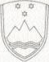

EMBASSY OF THE REPUBLIC OF SLOVENIA

No.: 15/2008
The Embassy of the Republic of Slovenia presents its compliments to the Honorable Presidency of the Permanent Council of the Organization of American States and has the honor to inform that H.E. Dr. Dimitrij Rupel, Minister of Foreign Affairs of the Republic of Slovenia and President of the European Union General Affairs and External Relations Council, would welcome the opportunity to address the Permanent Council of the Organization of American States on April 14, 2008.
input.doc
The Embassy of the Republic of Slovenia avails itself of this opportunity to renew to the Organization of American States the assurances of its highest consideration.
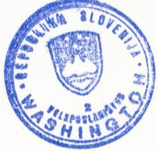
Washington, April 9, 2008

THE HONORABLE
PRESIDENCY OF THE PERMANENT COUNCIL ORGANIZATION OF AMERICAN STATES
WASHINGTON, D.C.

