OEA/Ser.G
CP/INF. 5778/08
10 December 2008
Original: English

NOTE FROM THE PERMANENT MISSION OF THE UNITED STATES
REQUESTING THAT THE TOPIC “COMMEMORATION OF THE 60TH ANNIVERSARY OF THE ADOPTION OF THE UNIVERSAL DECLARATION OF HUMAN RIGHTS” BE INCLUDED ON THE ORDER OF BUSINESS OF THE REGULAR MEETING OF THE PERMANENT COUNCIL, SCHEDULED FOR DECEMBER 17, 2008

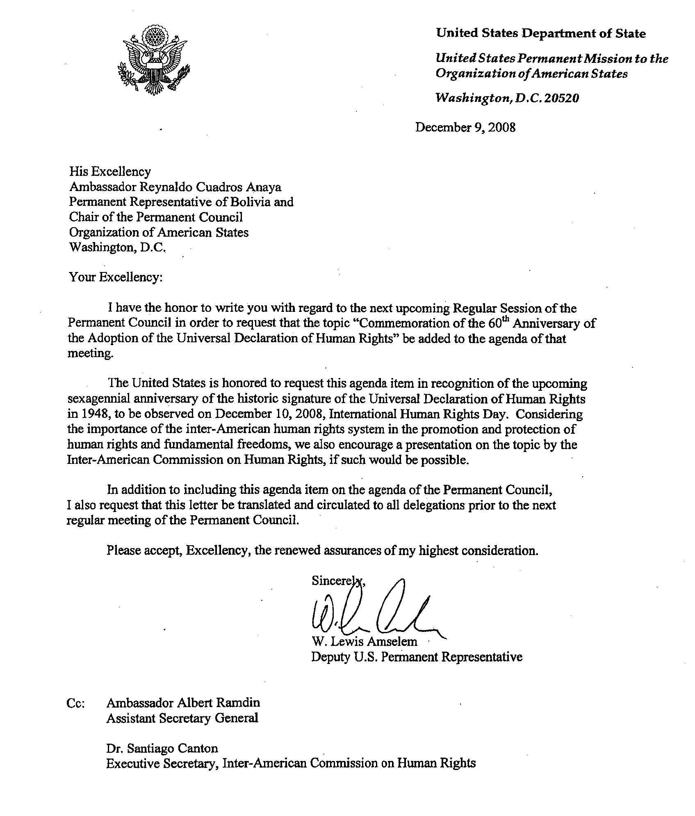
input.doc

