OEA/Ser.G
CP/INF.5797/09
13 February 2009
Original: English

NOTE FROM THE PERMANENT MISSION OF ANTIGUA AND BARBUDA
REQUESTING THE INCLUSION OF THE ELECTION ON A MEMBER OF THE
LEO ROWE FUND COMMITTEE ON THE ORDER OF BUSINESS OF THE
REGULAR SESSION OF THE PERMANENT COUNCIL SCHEDULED FOR
FEBRUARY 18, 2009
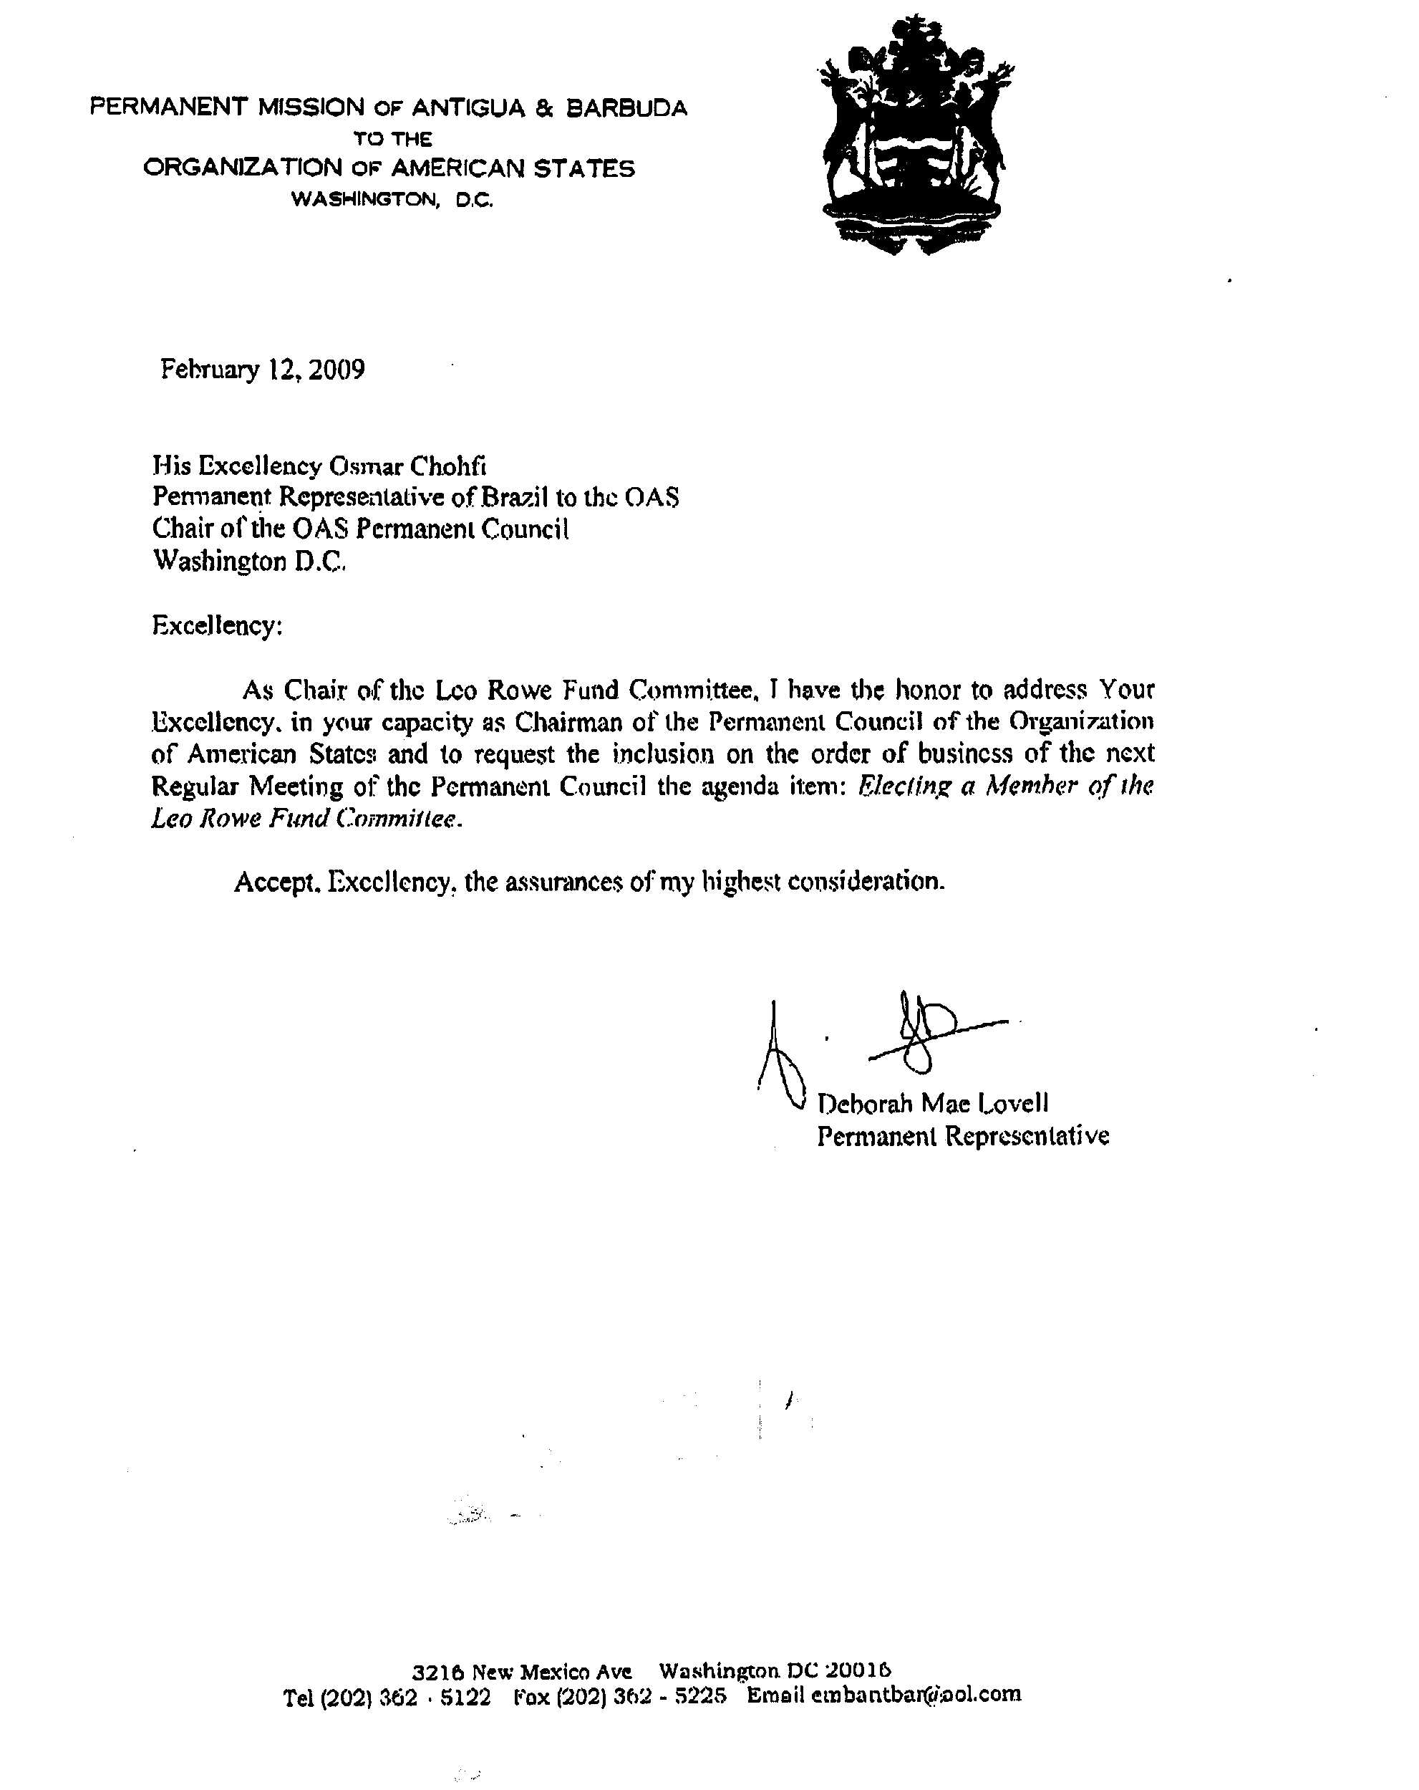
input.doc

