OEA/Ser.G
CP/INF.5848/09
23 May 2009
Original: Spanish

NOTE FROM THE CHAIR OF THE INTER-AMERICAN COMMITTEE AGAINST TERRORISM
WITH REFERENCE TO THE DRAFT RESOLUTION “SUPPORT FOR THE WORK OF THE INTER-AMERICAN COMMITTEE AGAINST TERRORISM”
(AG/doc.4915/09)

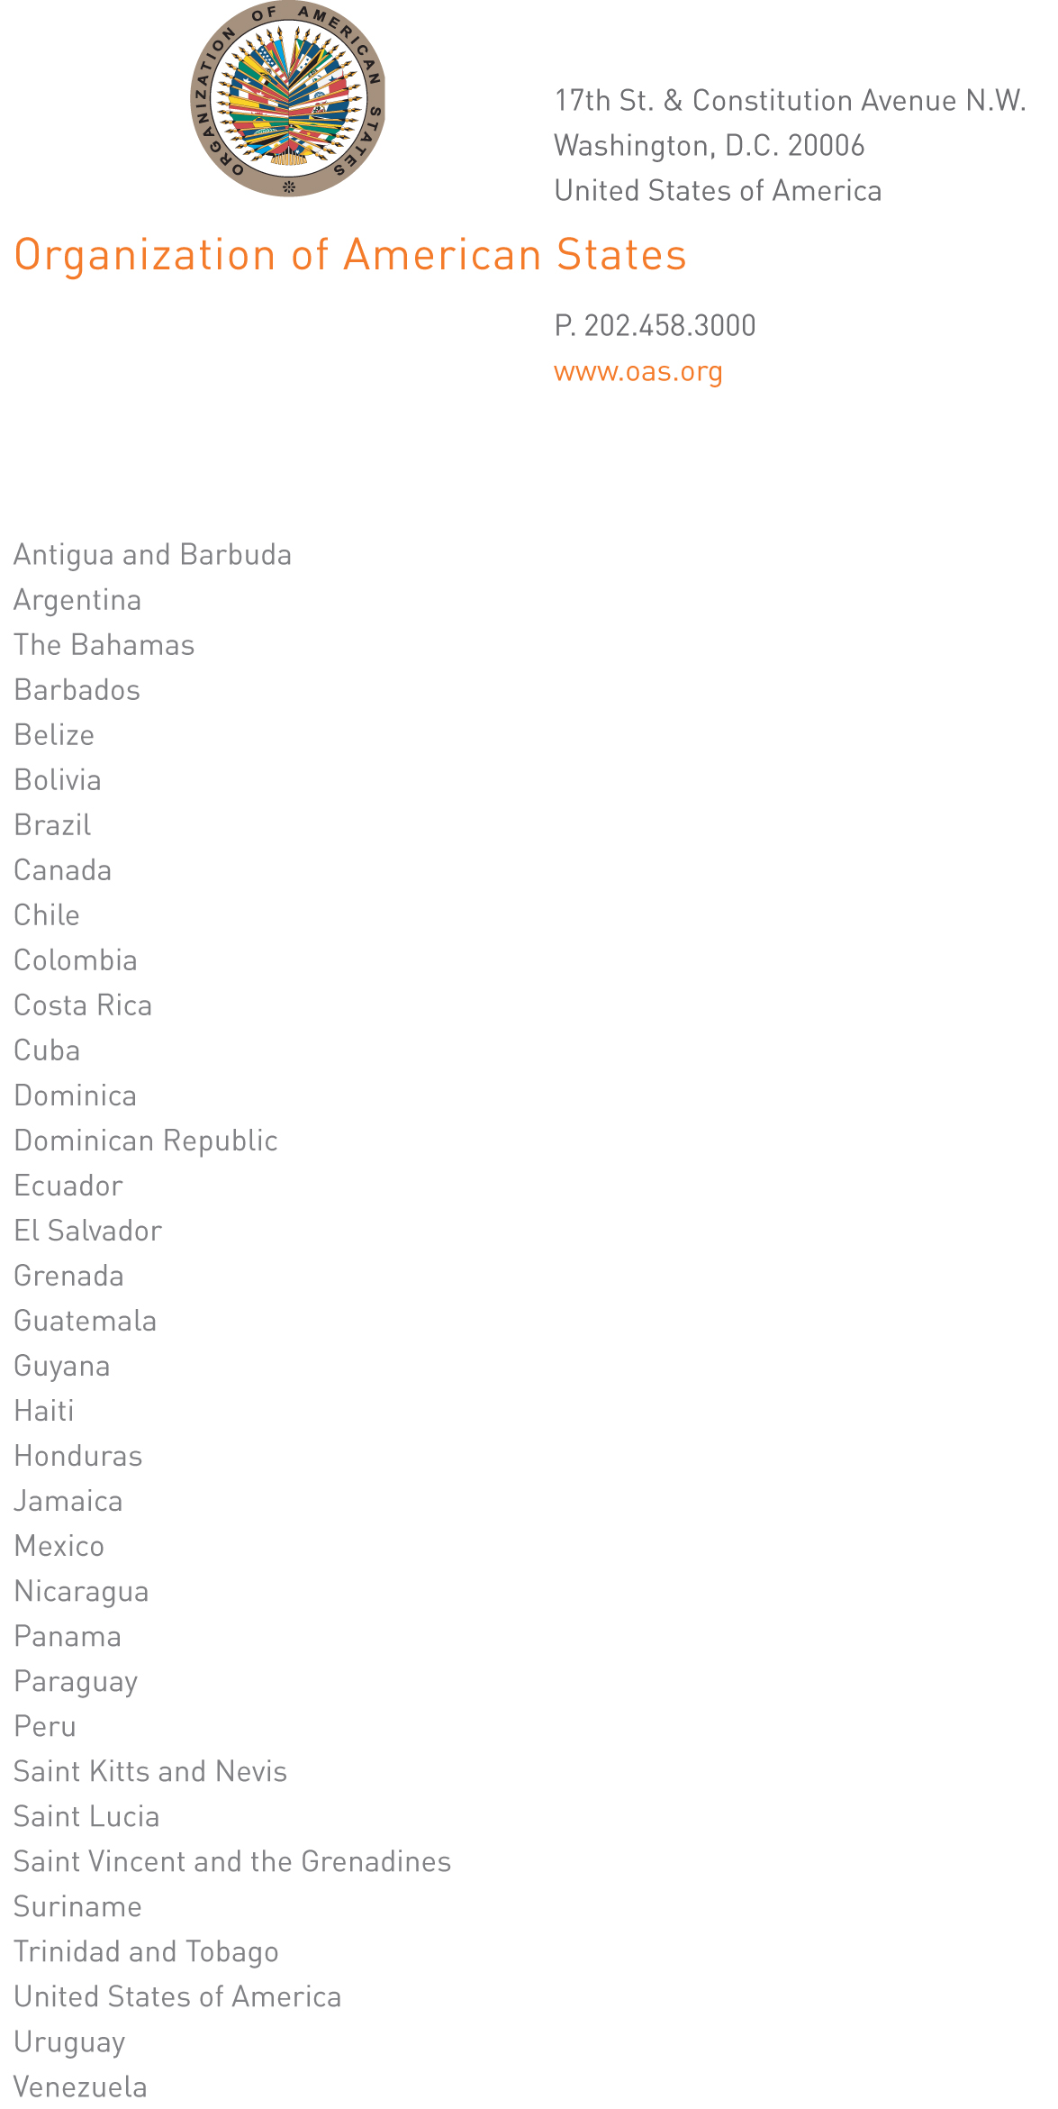
cicte@oas.org

CICTE-79/09

May 20, 2009

Excellency:

I have the honor to address Your Excellency with reference to draft resolution AG/doc.4915/09 entitled “Support for the Work of the Inter-American Committee against Terrorism,” approved by the Permanent Council at its regular meeting on May 13, 2009.

In that regard, I am hereby advising that the Tenth Regular Session of the Inter-American Committee against Terrorism (CICTE), scheduled for March 17-19, 2010, will be held at the headquarters of the Organization of American States, in Washington, D.C., United States of America.
input.doc

Accordingly, I should be most grateful if the information on the venue of the event could be included in operative paragraph 12 of the above-mentioned draft resolution before it is forwarded to the thirty-ninth regular session of the General Assembly of the Organization.

Accept, Excellency, the renewed assurances of my highest consideration.

Gustavo Albin
Ambassador, Permanent Representative of Mexico to the OAS
Chair of the Inter-American Committee against Terrorism

Ambassador Graeme Clark
Permanent Representative of Canada to the OAS
Chair of the Permanent Council
Organization of American States
Washington, D.C.

