OEA/Ser.G
CP/INF.5899/09
4 September 2009
Original: Spanish

NOTE FROM THE CHAIR OF THE INTER-AMERICAN JURIDICAL COMMITTEE FORWARDING TO THE PERMANENT COUNCIL RESOLUTION CJI/RES. 160 (LXXV-O/09),
“FOLLOW-UP ON THE APPLICATION OF THE INTER-AMERICAN
DEMOCRATIC CHARTER”

August 21, 2009
CJI/O/37/09

Excellency:

I have the honor to address Your Excellency to transmit, through you, to the Permanent Council resolution CJI/RES. 160 (LXXV-O/09), “Follow-up on the Application of the Inter-American Democratic Charter,” adopted by the Inter-American Juridical Committee at its meeting of August 12, 2009, during its 75th regular session, held in Rio de Janeiro, Brazil, from August 3 to 14, 2009.

Accept, Excellency, the assurances of my highest consideration.

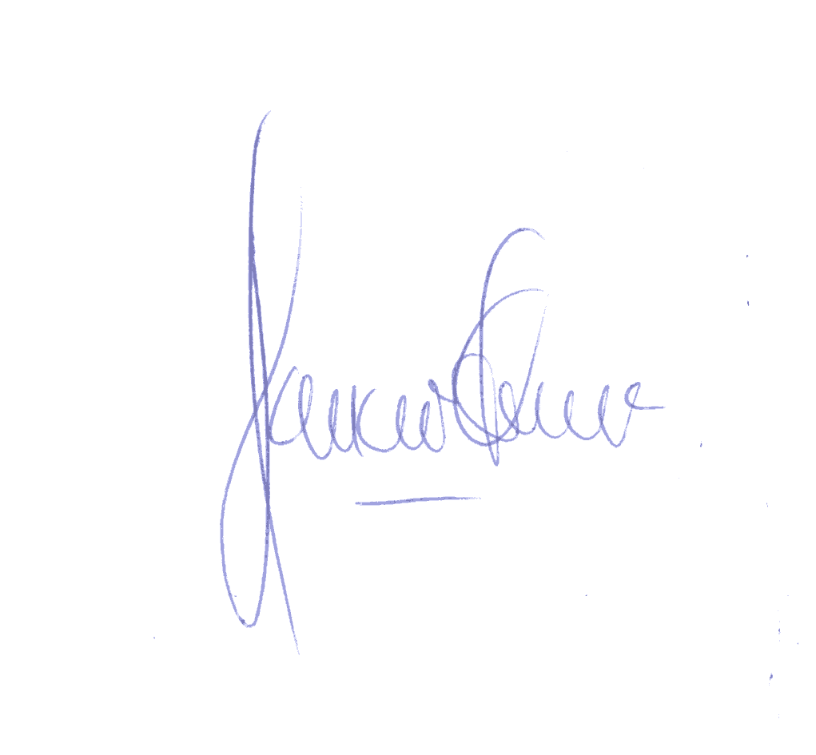
Jaime Aparicio
Chair
Inter-American Juridical Committee

His Excellency
Pedro Oyarce
Ambassador, Permanent Representative of Chile
to the Organization of American States
Chair of the Permanent Council
Washington, D.C.
U.S.A.

http://scm.oas.org/pdfs/2009/CP22837E-1.pdf (Resolution CJI/RES. 160 (LXXV-O/09)
input.doc

