OEA/Ser.G
CP/INF.5926/09
27 October 2009
Original: Spanish

PRESENTATION OF CREDENTIALS by AMBASSADOR
FRANCISCO PROAÑO ARANDI,
Permanent Representative OF ECUADOR
TO THE ORGANIZATION OF AMERICAN STATES
October 26, 2009

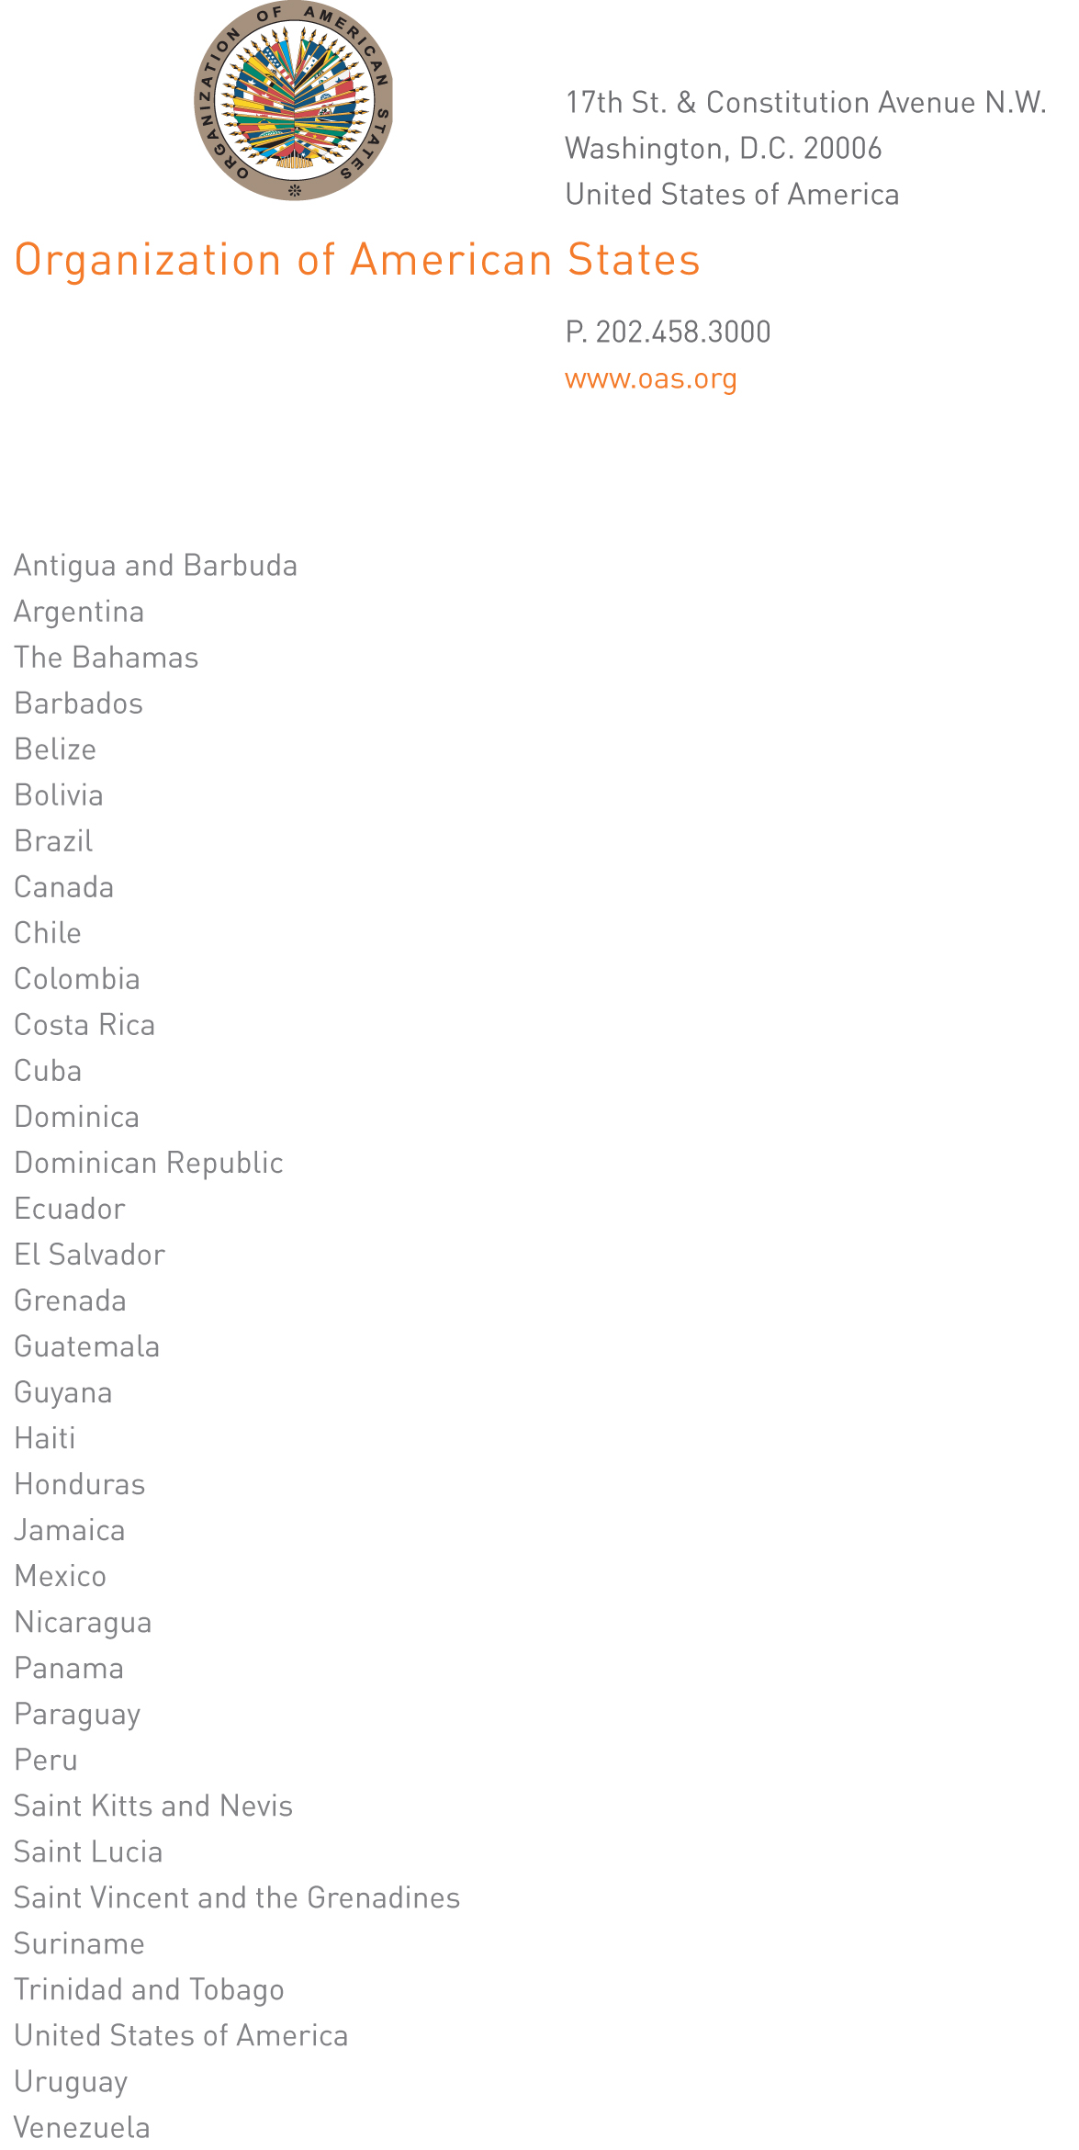

Excellency,

I have the honor to address Your Excellency to inform you that, on October 23, 2009, Ambassador Francisco Proaño Arandi presented his credentials as Permanent Representative of Ecuador to the Organization of American States.

Accept, Excellency, the renewed assurances of my highest consideration.
input.doc

José Miguel Insulza
Secretary General

His Excellency
Luis Alfonso Hoyos
Ambassador, Permanent Representative of Colombia
to the Organization of American States
Washington, D.C.

