OEA/Ser.G
CP/INF.5934/09
11 November 2009
Original: Spanish

NOTE FROM THE PERMANENT MISSION OF MEXICO
TRANSMITTING THE “SPECIAL STATEMENT ON THE SITUATION
IN HONDURAS,” ISSUED BY THE RIO GROUP

Permanent Mission of Mexico

OEA02919

The Permanent Mission of Mexico to the Organization of American States presents its compliments to the Chair of the Permanent Council and, in its capacity as Pro Tempore Secretariat of the Rio Group, kindly requests that the document attached hereto, titled “Special Statement on the Situation in Honduras,” issued by that Group at its ministerial meeting in Montego Bay, Jamaica, on November 5, 2009, be distributed as a Permanent Council information document.

The Permanent Mission of Mexico to the Organization of American States avails itself of this opportunity to renew to the Chair of the Permanent Council the assurances of its highest consideration.

Washington, D.C., November 10, 2009

Chair of the Permanent Council
Organization of American States
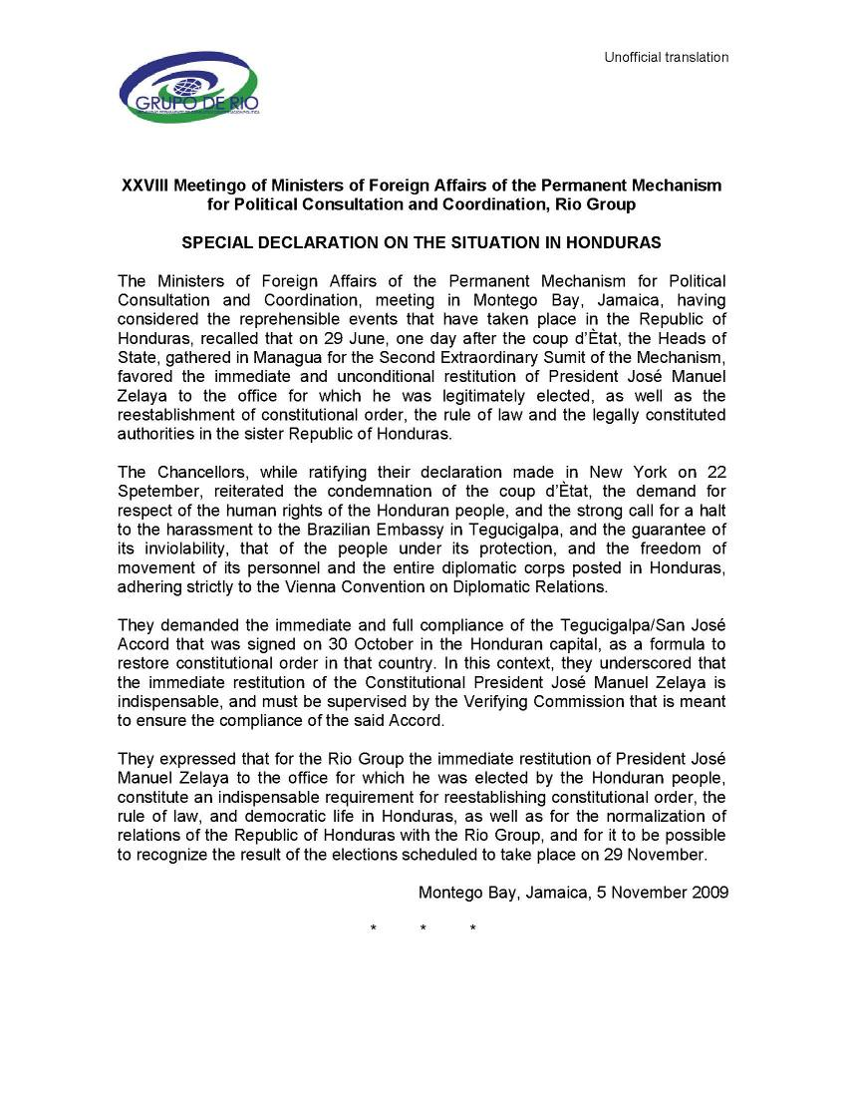
input.doc
input.doc

