OEA/Ser.G
CP/INF.5941/09
23 November 2009
Original: Spanish

CANDIDACY FOR A VACANCY ON THE INTER-AMERICAN COMMISSION ON HUMAN RIGHTS, RESULTING FROM THE RESIGNATION OF A MEMBER OF THE COMMISSION/

(Guatemala)

PERMANENT MISSION OF GUATEMALA
To the
Organization of American States

M12-OEA-E.6
No.579-09

Washington, D.C, November 23, 2009

Excellency:

I have the honor to address Your Excellency to submit the nomination of Dr. Frank La Rue Levy for membership on the Inter-American Commission on Human Rights, for the period 2010-2011 to serve out the rest of the term for which Commissioner Florentín Meléndez was elected, in elections to be held by the Permanent Council at its regular meeting on December 2, 2009, following Mr. Meléndez’ recent resignation.

Accordingly, I am hereby reaffirming the active interest Guatemala takes in human rights protection and promotion at the national as well as international levels. Our Government has therefore decided to nominate Attorney La Rue Levy in light of his excellent personal character, experience, and ideal qualification to be a member of the Inter-American Commission on Human Rights.

I should be most grateful if you would inform the member states of the Organization about this deserving nomination and have Mr. La Rue Levy’s curriculum vitae circulated.

Accept, Excellency, the renewed assurances of my highest consideration.

Jorge Skinner-Klee
Ambassador,
Permanent Representative

His Excellency
José Miguel Insulza
Secretary General
Organization of American States
Washington,D.C.
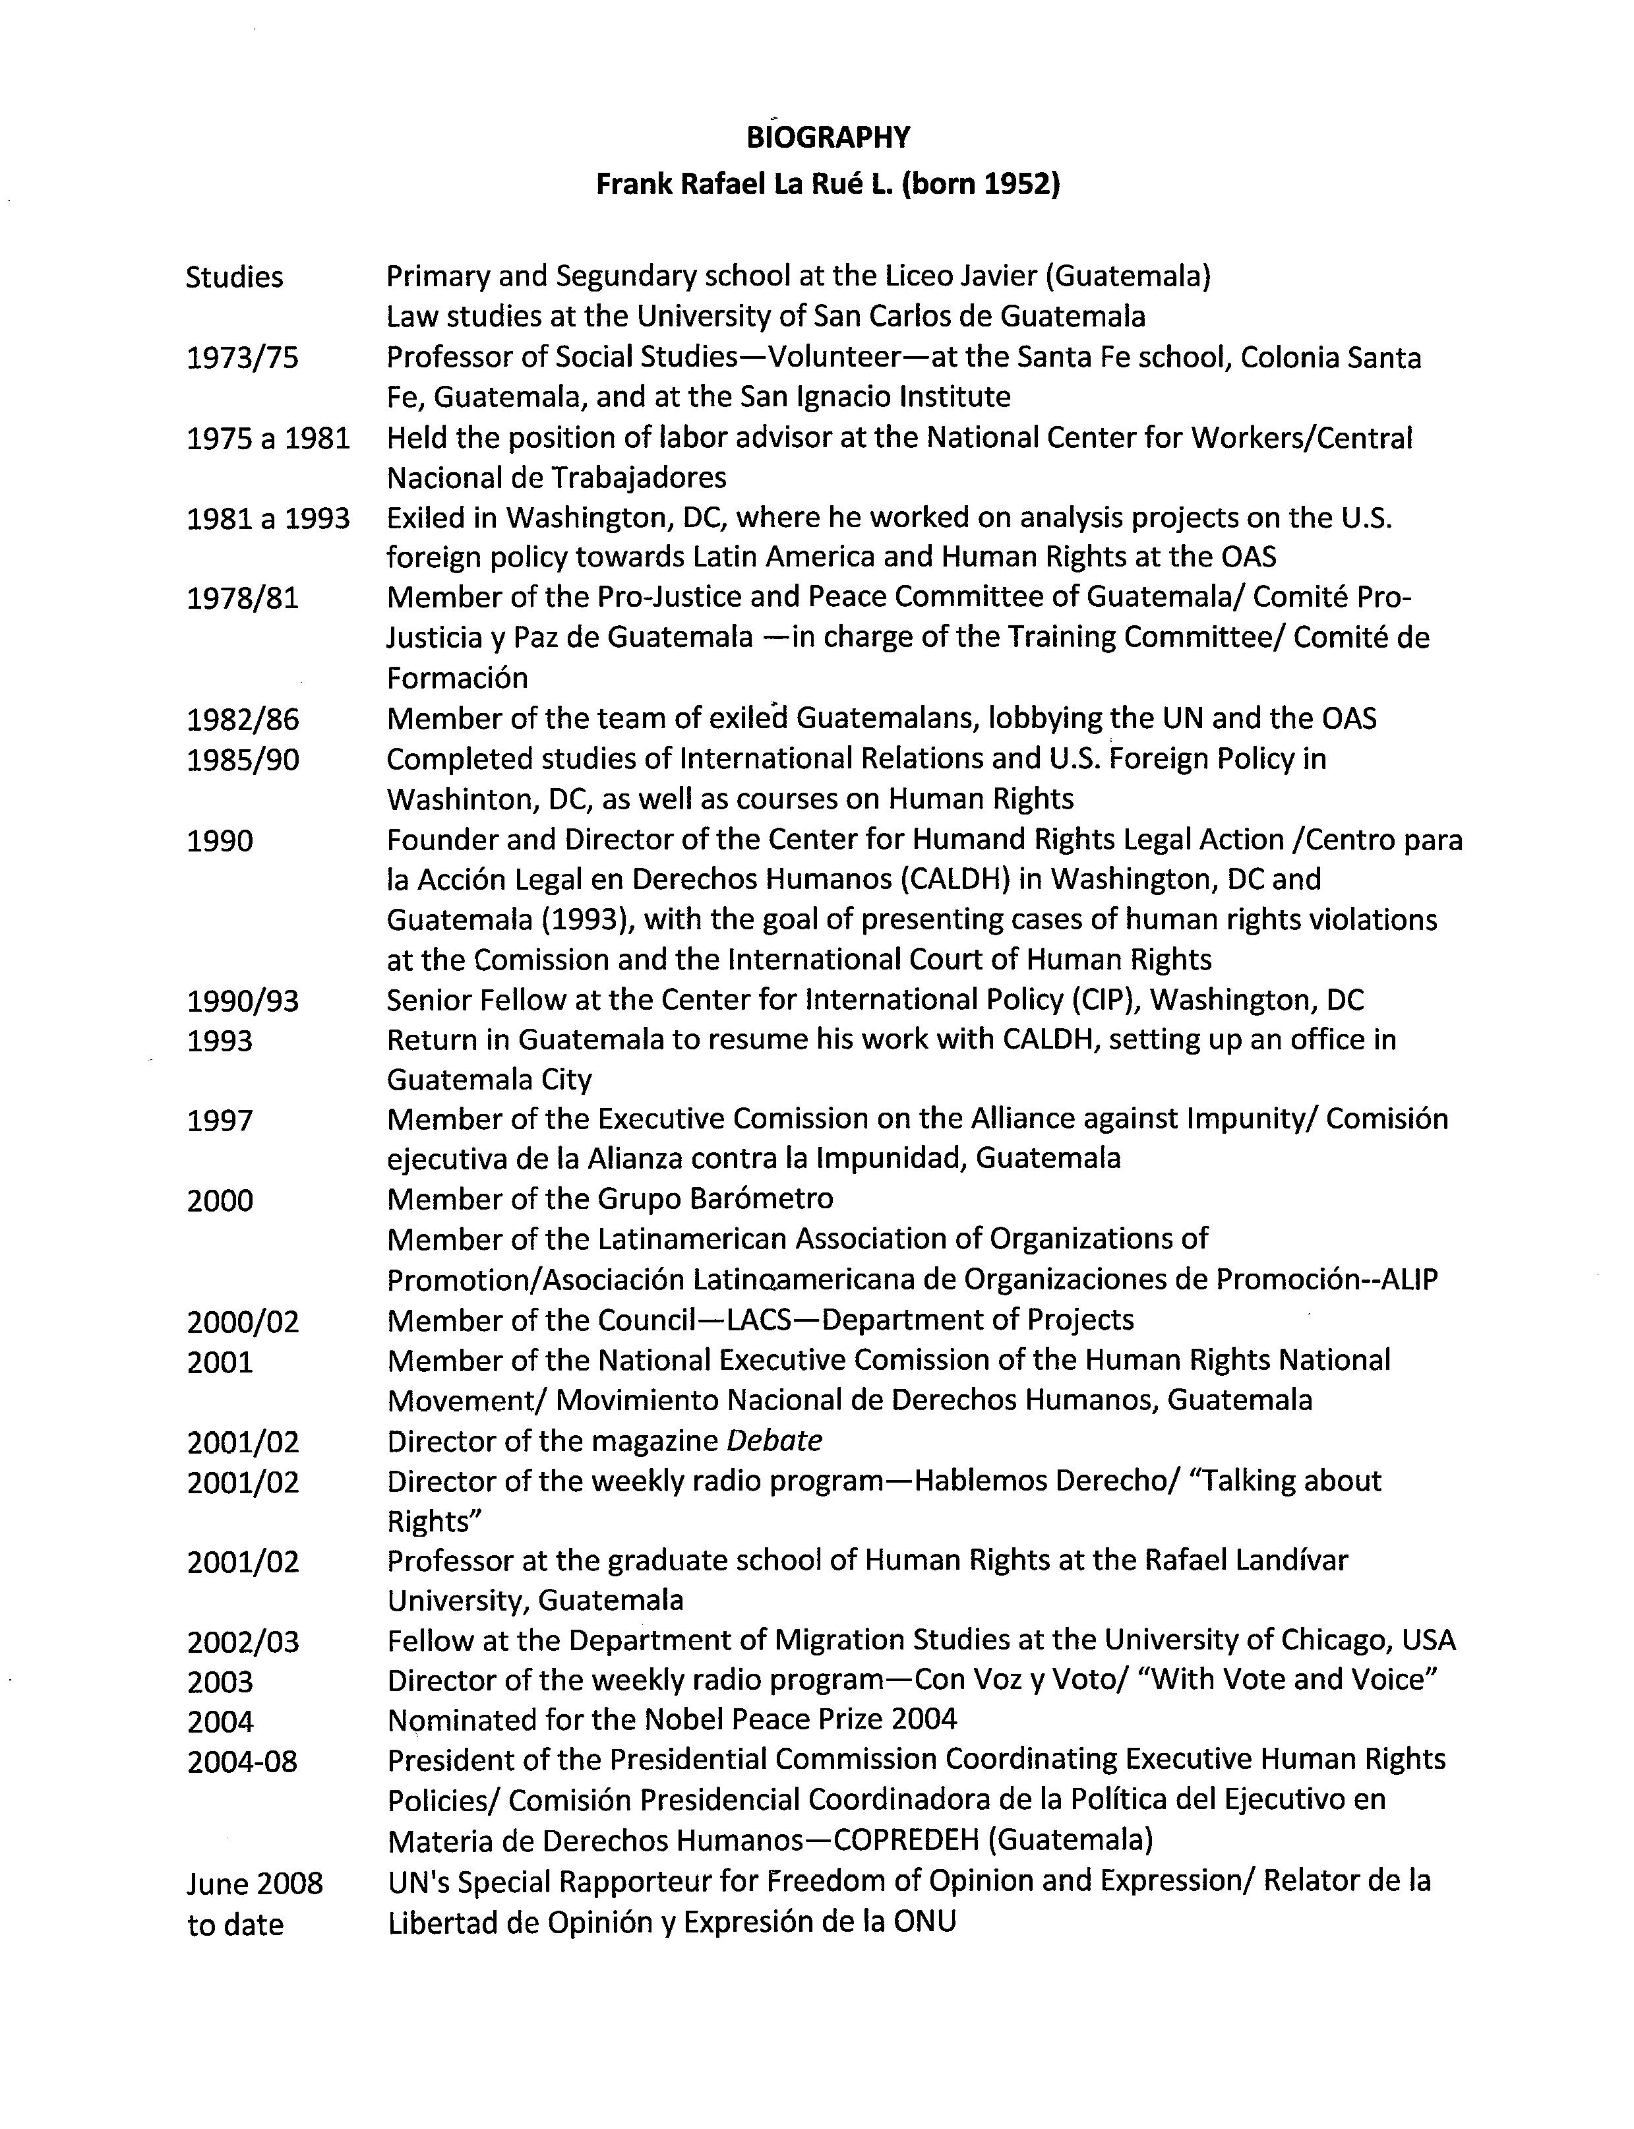
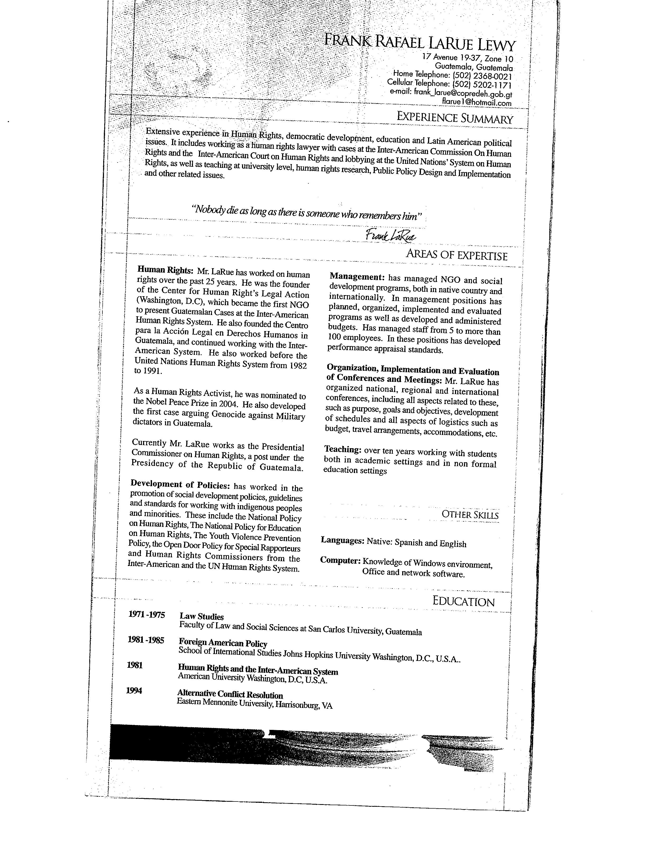
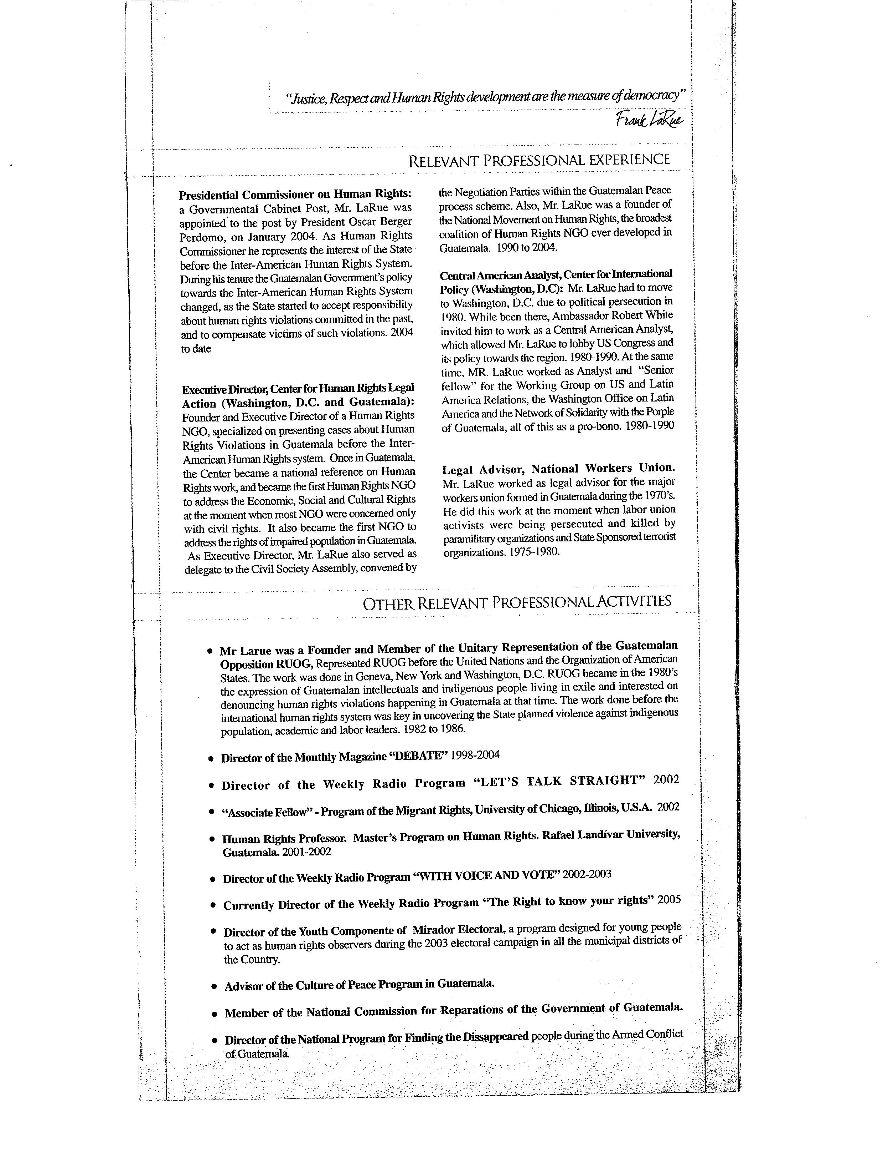
input.doc

. Note from the Secretary General advising of the vacancy on the Inter-American Commission on Human Rights, resulting from the resignation of a Commission member, CP/INF.5922/09

