OEA/Ser.G
CP/INF.5947/09
11 December 2009
Original: English

NOTE FROM THE PERMANENT MISSION OF THE UNITED STATES OF AMERICA
REQUESTING THE INCLUSION OF THE TOPIC
“COMMEMORATION OF INTERNATIONAL HUMAN RIGHTS DAY”
ON THE ORDER OF BUSINESS OF THE NEXT REGULAR SESSION
OF THE PERMANENT COUNCIL

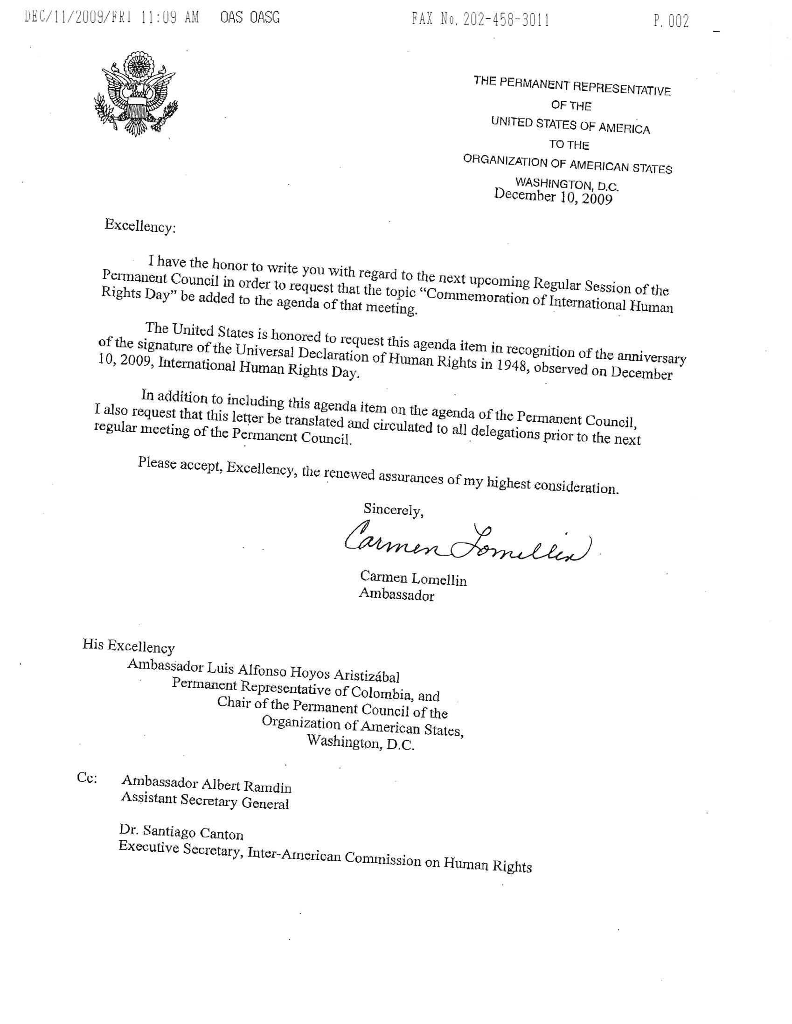
input.doc

