OEA/Ser.G
CP/INF. 5969/10
26 January 2010
Original: English

A ROAD MAP FOR RECOVERY, STABILIZATION AND DEVELOPMENT OF THE REPUBLIC OF HAITI AND REFERENCE DOCUMENTS FOR THE MINISTERIAL MEETING HELD IN MONTREAL, CANADA ON JANUARY 25, 2010

THIS VOLUME CONTAINS THE FOLLOWING:

- OAS - A ROAD MAP FOR RECOVERY, STABILIZATION AND DEVELOPMENT OF THE REPUBLIC OF HAITI ……………………………...1

- PADF –HAITI EARTHQUAKE RELIEF AND RECOVERY
STRATEGY JANUARY2010……………………………………………………..7

- PAHO – RESPONSE TO THE EARTHQUAKE IN HAITI …………….............11

- IICA – REFERENCE DOCUMENT FOR MONTREAL MEETING ON HAITI INTER-AMERICAN INSTITUTE FOR COOPERATION ON AGRICULTURE…………………………………………………………………..14

- IDB - RESPONSE TO EARTHQUAKE IN HAITI………………………………16

- IADB - CONTRIBUTION OF THE INTER-AMERICAN DEFENSE BOARD TO THE ORGANIZATION OF AMERICAN STATES HAITI RELIEF EFFORTS…………………………………………………………………………19

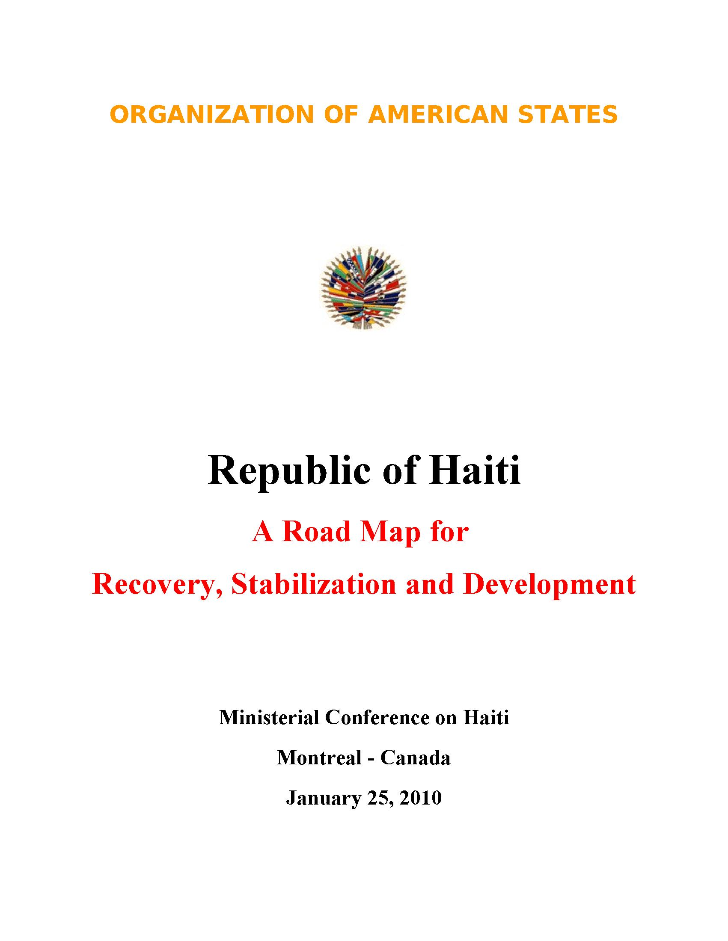

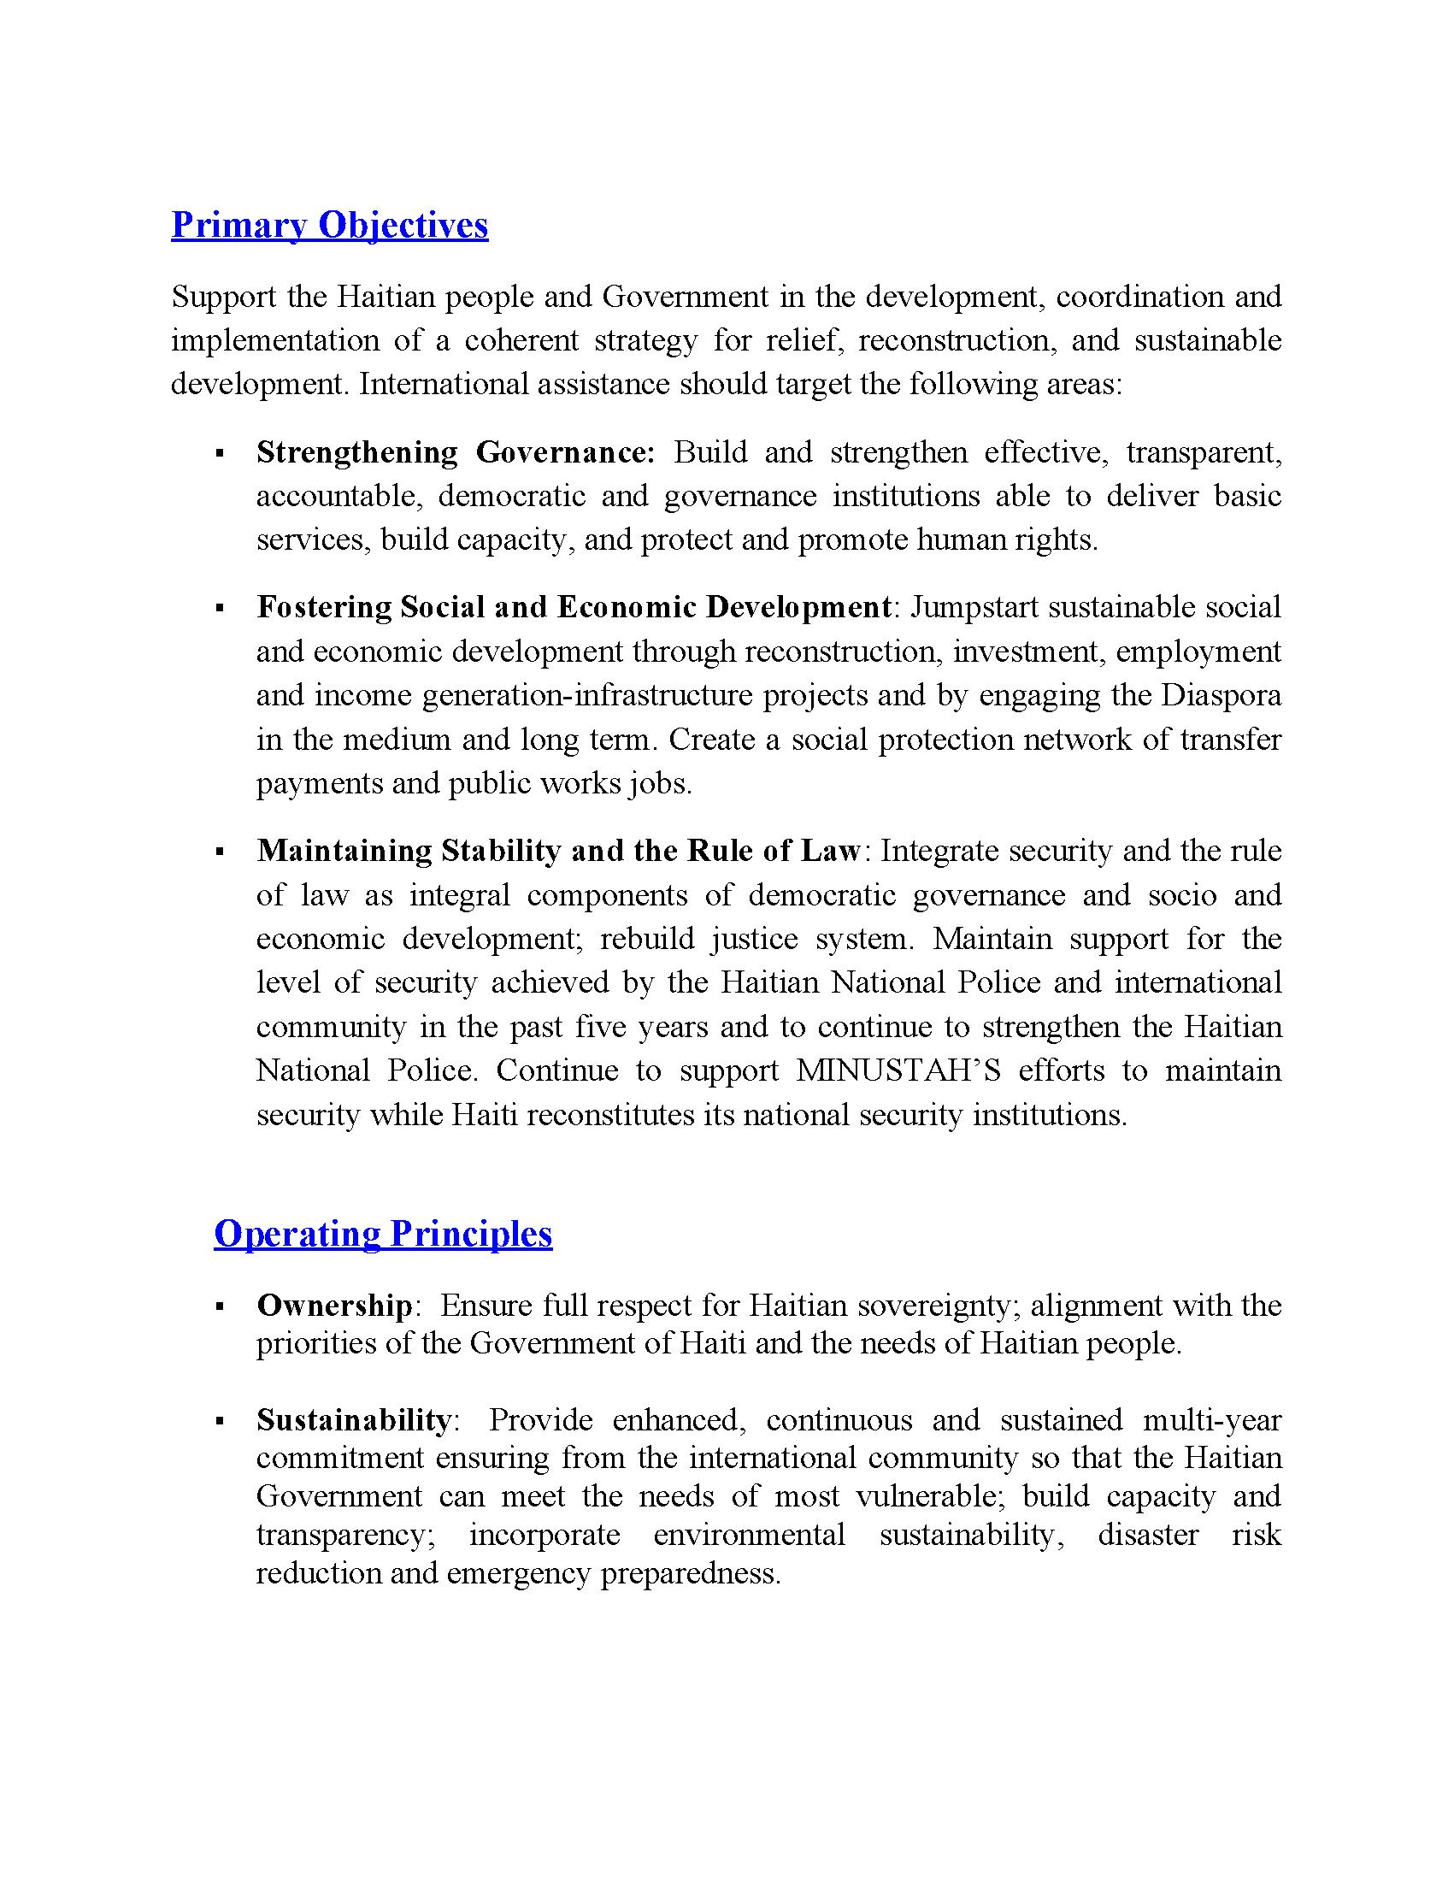

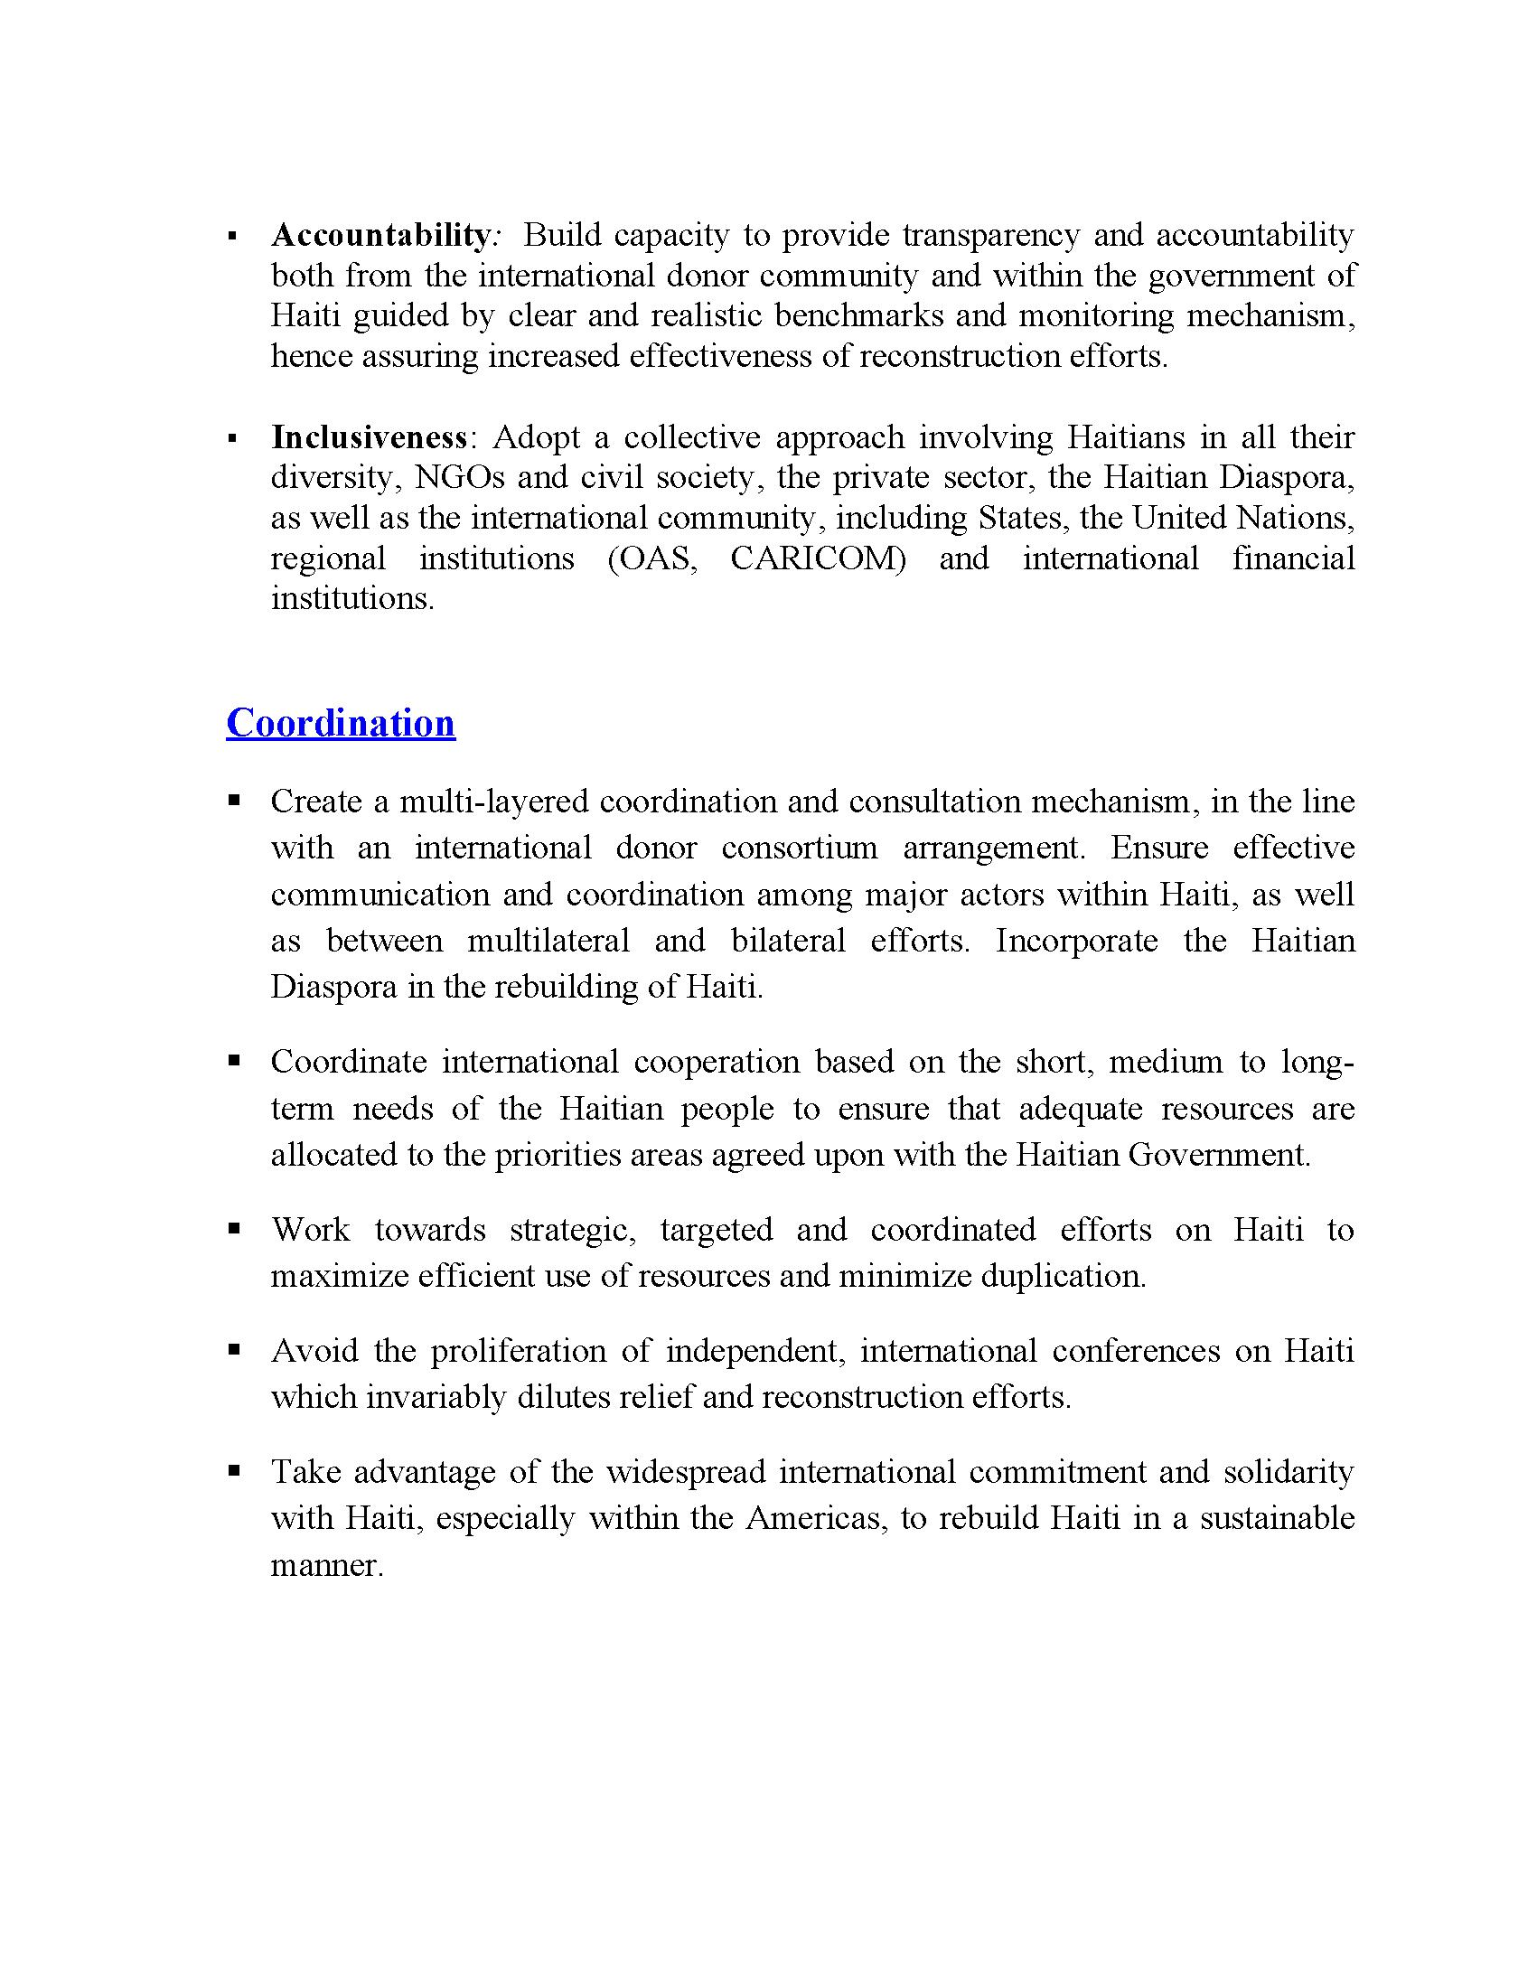

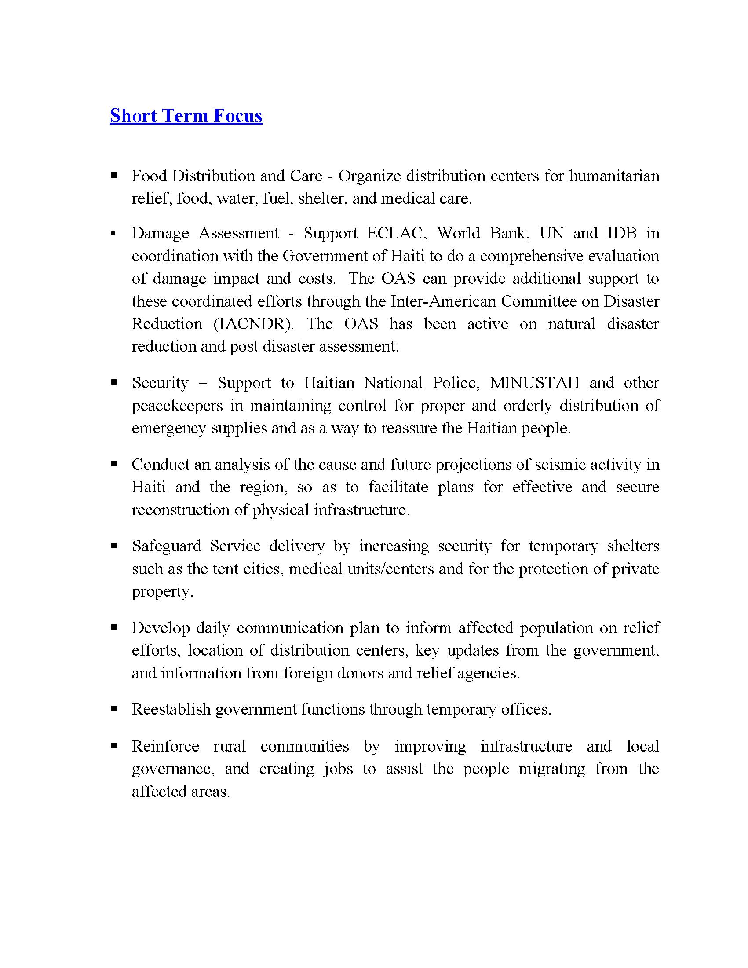

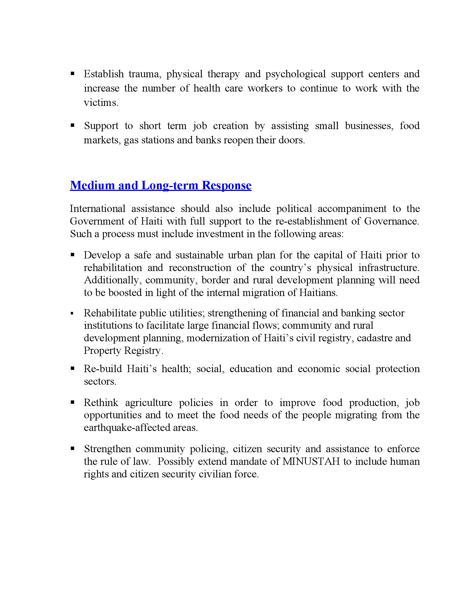

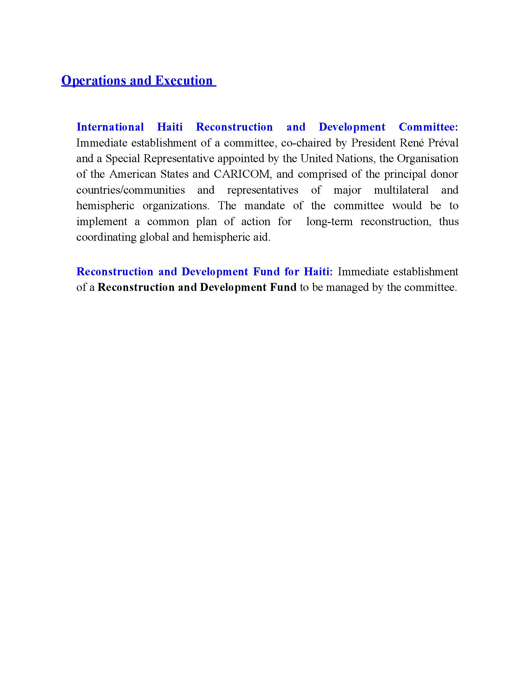

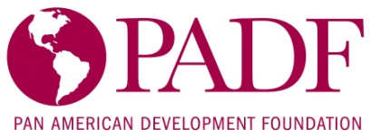
Haiti Earthquake Relief and Recovery Strategy
January 2010

Immediately after the January 12 earthquake that devastated parts of Haiti, PADF was providing on-the-ground assessments that were vital to establishing an emergency relief effort. In addition to its personnel in Haiti, PADF immediately dispatched two PADF disaster experts from the Dominican Republic to Port-au-Prince to coordinate all relief activities.

Assistance: To date, PADF has mobilized more than 50 tons of relief supplies for Haiti.
It has moved truckloads of supplies via the border into the country, received air cargo through the Port-au-Prince airport and serviced Jacmel by sea. Among the long list of supplies it has sent in: food, tents, tarps, water purification tablets, bottled water, medicine and more.
More aid is on the way to Haiti, including two shipping containers with 97,000 pounds of corn, a 20-foot container of medical supplies, blankets, sleeping bags, tents, and six containers of food and medical supplies. From Puerto Rico, for example, it is sending a barge with 100 pallets of bottled water.

International Experts: PADF has identified and engaged experts to assist in both relief and the important issue of recovery.
Kit Miyamoto, an earthquake structural engineer, is inspecting about 10 buildings a day, including those of key Government Ministries and other international donor groups, to ensure their safety and to provide suggested guidelines for rebuilding. The Foundation flew in a team of seven combat medics to assist in heavily affected areas. Other disaster professionals are en route to the scene.

Fundraising: PADF has reached out to individuals, corporations, governments and international agencies for assistance in the relief effort. The OAS was the first to respond that has provided the basis for additional donations.
To date, PADF has generated more than $2 million in cash and in-kind contributions of total needs of $10 million. This effort was facilitated by a $100,000 contribution from the OAS Disaster Assistance Fund (FONDEM) and individual contributions from employees of the OAS and other Inter-American agencies. Chevron, Bacardi, United Way Miami, Fed Ex, Ameriject, Aeropost, Argos, IMCA and the American Association of Latin American Chambers of Commerce, among others, have contributed with cash and services.
More than 1,000 individuals have donated cash to the relief effort through PanAmericanRelief.org. The Private Sector Forum launched a campaign in airports to collect cash donations; it is operational in Argentina, Ecuador, Uruguay and Peru. More countries will participate in the Private Sector Forum’s campaign.

Outreach: Within minutes of the earthquake, PADF was working with the media to provide information and analysis.

- It has produced 10 press releases, appeared on local, national and international broadcasts and become one of the leading sources for the media.

- PADF has partnered with the actor Jimmy Jean-Louis, a Haitian who is well-known in the United States, to be its goodwill spokesperson. Jimmy spent six days in Haiti providing interviews to journalists.

- A public awareness campaign that includes a 30-second television spot in English, two 60-second radio spots (English and Spanish), online banner ads and print advertisements have been produced and distributed. The media is running them at no cost to PADF.

- PADF’s PanAmericanRelief.org has received more than 20,000 visitors in nine days. The site is also in Spanish and Portuguese (www.AyudaPanamericana.org and www.AyjudaPanamericana.org).
Designated Areas of Work

PADF has a close working relationship with Haiti’s Office of Civil Protection (DPC), which has assigned to relief groups specific areas of responsibility to ensure that assistance is coordinated and distributed based on priorities.

- PADF is on the ground, distributing supplies to the following zones:
  - Downtown Port-au-Prince in the poor neighborhoods of Bel-Air – Delmas 32 – Cité Soleil – Carrefour Feuilles – Martissant and Simmonds-Pelé
  - Southeast province (emphasis on Jacmel, Leogane, Cayes- Jacmel and Marigot), which was hit hard by the earthquake and has limited access by road

- PADF has been in Haiti for nearly 30 years and is using its professional staff and community-based contacts to deliver supplies in an organized and efficient manner.

Distribution Strategy

PADF was one of the first NGOs to create its distribution based of operations in Santo Domingo, which can be easily serviced by the international airport and the cargo facilities. Using its Country Office and staff in Santo Domingo, PADF easily made the transition to earthquake response.

Dominican Republic

PADF has a warehouse in Santo Domingo, which is receiving relief supplies that arrive into the Dominican Republic. PADF has access to 10 donated trucks a day to transport relief supplies to one of two border locations.

- Jimani: This services Port-au-Prince’s relief operations.
- Pedernales: This city services the Southeast province, particularly Jacmel.

PADF’s economic and civil society work along the Haiti-DR border allowed it to leverage contacts, resources and goodwill among residents, businesses and government authorities. Because of this, PADF was able to quickly integrate its border operations into the relief process.

Haiti

PADF’s office in Port-au-Prince is largely undamaged (only 20 percent requires repairs) and is the center of its Haiti relief efforts. It has access to trucks, fuel, a warehouse and distribution personnel. It has 150 staff who were working in various PADF program and are available to support earthquake relief, recovery and reconstruction.
Partners

United States

- Organization of American States
- Other Inter-American Agencies such as PAHO, IICA, IADB
- U.S. Agency for International Development, the World Bank, IDB Multilateral Investment Fund (Border Program)
- Hollywood Unites for Haiti, a Los Angeles-based nonprofit
- Corporate and Private Donors such as Chevron, Bacardi, MoneyGram, MTV, FedEx, United Way Miami, Viacom, Royal Caribbean, Citi, and others.
- International NGOs, such as Feed the Children, Friends of the Orphans, and others.

Haiti

- Government: of Haiti’s Department of Civil Protection (DCP) and the Bureau of Monetization (GOH World Bank executing office).

- CBOs: Community Development Committees and local CBOs within target communes (PADF has more than 30 community-based organizations collaborating with it). It also works with community clinics, children’s shelters and other local organizations.

- Private Sector (in-kind support): AGERCA (private-sector disaster response and risk reduction group); American Chamber of Commerce in Haiti; Citi; Villa Creole; Boulos Group; Groupe Dynamic; and Haytian Tractor.

- Inter-American: The GOH Emergency Operations Center, PAHO, OAS, Dominican Government (border agency) and others.

PADF Proposals for Relief & Initial Recovery (for presentation at
the Montreal Conference)

Emergency Relief Supplies & Logistical Support ($10 million)

The Haiti earthquake has produced an unprecedented humanitarian crisis and large displacement of Haitians from Port-au-Prince and surrounding cities to smaller towns and rural areas of Haiti.
The unfolding crisis will continue throughout 2010 and require continuous provision of emergency relief supplies (e.g. bottle water, food, tents, blankets, plastic sheeting, tarps, water purification supplies, water containers, personal hygiene kits, medical kits and medicines, hand/work tools, etc.).
The airport and port at Port-au-Prince will have limited capacity to receive, off-load and distribute these commodities. Many will have to continue to be flown in to Santo Domingo in the Dominican Republic and supplied to Haitian victims and displaced in critical need.
PADF has established a logistical, supply, transport and distribution network for humanitarian aid centered at donated facilities in Santo Domingo with trucks sent regularly through Jimani on the border into Port-au-Prince. Other Inter-American agencies like PAHO and other NGOs are using these same facilities.
Most commodities are donated, but PADF requires funding for disaster personnel, supplies unavailable through donations, fuel, some transportation expenses, security, logistical and distribution costs, communications equipment, administration and management expense.
PADF expects to reach more than 400,000 earthquake victims and displaced Haitians during 2010.
Of the $10 million, PADF would use $5 million for disbursement in 2010 to support and expand this system that will leverage an equal amount of donated commodities.
In same context, with Haitian government approval, PADF proposes to convert the recently completed Belladere Border Center (financed by Canada’s Start program) into another logistical, supply and service center for the central area of Haiti to deal with displacement and other issues related to the earthquake. Jimani, DR, is quickly becoming overloaded with supplies and an alternative base on the Haiti side of the border is required.
Funding is required to complete the portions of the Center under the Haitian government’s purview (e.g. electric power generator, additional water supplies) and to use it as a relief service center.
This program would attempt to mitigate displacement into the DR, thereby reducing tensions in this conflictive border region.

Rapid Employment Generation “Cash for Work” in 2010-2011 ($30 million)

The governmental and productive infrastructure of Port-au-Prince has either been destroyed or badly disrupted by the earthquake. It will take many years to rebuild to higher standards with improved building codes. Extensive planning is required. In the mean time, Haitians must be employed, especially young Haitians or violence or attempted migration may occur.
It is of highest priority that an emergency jobs program (“cash for work””) be developed immediately, similar to those developed and implemented by PADF in the last decade and the 1990s. This would organize and employ large numbers of Haitian men, women, and youth (estimated at more than 100,000 during 2010-2011) to begin clearing rubble, cleaning streets, ditches, neighborhoods, and drainage canals; removing garbage; and rehabilitating urban infrastructure and possibly housing through provision of hand tools and basic training.
PADF has extensive experience in implementing a “Clean Streets” program in the 2000s funded by USAID and the IADB and a major Jobs program in the 1990s to provide massive, high-impact employment to mitigate out migration. PADF has similar ongoing activities through its Community-Driven Development program, and will build upon and expand these programs.
The proposed $30 million will be for fast disbursing cash payments to Haitian workers and implementation costs that will provide the program and management structure to facilitate donations of up to $150 million in additional contributions from international agencies and other sources.

Child Protection and Anti-trafficking ($5 million)

Based on a groundbreaking recent PADF study, more than 250,000 “restaveks,” which are unpaid child domestic servants in Haiti, live in the five major cities. In the aftermath of this crisis, tens of thousands of children who have lost or have been separated from their parents are now at increased risk of exploitation, abuse, abandonment, displacement, and trafficking. PADF leads the largest human rights project in the country, and will address the particular and growing needs of children and women resulting from the latest crisis, including trauma and psychosocial treatment, strengthening local institutions to recognize and combat abuse, and linkages with international groups and donors to undertake collective action in protecting women and children. It is currently providing psycho-social counseling, and it is preparing a program to assist the victims of sexual violence that international reports indicate has increased after the earthquake.

Internally Displaced Persons ($20 million)

An alarming trend is already occurring in Haiti, which is the unprecedented displacement of Haitians from affected areas into outlying towns and rural areas of Haiti. These areas are ill-equipped to handle the demands of shelter, food, jobs, and medical attention. Haitians are also crossing the border into the Dominican Republic, and soon will seek refuge in other countries in the Caribbean and the United States. An urgently needed IDP program will be carried out by PADF and other partners that provides an integrated approach to addressing the basic needs and livelihoods of priority IDP receiving areas. Based on its highly successful work with IDPs in Colombia totally $150 million, PADF will focus on income generation and linkages with international agencies and NGOs to provide shelter, food, education, and other services.

John Sanbrailo
Executive Director
Pan American Development Foundation
1889 F Street, NW
Washington, D.C. 20006
Tel. (202) 458-3969

PAN AMERICAN HEALTH ORGANIZATION
RESPONSE TO THE EARTHQUAKE IN HAITI
Submitted to the Organization of American States
21 January 2010

PAHO/WHO RESPONSE

The Pan American Health Organization (PAHO) is the regional office for the Americas of the World Health Organization (WHO), the United Nations’ specialized agency for health. PAHO is also the specialized organization for health of the Inter-American System. Prior to the 12 January 2010 earthquake, PAHO had 52 staff in-country to support Haiti’s Ministry of Public Health with advice and state-of-the-art expertise on a wide range of public health issues, including the health aspects of disasters and humanitarian relief. Staff suffered greatly from the loss of life, homes, and possessions. However, they have rebounded and are working hard on the response efforts. In the immediate aftermath of the earthquake, PAHO/WHO strengthened its operational capacity by 33% on the ground; in the coming days, the number of PAHO/WHO international staff working in Haiti will be three times the pre-earthquake number. The PAHO/WHO Country Office in the Dominican Republic is also providing full support to the relief efforts.

Haiti is the western hemisphere’s poorest country and core health indicators are alarming, with a crude mortality rate of 12 deaths per 1,000 population; an infant mortality rate of 57 per 1,000 live births and maternal mortality of 630 deaths per 100,000 live births—by far the highest in the Region of the Americas. Life expectancy at birth averages (men and women) 61.5 years . Despite these indicators, the country has remained free of cholera and polio.

- PAHO/WHO leads the U.N. Health Cluster. The cluster mechanism ensures coordinated assessments, joint analyses, and agreed-upon priorities and objectives. PAHO/ chairs daily Health Cluster meetings in which more than 55 agencies and over 75 individuals are participating. To improve coordination, three working subgroups on hospitals, public health assessments and drugs and medical supplies have been created. PAHO/WHO is responsible for issuing the daily Health Cluster Bulletin.

- PAHO/WHO is supporting the Ministry of Health to reestablish its stewardship and to restore the health services network. PAHO/WHO is working with the new National Crisis Management Commission to reestablish community-based health services using mobile teams or brigades for immediate treatment and triage of injuries; to establish fixed health posts in areas where people are congregating in open areas; and to support already existing facilities and new field hospitals with surgical capability. Government engagement is seen as a top priority. This will be critically important for the reconstruction period and long-term plans. The government in a number of venues has acknowledged PAHO’s support.

- PAHO/WHO participated in seven rapid hospital assessments with UNFPA and UNEP. The hospitals assessed are: Isai Jeanty, Choscal, Diquini, Hôpital de la Paix, the Haiti University Hospital (HUEH), Canapé Vert, and Saint François de Salles. According to assessments from 20 January, at least nine field hospitals from various countries and organizations are functioning and providing urgent surgical care. Specifically, the French field hospital is delivering obstetric surgical care, that of Brazil is providing neuro-surgery and maxillofacial surgery and the Russian field hospital is providing orthopedic surgeries.

- PROMESS is the PAHO-managed central pharmaceutical warehouse for Haiti’s Ministry of Health. It functioned as Haiti’s main medical storage and distribution hub even before the earthquake, and now plays a critical role in purchasing, and/or managing donations of medicines, blood and supplies and distributing them to health facilities and agencies providing health services. PROMESS is coordinating the distribution of a major donation of pharmaceuticals from the Reina Sofia Foundation. Since 13 January, PROMESS has distributed free medicines and medical supplies to 50 organizations and NGOs. Each day the number of requests increases.

- PAHO/WHO has established a field office in Jimaní (Dominican Republic) to serve as a permanent bridge and staging station between this border city and Port-au-Prince. The office is a staging/transfer point for emergency humanitarian supplies and personnel needed in the Haiti response operations. The same office will also be used to assist with the transport needs of injured, deal with the increased influx of trauma patients, coordinate fuel for hospitals, procure equipment, etc. LSS/SUMA, the humanitarian supply management system, has been set up in Jimini to capture information on the arrival of incoming humanitarian relief supplies. A satellite hub has been established at the airport in Port-au-Prince and management reports have been prepared for Civil Defense. The information registered by LSS/SUMA is expected to increase significantly in coming days. LSS/SUMA will also begin capturing information and registering supplies from WFP.

- PAHO/WHO is also providing full support to the Ministry of Health in the Dominican Republic to strengthen its health services in the border region and referral capacity for specialized care.

- In its Washington DC office, The Pan American Health Organization's Emergency Operations Center (EOC) functions as a centralized location for coordination and control of health-related emergency response activities. In major emergencies such as the earthquake in Haiti, it is operational round-the-clock and carries out a number of important functions: organization of daily Disaster Task Force meetings, in which public health experts throughout the Organization participate; coordination of the deployment of the Regional Health Emergency Response Team; the mobilization of equipment and supplies to the affected area; and the dissemination of daily situation reports and Health Cluster Bulletins to the international community. PAHO is actively engaging government responses of Canada, US, and other countries of Latin America and the Caribbean.

Proposals for Restoring Basic Health Services

On 15 January, the United Nations launched a Flash Appeal, which requested US$34.3 million to address health sector needs of all partners. Of this amount, WHO/PAHO requested US$10million in the following broad categories:

- Coordination of the health sector response and needs assessment, monitoring & evaluation, including coordination of international drug donations and reactivation of Haiti's central procurement agency for drugs and medical supplies (PROMESS); carrying out rapid health assessments.
- Outbreak control and environmental health, including re-establishing the capacity of prevention and control of communicable diseases, an early warning alert and response network, the routine disease reporting system, ensuring immunization including mass vaccination campaign against measles and prepare response to outbreaks.
- Safe water for health facilities and water quality control in health facilities, including sanitation, food safety and health care waste management.
- Restoration of basics health care services, including continuity of primary health care services, health care information systems, emergency basic repairs to health facilities/temporary health facilities and support of the management of chronic diseases.
- Availability of essential drugs and medical supplies, including ensuring the proper functioning of the PAHO-managed Haiti central procurement agency for drugs and pharmaceutical supplies (PROMESS), the availability of surgical and trauma kits, essential medicines and health supplies.

To date, PAHO and WHO have received confirmed contributions of more than US$12 million and there is agreement among the international community that there will be a revised Flash Appeal issued soon.

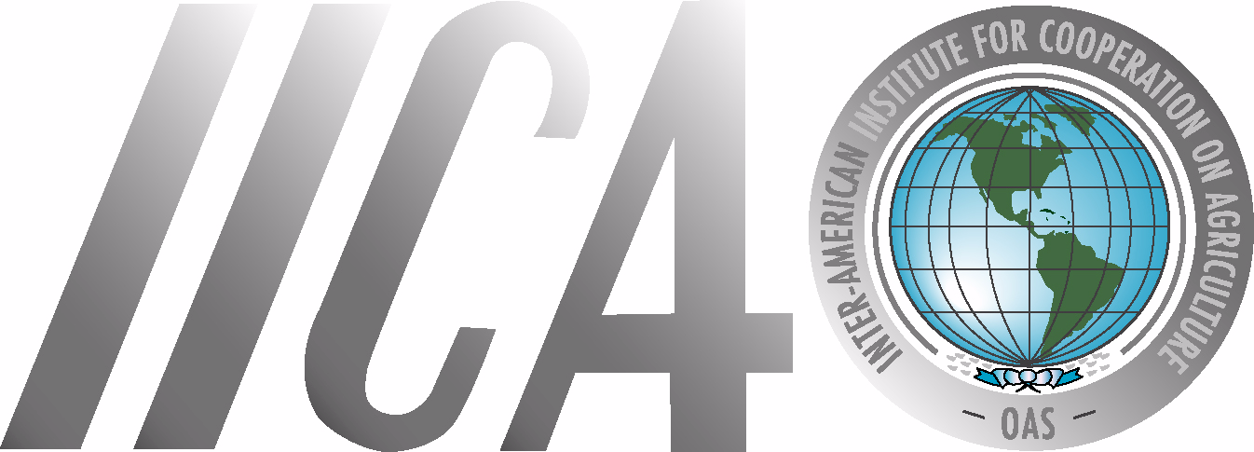

Reference Document for Montreal Meeting on Haiti
Inter-American Institute for Cooperation on Agriculture
(IICA)

IICA has worked closely with the Minister of Agriculture of Haiti to prioritize actions. We are pleased to report on the following concrete results and plans based upon frequent discussions with the Minister.

Actions Completed to Date:

- A rapid assessment of the damages to the rural and agricultural sectors under the coordination of the Ministry of Agriculture and with other partners.
- Identified the following crops to plant in March of this year: corn, beans rice, sorghum, yams and sweet potatoes. This growing season is critical because it accounts for 60% of the annual agricultural production in the country. To support this critical growing season the country requires seeds, fertilizers, small equipment and tractors.
- Held discussions with the Ministry and FAO to share information resulting from their initial assessments and create a work plan to collaborate closely.
- Noted the increasing migration from the urban to rural sectors which will require actions to employ and support the increased population through agriculture. Current estimates are that 1.5 million people have left the cities for the rural areas.
- Provided food and other goods to IICA employees and employees of the Ministry of Agriculture.
- Met with the World Bank to and agreed to: 1) share the results of the assessment just completed, 2) accelerate the funding of the existing Avian Influenza project (approximately $1million), 3) accelerate the existing project to strengthen the Ministry of Agriculture and, 4) apply a portion of the $100 million pledged by the World Bank to assist Haiti. This will include the estimation of land, labor and inputs required for the identified crops (seeds, fertilizers, small equipment, etc).
- Confirmed that the Haiti Minister of Agriculture will join IICA in meetings in Washington, DC and Ottawa, Canada the week of February 1 to secure project funding. Examples are the World Bank, Inter-American Development Bank, United States Department of Agriculture, United States Agency for International Development (USAID), International Finance Corporations, the Canadian International Development Agency (CIDA) and Oxfam-Quebec.
- Identified a large warehouse managed by the PADF in Dominican Republic that can serve as storage and staging location for supplies.
- Preparation of the needed projects to address short term needs while developing medium and long-term projects approved by the Ministry of Agriculture.
- Confirmed that IICA offices are operational and prepared to support ongoing efforts. Our network of agronomists and other experts are already working closely with the Ministry of Agriculture.
- Secured the full support of the IICA Office in the Dominican Republic which is working closely with its Ministry of Agriculture in coordination with IICA’s Director General and Headquarters staff.
- Met with CIDA to mobilize resources for the agricultural aspects of the reconstruction of Haiti.

Future Actions:

- Prepare a report on the initial assessment of damages to the rural and agricultural sector by the 28th of January.
- Develop immediate as well as medium and long-term projects based upon the assessment.
- Share the assessment report and project profiles with organizations interested in rebuilding the rural sector and agriculture of Haiti.
- Complete the meetings in Washington, DC and Ottawa, Canada with the Haiti Minister of Agriculture.
- Analyze further the implications of the significant urban to rural migration and determine steps to address rural development imperatives through specific projects (e.g. creating employment opportunities through agriculture).
- Evaluate projects associated with animals, vaccines, etc. in addition to plant crops.
- Continue the development of existing projects such as the Pro-Huerta project and the credit and insurance project involving mangoes and bananas.
- IICA will meet with donors to request an acceleration of approval procedures given the urgency.

INTER-AMERICAN DEVELOPMENT BANK RESPONSE TO EARTHQUAKE IN HAITI
Submitted to the Organization of American States

January 22, 2010

As Haiti’s largest multilateral donor, with an uninterrupted presence for 50 years, the IDB has a strong commitment with the Government of Haiti (GOH) and its people. In light of this, the IDB is mobilizing its financial and human resources to address Haiti’s multiple needs after the earthquake. The Bank intends to be an important contributor to the recovery and reconstruction efforts and will take action on the following initiatives:

Restoring Public Institutions and Resuming Disbursements: The Bank is working closely with the IMF and World Bank to address GOH capacity constraints through the provision of staff, consultants and financial resources. The IDB will also support re-establishment of the GOH economic team; restoration of the functionality of the payments system and related financial services; and a rapid assessment of business infrastructure/activity.

Post-Disaster Needs Assessment (PDNA): In partnership with the GOH, the Bank will contribute to a comprehensive Post-Disaster Needs Assessment along with the WB, UNDP, and the EU. The international partners are currently engaging the government to gain consensus on the timing of an initial planning mission and the mission’s draft terms of reference. This evaluation will be an important input for the Government of Haiti’s reconstruction plan.

Additional Financing for Relief, Recovery and Reconstruction: The Bank is actively mobilizing resources from its different financing windows to support Haiti’s post-disaster short term and long-term challenges. Besides from initial relief actions, based on initial estimates, total IDB financing for programming in Haiti in response to the earthquake equals roughly US$300 million, combining both new and existing funds. The IDB will approve up to $128 million in new grants for Haiti this year, potentially providing more resources for reconstruction. In addition, IDB’s Haiti portfolio currently holds some $330 million in undisbursed funds, of which about $50 million could be redirected to high-priority civil works and reconstruction projects New resources would equal approximately $150 million, including new Technical Cooperations as well as a proposed IDB matching grant designed to raise funds from public and private donors.

Priority Areas of Bank Engagement: The Bank is giving priority to analyzing how to secure maximum resources for basic infrastructure reconstruction and rehabilitation. The Bank has active investment projects in four key areas: a total of US$105 million or 15 percent of the active portfolio for state modernization, governance, and local development; US$302 million or 42 percent for infrastructure (energy and transport); and US$ 145 million or 19 percent for agriculture and the environment, and US$224 million or 29 per cent for access to basic services (including social infrastructure rehabilitation in the water and sanitation, and education sectors).
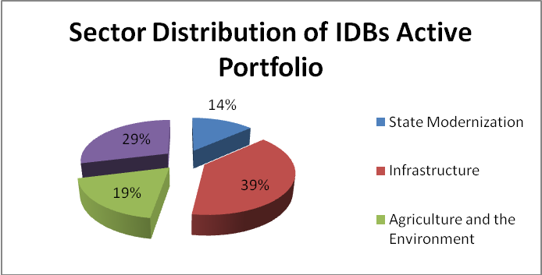
Given the Bank’s experience in infrastructure and extensive work in that sector in Haiti, it is prepared to play a key role in establishing a reconstruction fund to finance priority reconstruction works and channel resources from both private and public sources. This fund could become an integral part of a framework for long-term disaster risk management in Haiti. Undisbursed resources of existing commitments and additional funding will be redirected to urgent works, particularly in the areas of housing, water and sanitation, electricity, social infrastructure reconstruction, and transport.

Debt Relief: The Board of Governors could consider the possibility of providing further debt relief to Haiti, on top of the $511 million in debt cancellation announced last year. Currently, the pending debt stands at $441 million in USD and $6 million in local currency in loans that are financing investments in key sectors including roads, water and sanitation, electricity and agriculture.
Most of that debt consists of 40-year soft loans approved between 2004 and 2007, and therefore are still under a 10-year grace period on principal repayments. Interest payments are being covered with resources from a trust fund backed by donor countries. Since 2007 the IDB provides only grants to Haiti.

Guiding Principles

Importance of Government Ownership: The Bank acknowledges the importance of ownership of the reconstruction plan by the Haitian Government and ultimately the Haitian people. The GOH must be present in the design and execution of the reconstruction plan. The IDB, along with other major development partners will assist the GOH through different means to ensure that public institutions are capable of coordinating and executing all necessary activities in the process.

Maintain the focus on long-term development: As the reconstruction and economic recovery strategy is identified, there will be potential to create a basis for more sustainable and resilient institutions and services in Haiti going forward. A central element would be a new urban development model for Port-au-Prince and the promotion of more balanced development across urban centers as well as between urban and rural area.

The IDB is supporting national and international efforts to provide emergency and humanitarian assistance to the affected population in the Port-au-Prince Metropolitan area. Some of the items provided include food supplies, clothing, drinkable water, medicines, and materials for temporary shelter needs, among other relief items.

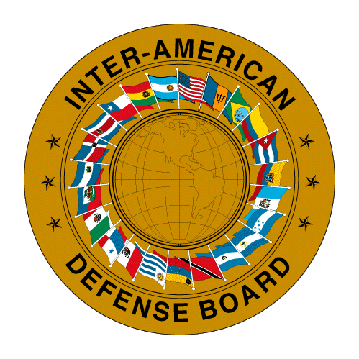

INTER-AMERICAN DEFENSE BOARD

2600 16TH Street, N.W.

Contribution of the Inter-American Defense Board to
Organisation of American States Haiti Relief Efforts

22nd January, 2010

Action by Inter-American Defense Board

Upon learning of the disaster unfolding in Haiti, the Inter-American Defense Board (IADB) immediately proceeded to mobilize its staff to begin the process of data collection from as many sources as possible. Open source information was available from major news channels and media houses, as well as from the internet. But the overall information flow was weak because virtually all the systems established to provide communication from within Haiti to the outside had collapsed. The United Nations mission, MINUSTAH proved to be an invaluable source of information despite sustaining significant losses itself.

As events unfolded, it became clear from the preliminary information that apart from heavy civilian casualties, the entire command and control structure in place in Haiti had suffered losses that severely impacted the ability of the political leadership to function. This situation extended even to MINUSTAH which suffered losses in the upper echelon of its own leadership, but which was able to quickly regroup because of the inherent redundancy built into its military structure.

Continued liaison with MINUSTAH, as well as collection and analysis of open source information, throughout the night of 12 January and into the morning of 13 January allowed the Board to prepare the first in a series of situation reports. This report was presented to the Board’s Council of Delegates which proceeded to alert the respective governments of its members to the magnitude of the catastrophe which had befallen Haiti.

Recognizing that no one country in the hemisphere could effectively deal with the situation in Haiti, and that the Inter-American System would necessarily have to become involved in coordinated relief efforts, the leadership of the Board resolved to assist the Organisation of American States (OAS) within the scope of its mandate as contained within its Statutes. As a result, the Board executed and/or continues to execute the following actions:

- Establishment and manning of a Situation Room in conjunction with OAS staff at San Martín Room at OAS Headquarters
- Preparation and dissemination of daily situation reports
- Preparation and updating of a matrix summarizing aid provided
- Liaison with MINUSTAH command
- Liaison with OAS leadership
- Liaison with PAHO Emergency Operations Centre (EOC)
- Liaison with defense authorities within member countries
- Liaison with agencies forming the Inter-American System e.g. PADF, IACNDR
- Coordination of a visit to Haiti by OAS representatives with support from the Armed Forces of the Dominican Republic and the MINUSTAH mission

Future Action by Inter-American Defense Board
input.doc

As relief efforts continue in Haiti and the mission inevitably changes to one of recovery, the Board recognizes the importance of assisting the OAS leadership in its efforts to make informed decisions. The Board will therefore continue to provide services within its mandate as follows:

- Manning of the Situation Room in conjunction with OAS staff as required
- Preparation and dissemination of situation reports
- Updating of aid matrix
- Liaison with MINUSTAH, OAS leadership, PAHO EOC, and agencies of the Inter-American System
- Liaison with defense authorities within member countries
- Preparation of an After Action Report on the establishment of the Situation Room and including an analysis of the actions taken by the OAS and Inter-American System as part of relief efforts
- Recommendations of standard operating procedures and guidelines for the setting up of future situation rooms

Health in the Americas, 2007.

