OEA/Ser.G
CP/INF. 5972/10
26 January 2010
Original: English/French

STATEMENT BY THE CHAIRMAN OF THE HAITI MINISTERIAL PREPARATORY CONFERENCE IN MONTREAL, JANUARY 25, 2010

(Presented by the Permanent Mission of Canada)

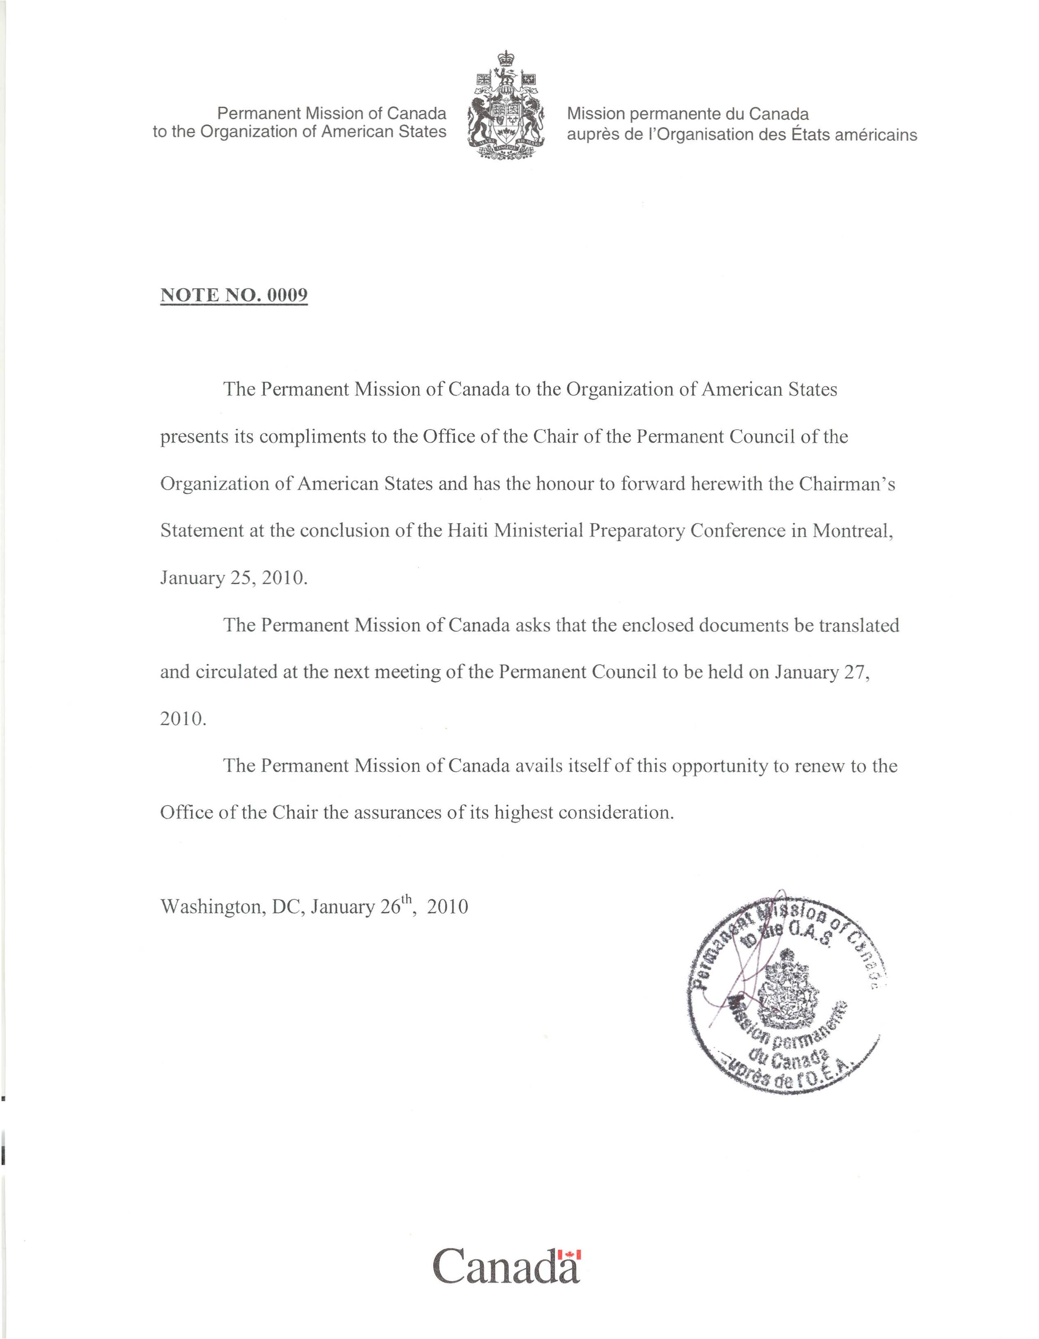

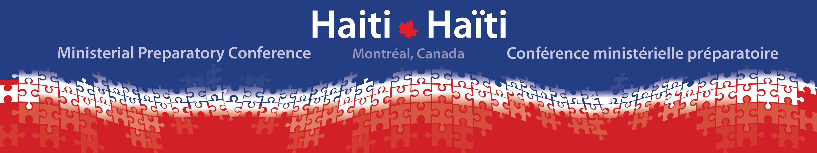
CHAIRMAN’S STATEMENT
25 January 2010

The Government of Haiti, alongside members of the international community with a deep and longstanding commitment to the people of Haiti, gathered in Montreal, Canada, on 25 January 2010. We solemnly expressed our profound sorrow for the devastating loss of life following the catastrophic earthquake that befell Haiti on 12 January 2010. As a group, we paid special tribute to the remarkable resilience, strength and courage of the Haitian people and reaffirmed our solidarity with Haiti throughout the relief, recovery and reconstruction process.

Participants stressed that the current situation remains dire, that the needs are immense and that the Haitian people continue to suffer. We resolved to remain swift and steadfast in our support. We will continue to urgently respond to pressing requirements in the most affected areas.

Participants recognized the continued leadership and sovereignty of the Government of Haiti. We reiterated our commitment to undertake a coordinated, coherent and comprehensive approach to meeting Haiti’s immediate and longer-term needs. Together, we are fully committed to building a new Haiti that meets the legitimate and long-held aspirations of the Haitian people for their country.

I. The following principles will guide our joint approach to Haiti’s reconstruction and development:

Ownership: Haitians own their future. We will respect Haitian sovereignty, will directly involve the Haitian people, and will be aligned with the priorities of the Government of Haiti.

Coordination: We will work together. Under the leadership of the Government of Haiti, and with a key coordination role by the United Nations, we will coordinate our efforts with national, international and regional organizations of the Americas, international financial institutions and a broad range of partners, to the benefit of the Haitian people. We will define priority sectors and responsibilities.

Sustainability: We will stand with Haiti for the long term. An initial 10-year commitment is essential, as is a concerted effort to build Haiti’s capacity. Sustainable development, including environmental sustainability, climate resilience, disaster risk reduction and emergency preparedness, will be a cornerstone of our joint approach.

Effectiveness: We will deliver. We will adhere to the principles of aid effectiveness and good humanitarian donorship, and will build on lessons learned.

Inclusiveness: We will reach out. We will encourage and facilitate the involvement of Haitians in their diversity, non-governmental organizations, local and international civil society, the Haitian Diaspora, and the private sector.

Accountability: We will be accountable. Mutual transparency and accountability on the part of the Government of Haiti and the international community, including in the allocation and management of resources, will form an integral component of our joint approach. We will establish robust tracking and evaluation systems to assess performance and measure results.

II. While continuing to deliver humanitarian assistance, participants highlighted the following longer-term strategic objectives:

Strengthened Democratic Governance
- To build effective, accountable and transparent democratic institutions able to deliver basic services and to protect and promote human rights.

Sustained Social and Economic Development
- To create the conditions for sustainable long-term development, economic growth and poverty reduction, drawing equally on both women and men, and meeting the needs of the most vulnerable.

Enduring Stability and Respect for the Rule of Law
- To continue to support the United Nations Stabilization Mission in Haiti’s (MINUSTAH) efforts to maintain security, especially through the contribution of police and military, while Haiti reconstitutes its national security institutions and rebuilds its justice system.
- To integrate security, justice and the rule of law as essential components of democratic governance and social and economic development.

These long-term strategic objectives build on the early progress in implementing Haiti’s National Growth and Poverty Reduction Strategy Paper and the Government of Haiti’s 2009 Report: A New Paradigm. They also provide a platform for regional efforts, particularly in concert with the Caribbean Community (CARICOM) and the Organization of American States (OAS).
input.doc

III. Participants agreed to maintain high-level international attention and focus on Haiti. We pledged to continue to provide support to meet basic needs, and reached a common understanding on a
road map towards Haiti’s reconstruction and development.

Assessment
- Restore the operational capacity of the Government of Haiti to ensure its ability to meet its governance responsibilities and engage with its people.
- Urgently conduct post-disaster and reconstruction-focussed needs assessments.

Coordination and Support
- Urgently convene an international conference to be held in March in the United States, steered by the Government of Haiti, and with the support of key donors and partners, including the United States, Canada, Brazil, the European Union and France.
- Agree on an effective coordination mechanism to ensure coherence of effort.

Action
- Convene technical meetings to create an action plan to guide reconstruction and development.
- Establish clear and realistic benchmarks and an ongoing tracking mechanism for implementation of the action plan.

Montreal, Canada, 25 January 2010

