OEA/Ser.G
CP/INF.5975/10
29 January 2010
Original: English

NOTE FROM THE PERMANENT MISSION OF CANADA REQUESTING THE INCLUSION OF THE TOPIC “RESPECT FOR FREEDOM OF EXPRESSION” ON THE ORDER OF BUSINESS OF THE REGULAR MEETING OF THE PERMANENT COUNCIL TO BE HELD ON FEBRUARY 3, 2010

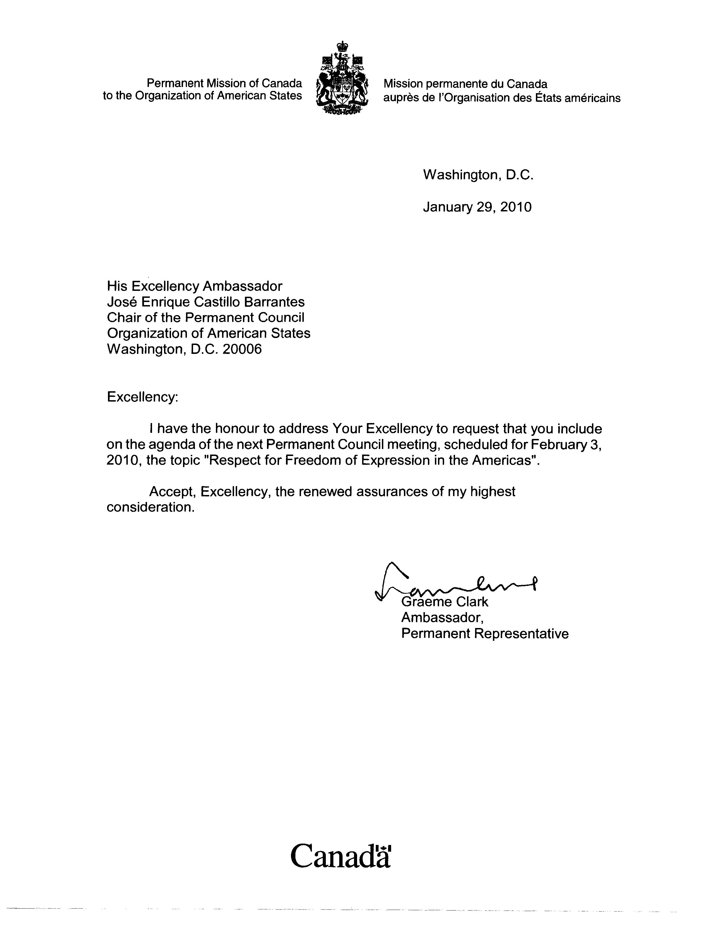
input.doc

