OEA/Ser.G
CP/INF.5995/10
3 March 2010
Original: Spanish

NOTE FROM THE INTER-AMERICAN COURT OF HUMAN RIGHTS FORWARDING THE “RULES FOR THE OPERATION OF THE VICTIMS' LEGAL ASSISTANCE FUND OF THE
INTER-AMERICAN COURT OF HUMAN RIGHTS”

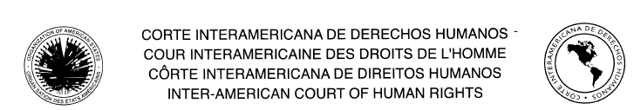
_________________________________________________________________________________
SECRETARIAT OF THE COURT

San José, February 23, 2010
REF.: CDH-S/367

Excellency:

I have the honor to address Your Excellency to forward, on instructions from the plenary session of the Inter-American Court of Human Rights, the attached Rules for the Operation of the “Victims’ Legal Assistance Fund of the Inter-American Court of Human Rights,” which the Court approved at its 86th Regular Session, held from January 25 to February 5, 2010.

These Rules, which take effect on June 1 this year, were issued pursuant to Organization of American States (OAS) General Assembly resolution AG/RES. 2426 (XXXVIII-O/08), of June 3, 2008, which provides for the “Establishment of the Legal Assistance Fund of the Inter-American Human Rights System,” and pursuant to Permanent Council resolution CP/RES. 963 of November 11, 2009, which adopted the “Rules of Procedure for the Operation of the Legal Assistance Fund of the Inter-American Human Rights System.”

Accept, Excellency, the renewed assurances of my highest consideration.

Pablo Saavedra Alessandri
Secretary

His Excellency
Ambassador José Enrique Castillo Barrantes
Chair of the Permanent Council
Organization of American States
501 Pennsylvania Ave., N.W.,
Washington, D.C. 20001
Fax (202) 682-7624
http://scm.oas.org/pdfs/2010/CP23821E.pdf

input.doc

