OEA/Ser.G
CP/INF.6011/10
8 March 2010
Original: Spanish

NOTE FROM THE OFFICE OF THE SECRETARY GENERAL FORWARDING
A NOTE FROM THE PERMANENT MISSION OF CHILE
REGARDING THE EARTHQUAKE IN CHILE
ON FEBRUARY 27, 2010
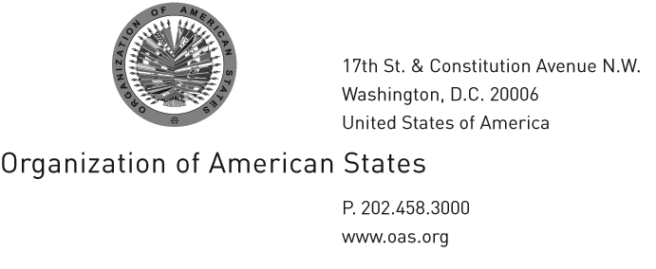

SG

The General Secretariat of the Organization of American States–Office of the Secretary General–presents its compliments to the Chair of the Permanent Council and has the honor to forward to it, for transmission to the member states, a note from the Permanent Mission of Chile regarding the earthquake in Chile on February 27, 2010.

The General Secretariat of the Organization of American States–Office of the Secretary General–avails itself of this opportunity to renew to the Chair of the Permanent Council the assurances of its highest consideration.

March 2, 2010

Permanent Mission of Chile
to the
Organization of American States

No. 045

The Permanent Mission of Chile to the Organization of American States presents its compliments to the Organization of American States (OAS)–General Secretariat–and, in connection with the earthquake in our country, has the honor to submit a list of the needs identified by Chile’s National Emergency Office (ONEMI). The intention is to make this information available to countries interested in knowing our aid requirements.

The specific needs identified are:
input.doc

- Mobile bridges
- Field hospitals with surgical facilities
- Satellite telephones and repeater stations
- Generators
- Structural damage assessment systems (for hospitals, schools, public buildings, etc.)
- Saltwater purification systems
- Field camps
- Autonomous dialysis centers
- Mobile dining facilities
- Rescue workers

Any technical questions concerning this assistance should be addressed to National Emergency Office staff member Mr. Pedro Salamanca, by e-mail at psalamanca@onemi.gov.cl or by telephone at his cell phone number 56 981297769.

The Permanent Mission of Chile appreciates the concern and solidarity expressed by the Organization of American States and avails itself of this opportunity to renew to the General Secretariat the assurances of its highest consideration.

Washington, D.C., March 1, 2010

