OEA/Ser.G
CP/INF.6016/10
12 March 2010
Original: English

NOTE FROM THE PERMANENT MISSION OF THE COMMONWEALTH OF DOMINICA
ADVISING THAT IT WILL BE UNABLE TO ASSUME THE CHAIRMANSHIP
OF THE PERMANENT COUNCIL FOR THE PERIOD FROM APRIL 1 TO JUNE 30, 2010

The Secretariat of the Permanent Council has the honor to forward to member states note PM.DOM.DC.04.10, dated February 17, 2010, from the Permanent Mission of Dominica, informing it that the Commonwealth of Dominica will be unable to assume the chairmanship of the Permanent Council for the period from April 1 to June 30, 2010.

Article 5 of the Rules of Procedure of the Permanent Council establishes that “[i]f the state to which the office of chair corresponds does not have a principal representative, the vice chair shall serve as chair. If the state to which the office of vice chair corresponds does not have a principal representative, the principal representatives of the states in reverse alphabetical order shall serve in turn as vice chair on an acting basis. The incumbency of such substitute in either office shall terminate with the arrival in the Permanent Council of the principal representative of the state to which that office pertains by right.”

In accordance with that provision, the Permanent Representative of the United States, Ambassador Carmen Lomellin, will assume the office of chair of the Permanent Council for the period April 1 to June 30, 2010.

Likewise, Article 7 of the Rules of the Council establishes that “[i]f the offices of chair and vice chair of the Permanent Council should both devolve upon the principal representative of the same state, that representative shall be the chair. The office of vice chair shall devolve upon the principal representative of the state next in reverse alphabetical order, and thus successively.”

As established in Article 7 and since El Salvador is currently represented by an interim representative, the Permanent Representative of Ecuador, Ambassador Francisco Proaño, will assume the office of vice chair of the Permanent Council for the referenced period.
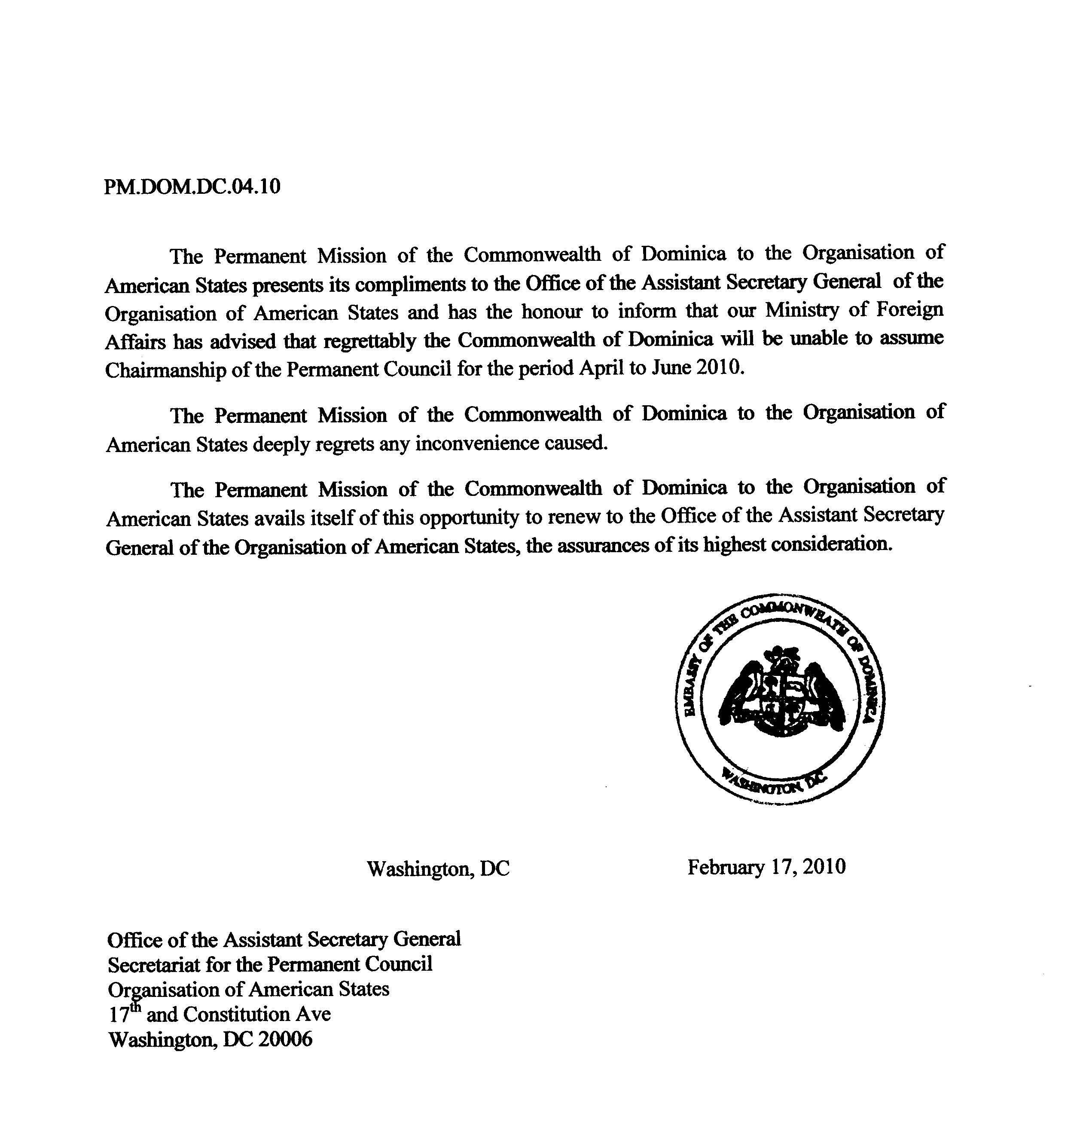

input.doc

