OEA/Ser.G
CP/INF.6022/10
26 March 2010
Original: English

NOTE FROM THE PERMANENT MISSION OF CANADA REQUESTING THE INCLUSION OF THE TOPIC “CORPORATE SOCIAL RESPONSIBILITY IN THE AMERICAS”
ON THE ORDER OF BUSINESS OF THE REGULAR MEETING OF
THE PERMANENT COUNCIL TO BE HELD ON APRIL 7, 2010

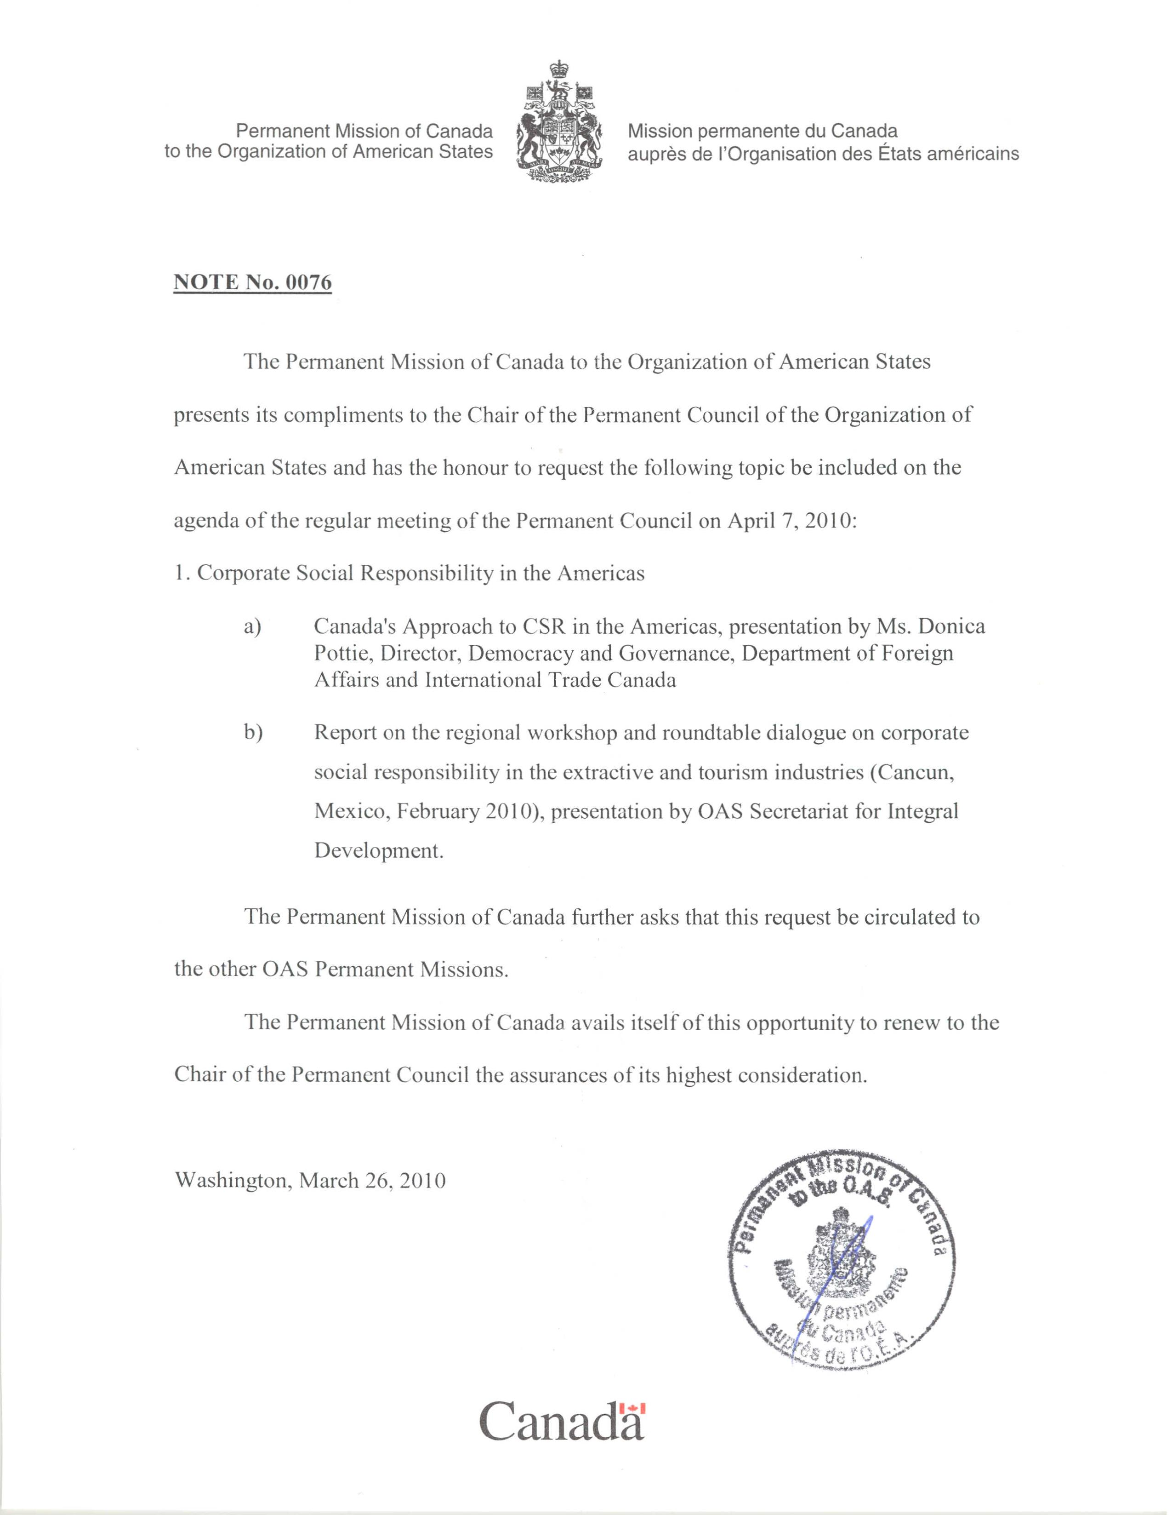
input.doc

