OEA/Ser.G
CP/INF.6025/10
31 March 2010
Original: Spanish

NOTE FROM THE COMMITTEE OF THE LEO S. ROWE PAN AMERICAN FUND REQUESTING THE INCLUSION OF AN ITEM ON THE ORDER OF BUSINESS OF THE NEXT REGULAR MEETING OF THE PERMANENT COUNCIL

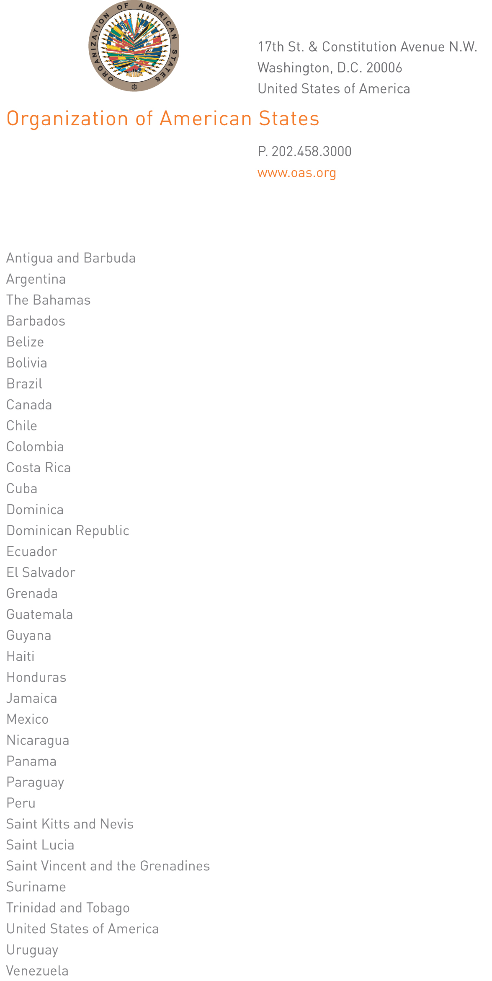
March 2010

LSRF/127/2010

Excellency,

In my capacity as Technical Secretariat of the Committee of the Leo S. Rowe Pan American Fund, I have the honor to address Your Excellency to request that the following item be included on the order of business of the next meeting of the Permanent Council:

Election of a member of the Committee of the Leo S. Rowe Pan American Fund.

This request is being made pursuant to Article 3 of the Statutes of the Fund, as the term of Peru, one of the four members of the Committee, is coming to an end.

Accept, Excellency, the assurances of my highest consideration.

Linda M. Sevillano
input.doc
Technical Secretariat of the
Committee of the Leo S. Rowe Pan American Fund
Department of Human Development, Education, and Culture

His Excellency
Ambassador José Enrique Castillo Barrantes
Chair of the Permanent Council and
Permanent Representative of Costa Rica

Cc: Ambassador Deborah-Mae Lovell
Chair of the Committee of the
Leo S. Rowe Pan American Fund

