OEA/Ser.G
CP/INF.6050/10
7 May 2010
Original: English

NOTE FROM THE PERMANENT MISSION OF THE UNITED STATES REQUESTING THE INCLUSION OF THE ITEM, “COMMEMORATION OF WORLD PRESS FREEDOM DAY” ON THE ORDER OF BUSINESS OF THE NEXT REGULAR MEETING OF THE PERMANENT COUNCIL, TO BE HELD ON MAY 6, 2010/

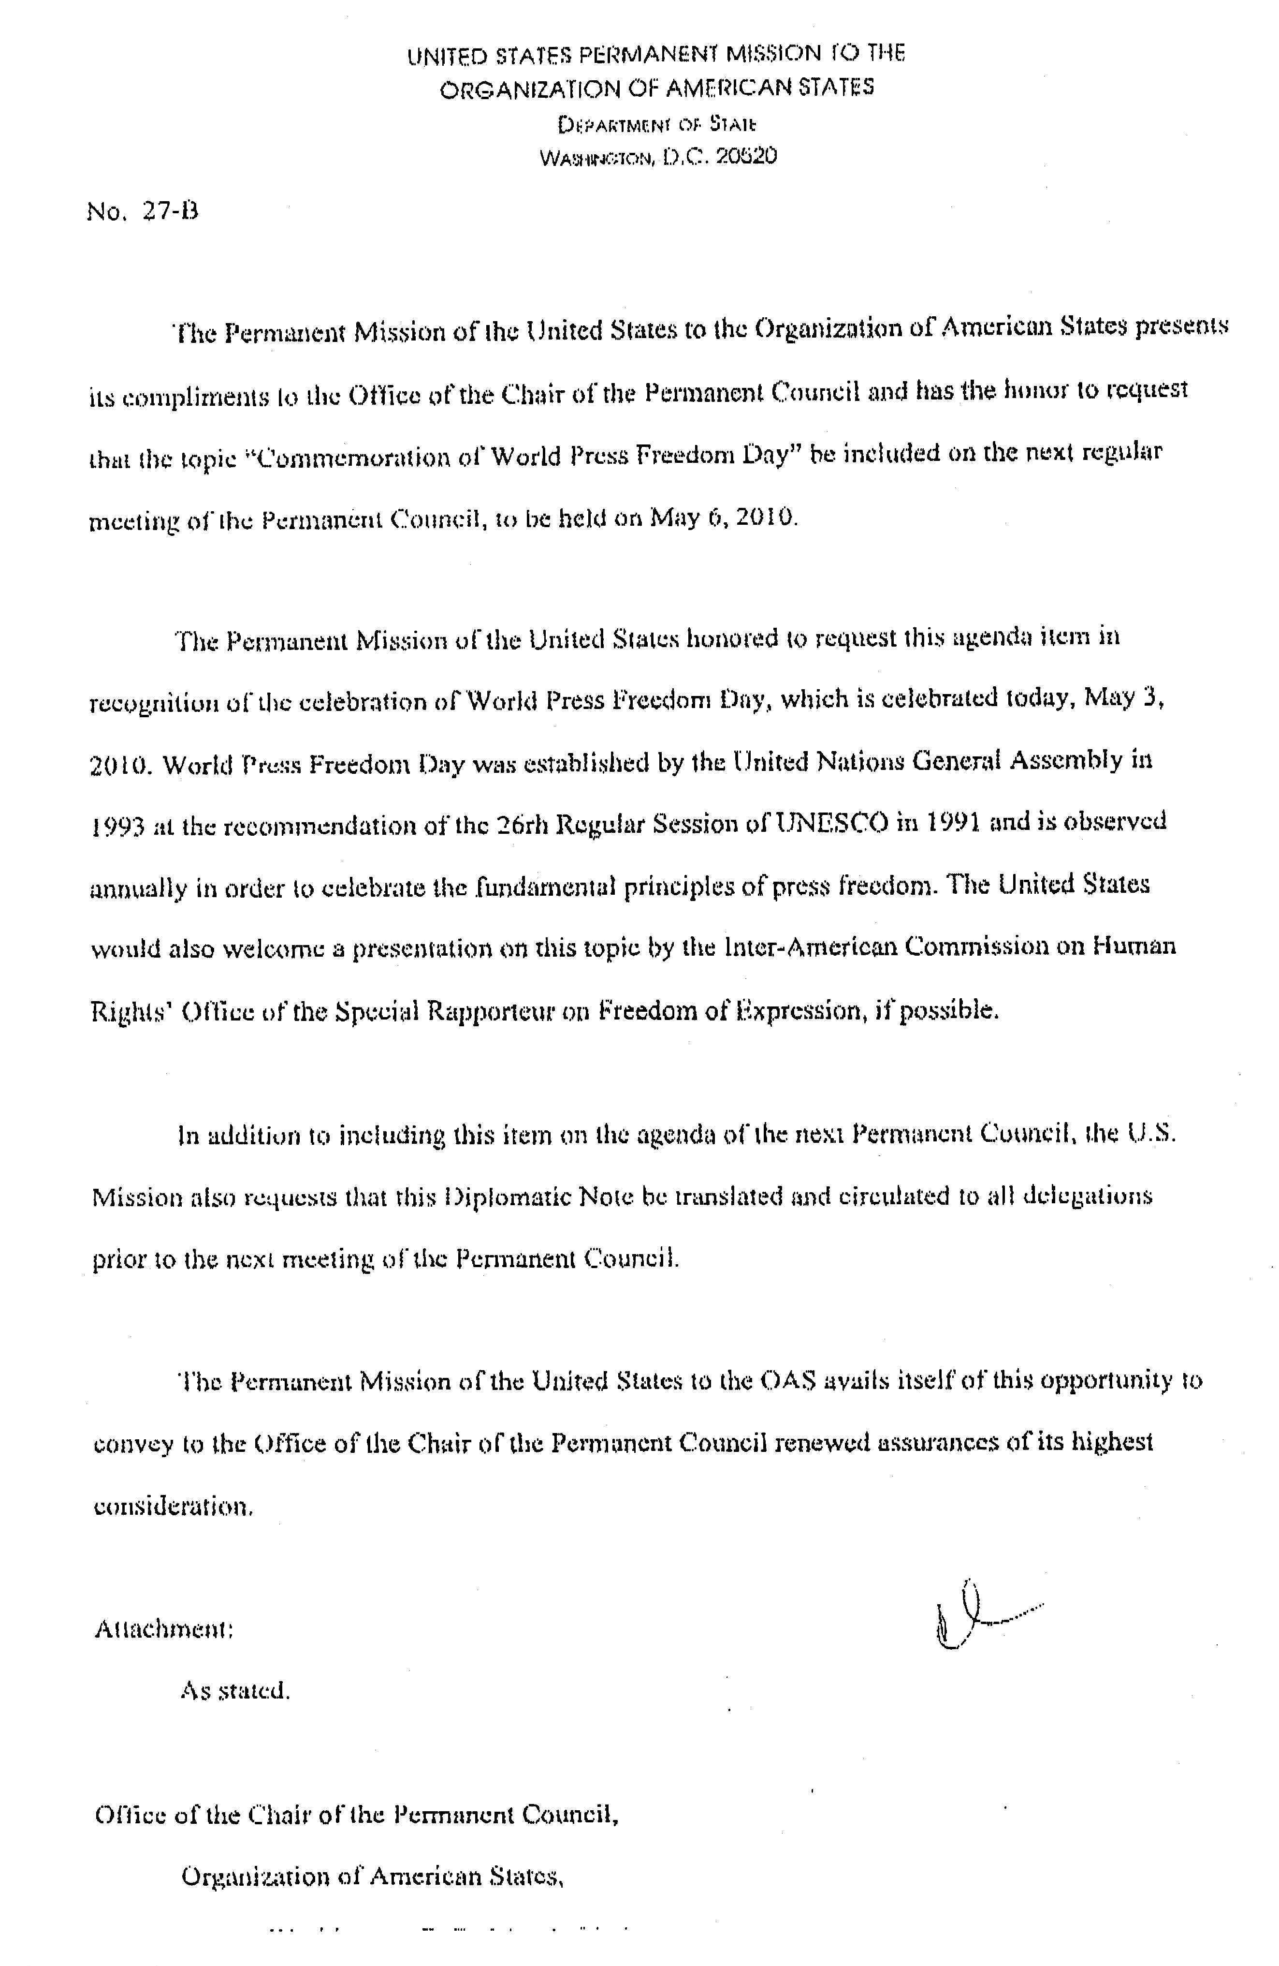
input.doc

? The consideration of this request was postponed until May 12, 2010 with the agreement of the Permanent Mission of the United States, due to the length of the agenda for the Council session held on May 6, 2010

