OEA/Ser.G
CP/INF.6060/10
26 May 2010
Original: English

NOTE FROM THE “CONSORCIO DESARROLLO Y JUSTICIA” AND “FREEDOM HOUSE” ORGANIZATIONS REGARDING THE DRAFT RESOLUTION
“INCREASING AND STRENGTHENING CIVIL SOCIETY PARTICIPATION
IN THE ACTIVITIES OF THE ORGANIZATION OF AMERICAN STATES
AND IN THE SUMMITS OF THE AMERICAS PROCESS”

(Document CP/CISC-502/10 rev..3)

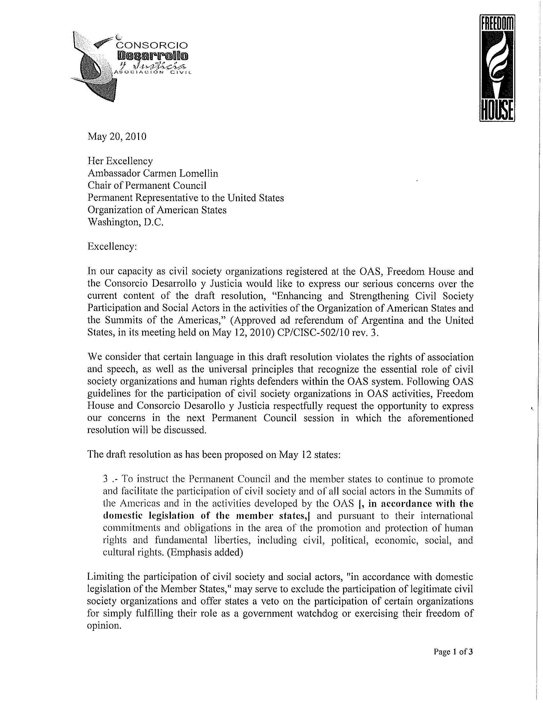

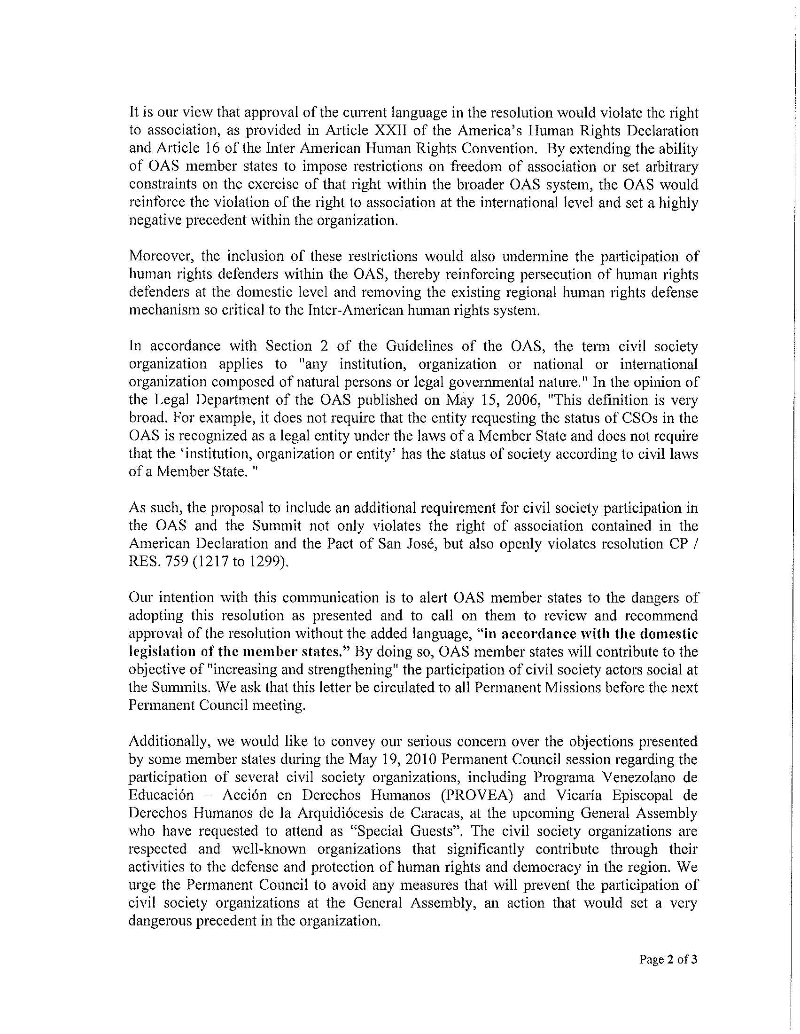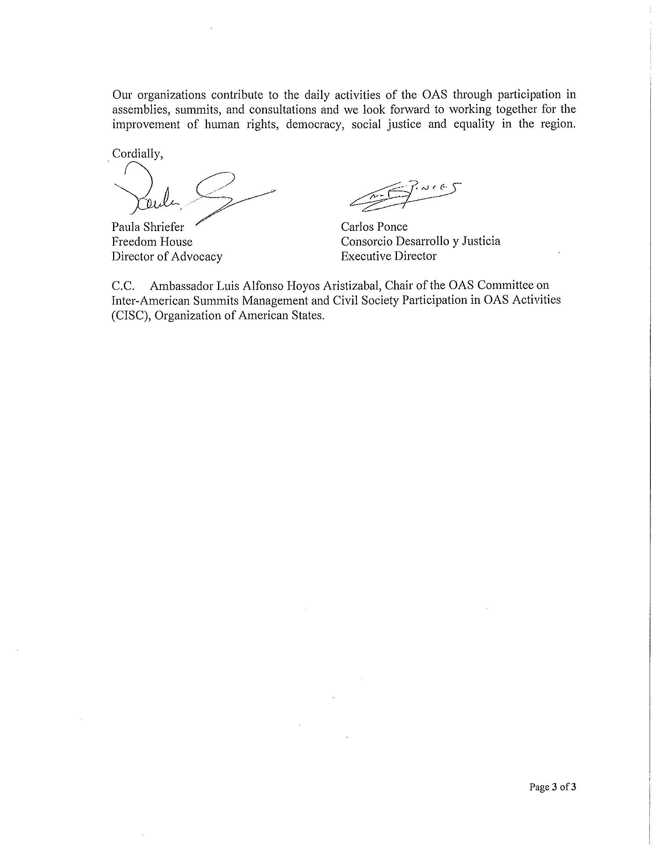
input.doc

