OEA/Ser.G
CP/INF.6077/10
8 July 2010
Original: Spanish

PRESENTATION OF CREDENTIALS BY AMBASSADOR HUBERT J. CHARLES,
PERMANENT REPRESENTATIVE OF DOMINICA TO THE
ORGANIZATION OF AMERICAN STATES
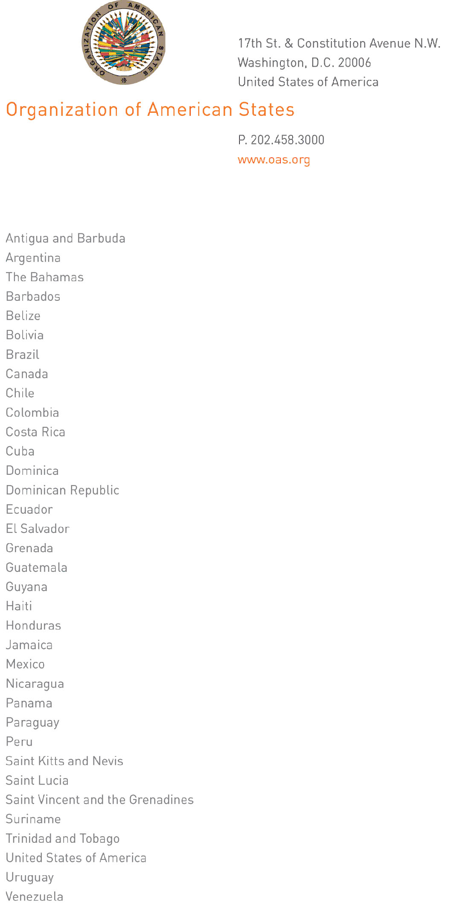

July 6, 2010

His Excellency
Ambassador Francisco Proaño
Permanent Representative of Ecuador
to the Organization of American States
Chair of the Permanent Council
Washington, D.C.
input.doc

Excellency:

I have the honor to address Your Excellency to inform you that on June 23, 2010, Ambassador Hubert J. Charles presented his credentials as Permanent Representative of Dominica to the Organization of American States.

Accept, Excellency, renewed assurances of my highest consideration.

José Miguel Insulza
Secretary General

