OEA/Ser.G
CP/INF.6090/10
3 August 2010
Original: Spanish

PRESENTATION OF CREDENTIALS BY
AMBASSADOR MARÍA ISABEL SALVADOR CRESPO,
PERMANENT REPRESENTATIVE OF ECUADOR TO THE
ORGANIZATION OF AMERICAN STATES
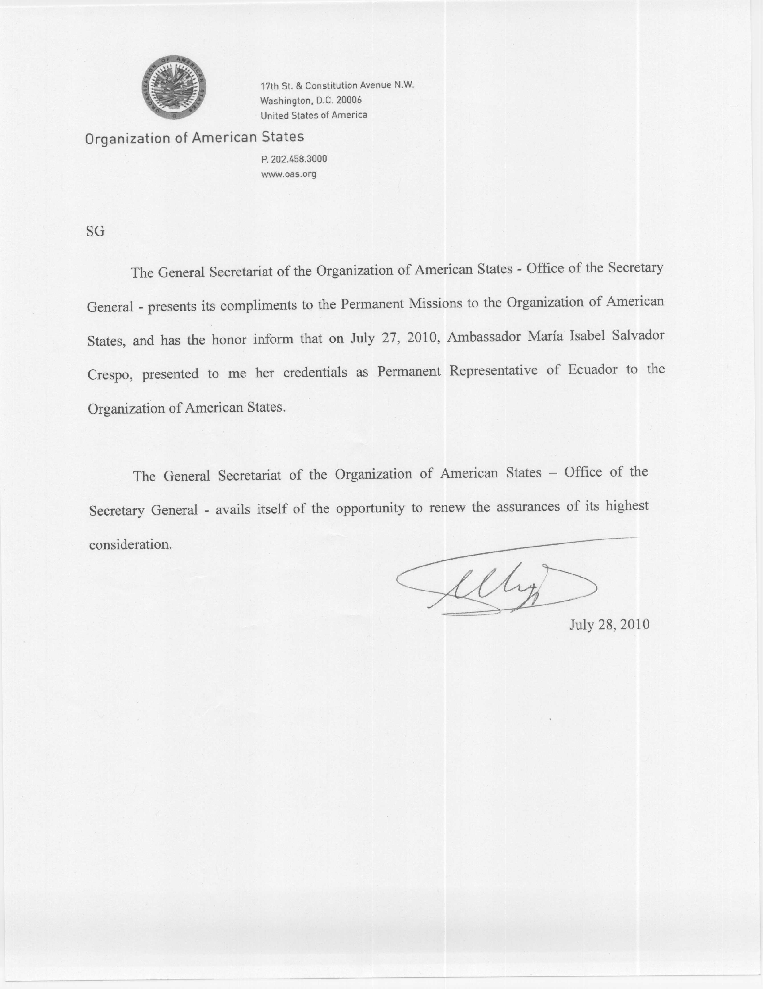

input.doc

