OEA/Ser.G
CP/INF.6103/10
23 September 2010
Original: English

NOTE FROM THE PERMANENT MISSION OF GRENADA
INFORMING OF THE GOVERNMENT OF GRENADA’S DECISION TO PRESENT ITS CANDIDATURE TO SERVE ON THE EXECUTIVE COMMITTEE OF THE
PAN AMERICAN HEALTH ORGANIZATION (PAHO)

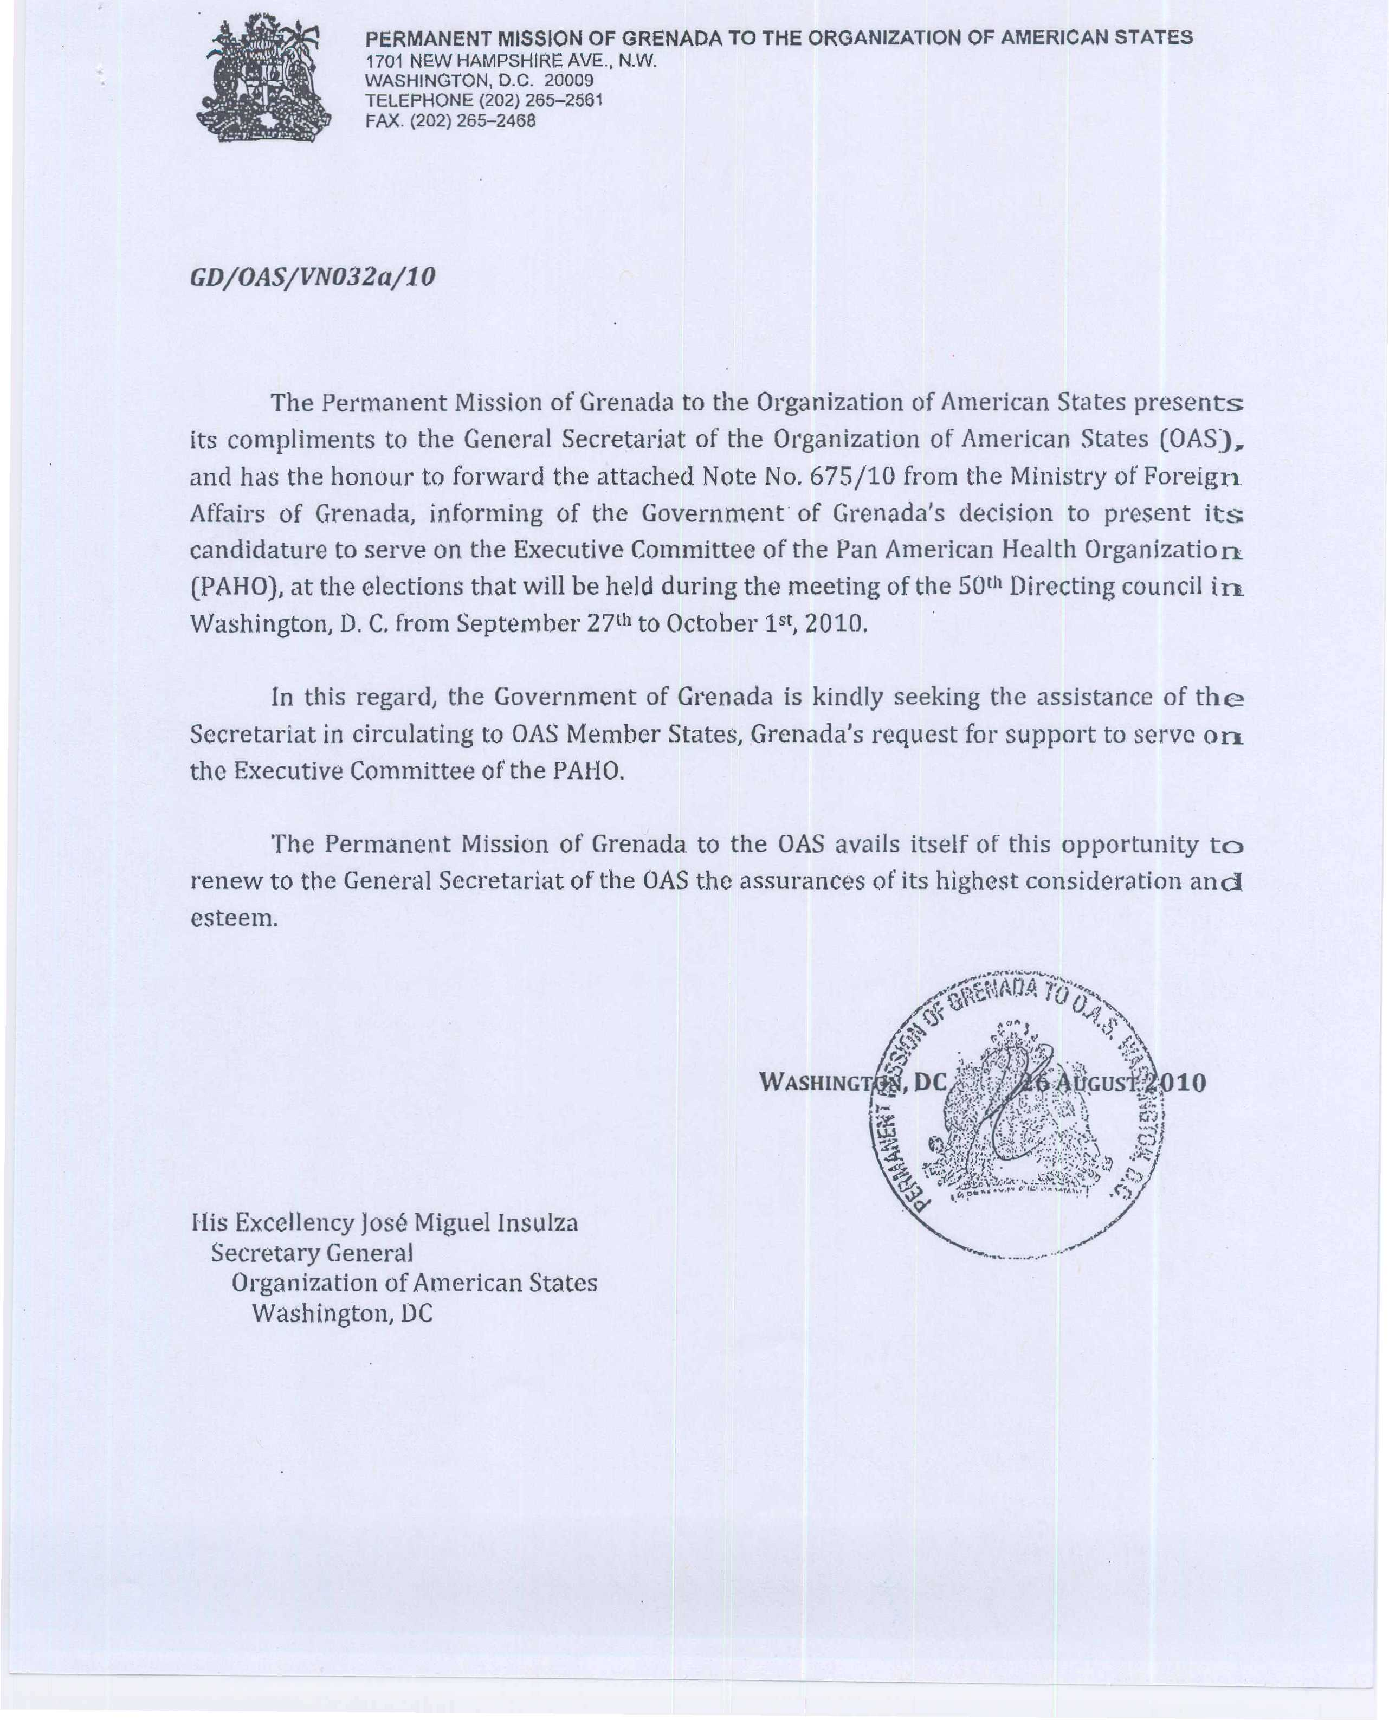
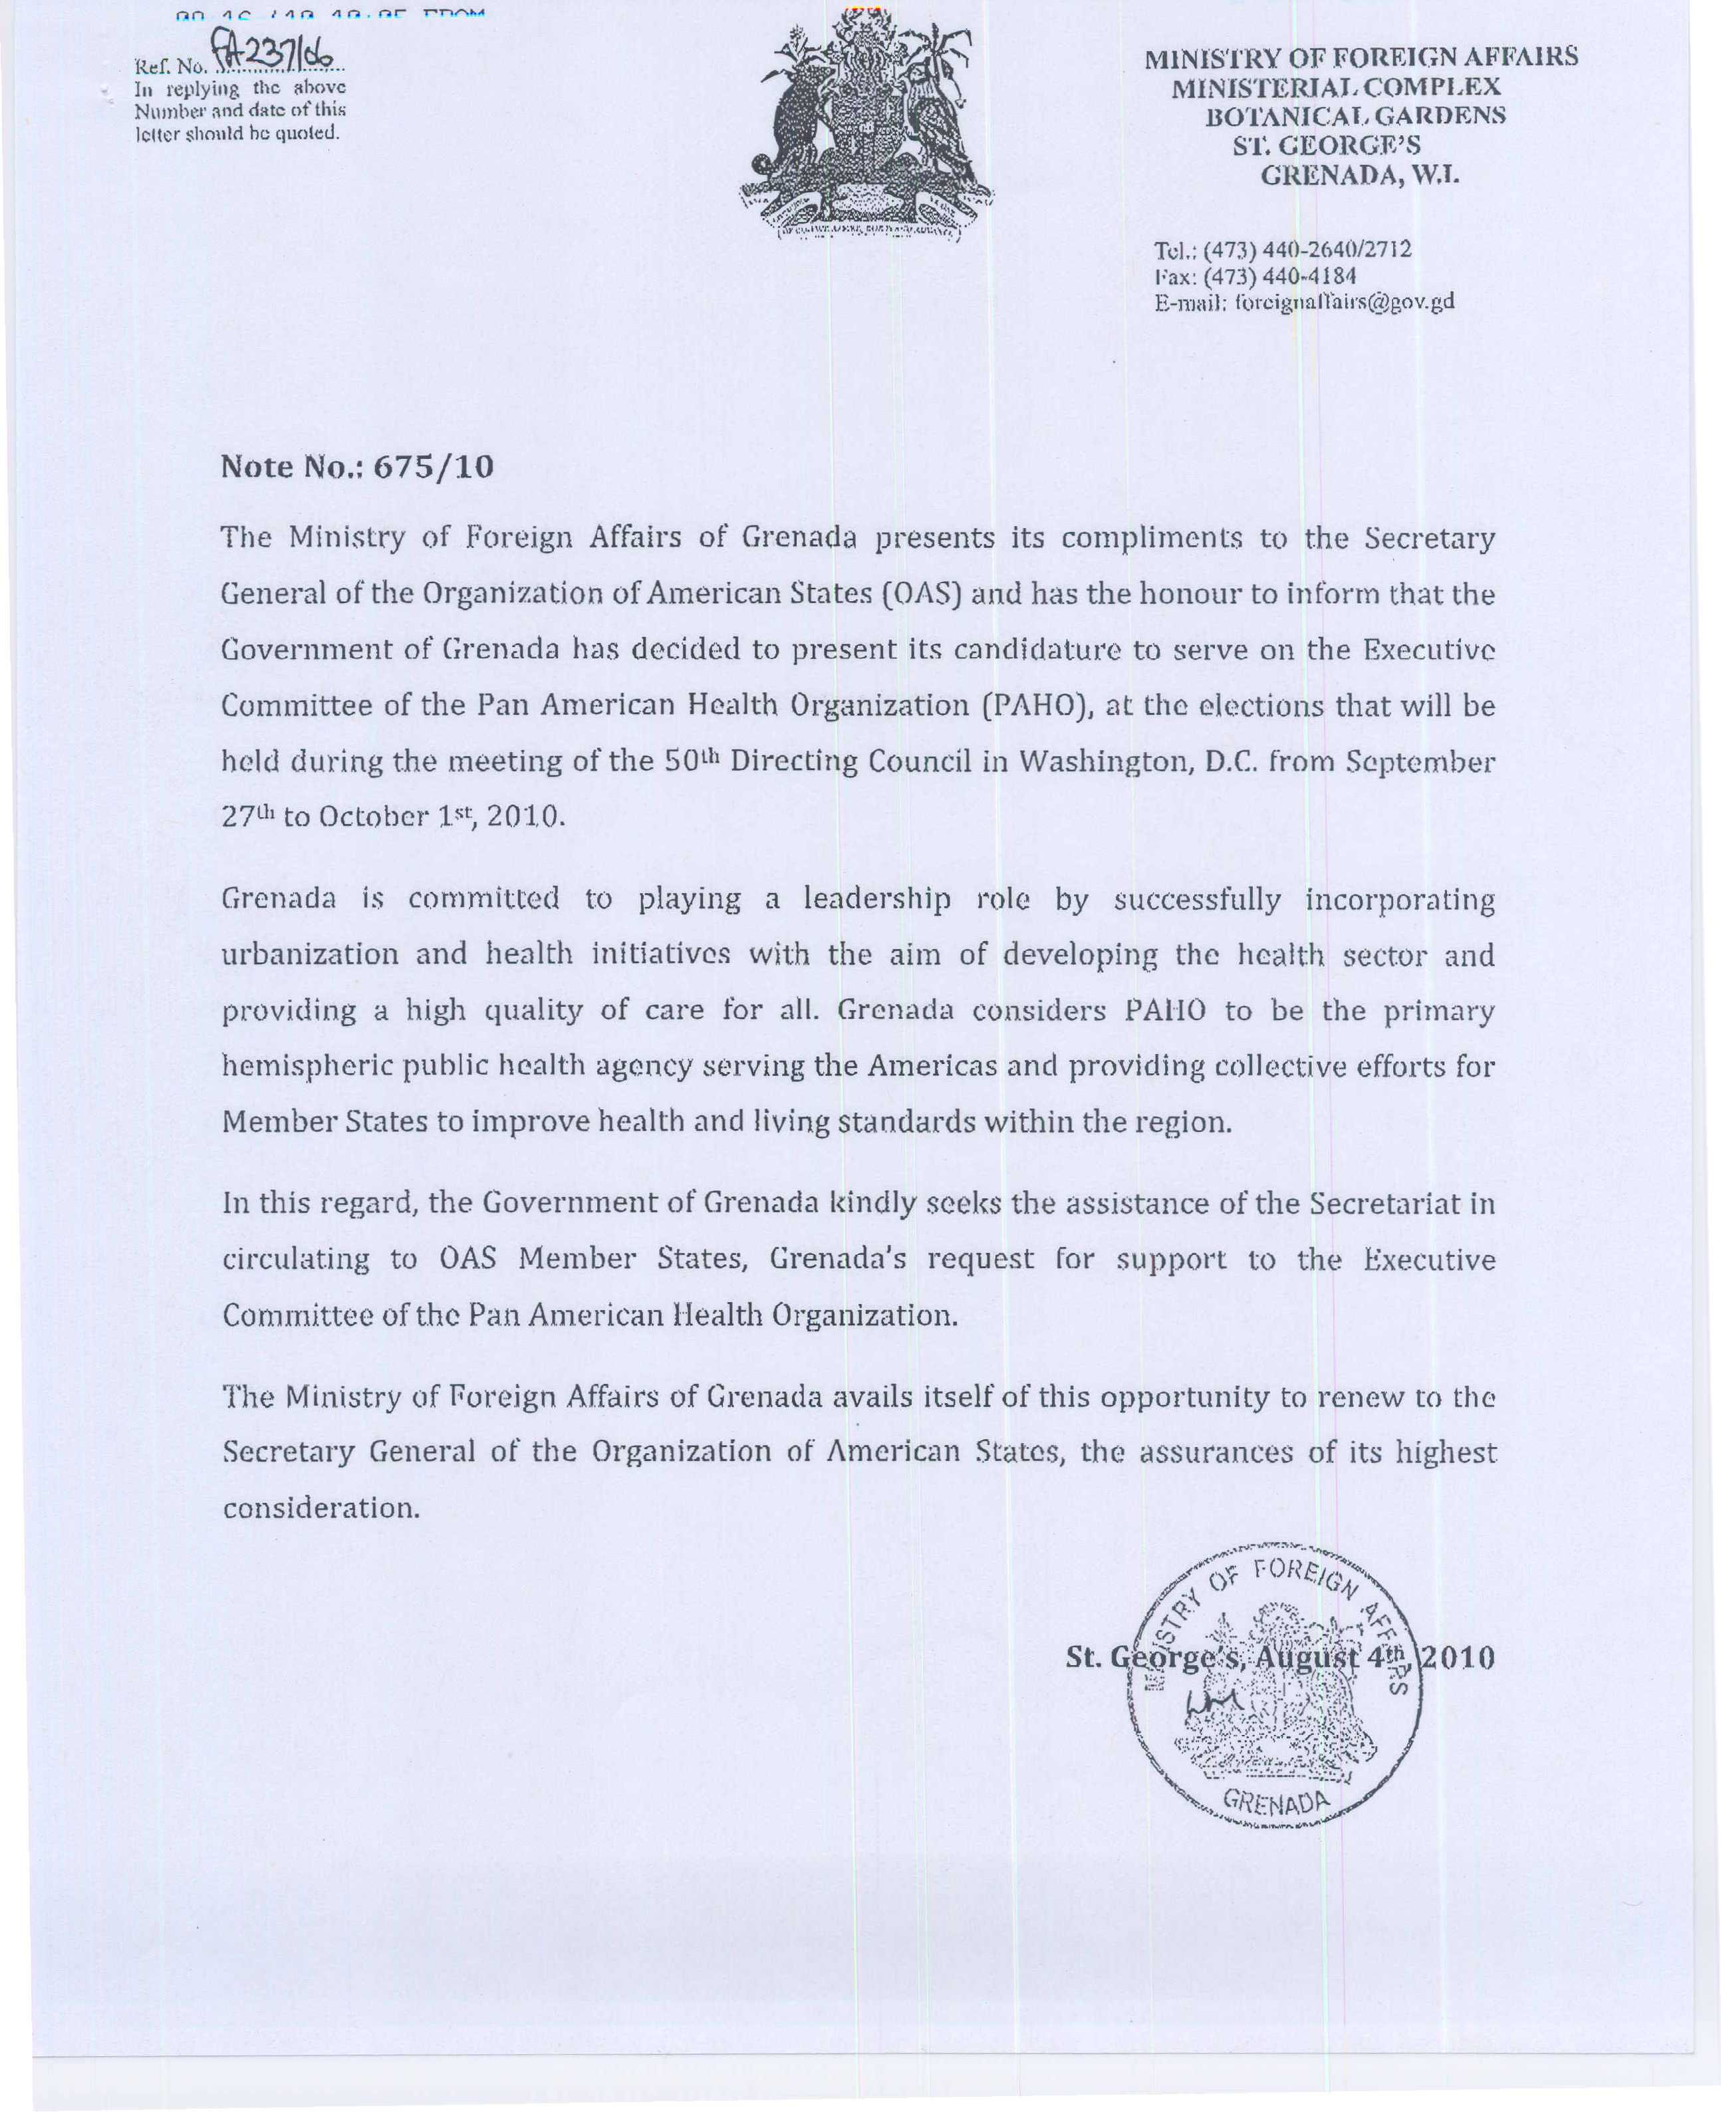
input.doc

