OEA/Ser.G
CP/INF. 6138/10
4 November 2010
Original: English

NOTE FROM THE PERMANENT MISSION OF THE REPUBLIC OF TRINIDAD AND TOBAGO REQUESTING A SPECIAL SESSION OF THE PERMANENT COUNCIL
TO WELCOME THE HONORABLE KAMLA PERSAD-BISSESSAR,
PRIME MINISTER OF THE REPUBLIC OF TRINIDAD AND TOBAGO

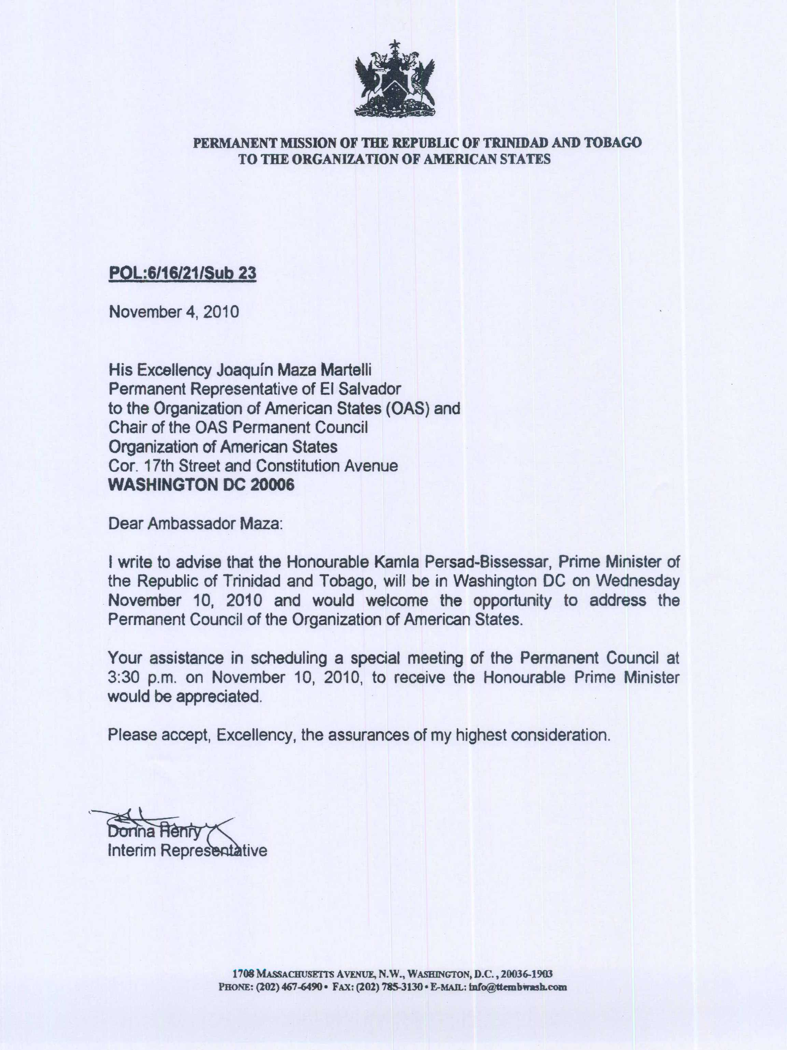
input.doc

