OEA/Ser.G
CP/INF.6165/10
30 November 2010
Original: Spanish

NOTE VERBALE FROM THE CHAIR OF THE PERMANENT COUNCIL
TO THE SECRETARY GENERAL ADVISING THAT HE WILL BE
AWAY FROM HEADQUARTERS
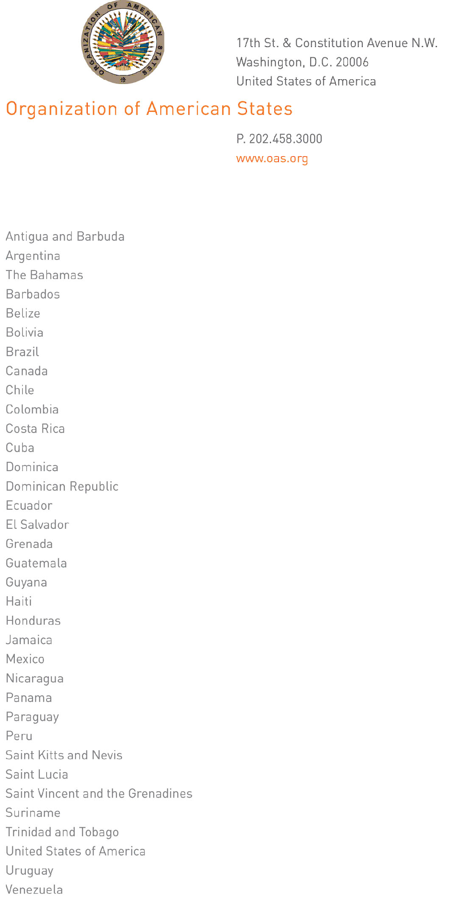
Washington, D.C., November 30, 2010

Excellency:

I am pleased to write you to let you know that I will be on official mission in San Salvador and will therefore be away from the Organization, from December 1 through 11 inclusive.

Finally, I am hereby confirming the commitment by the Foreign Minister of the Republic, Mr. Hugo Martínez, to present to the Permanent Council next December 13 the Central Theme that will guide the discussions at the forty-first regular session of the General Assembly, to be held in the city of San Salvador in June 2011.
input.doc

Accept, Excellency, the renewed assurances of my highest consideration.

Joaquín Alexander Maza Martelli
Ambassador
Permanent Representative of El Salvador
Chair of the Permanent Council

His Excellency
José Miguel Insulza
Secretary General
Organization of American States
Washington, D.C.

