OEA/Ser.G
CP/INF.6175/10
28 December 2010
Original: Spanish

NOTE FROM THE SECRETARY GENERAL TO THE CHAIR OF THE
PERMANENT COUNCIL, ADVISING OF HIS ABSENCE
FROM HEADQUARTERS
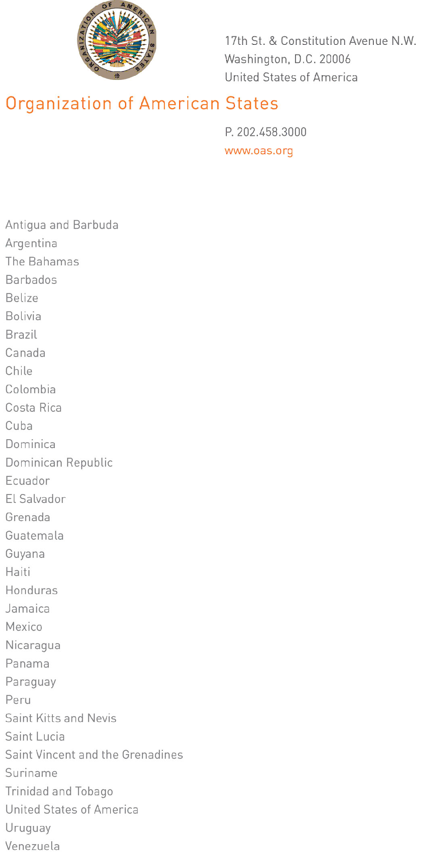
December 28, 2010

His Excellency Joaquín Maza
Ambassador, Permanent Representative of El Salvador
to the Organization of American States
Chair of the Permanent Council
Washington, D.C.

Excellency:
input.doc
I have the honor to address Your Excellency to let you know that I will be away from Headquarters from December 28 to 30, 2010.

During my absence, Ambassador Albert Ramdin, Assistant Secretary General, will be in charge of the General Secretariat.

Accept, Excellency, renewed assurances of my highest consideration.

José Miguel Insulza
Secretary General

