OEA/Ser.G
CP/INF.6187/11
18 January 2011
Original: English

NOTICE

The Secretariat of the Permanent Council of the Organization of American States presents its compliments to the Permanent Missions and has the honor to forward herewith a copy of the letter from the Secretary General to the Chair of the Council, advising that he will be away from headquarters on January 18, 2011.
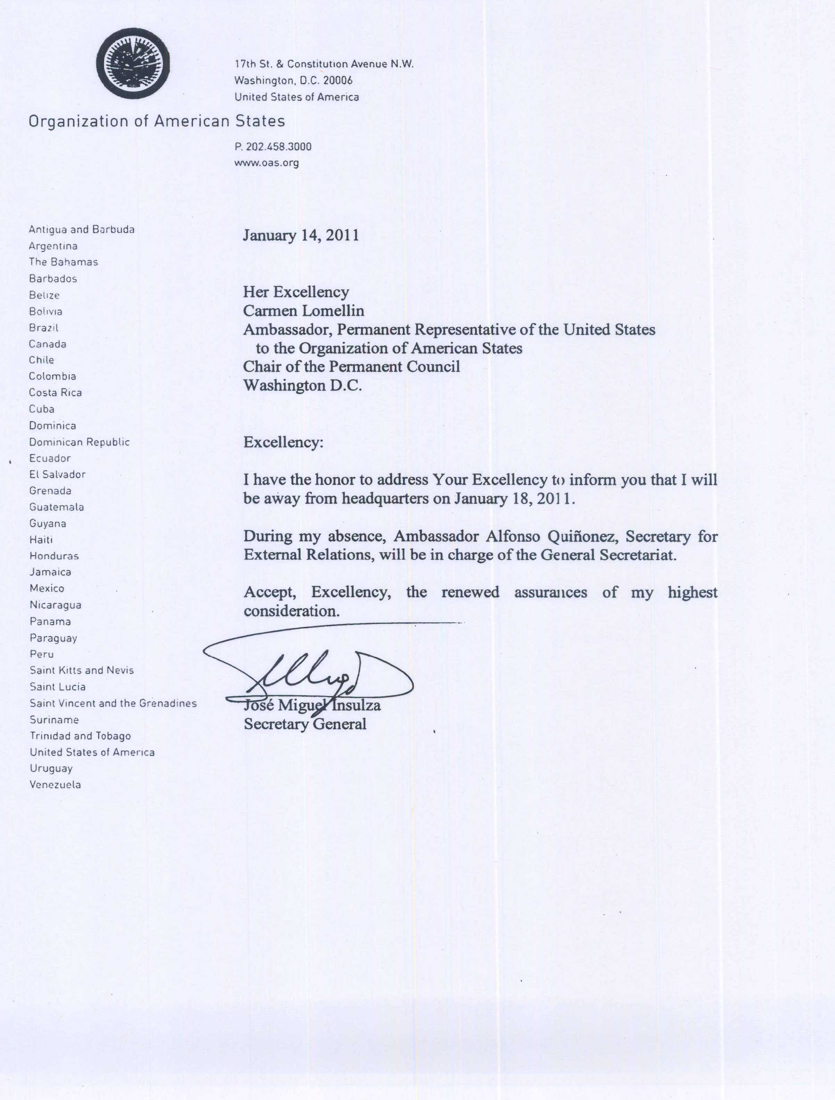
input.doc

