OEA/Ser.G
CP/INF. 6204/11
7 March 2011
Original: Spanish

NOTE FROM THE CHAIR OF THE COMMITTEE ON JURIDICAL AND POLITICAL AFFAIRS REQUESTING THE INCLUSION OF THE TOPIC “REPORT OF THE CHAIR OF THE CAJP ON THE MEETING OF DONORS TO STRENGTHEN THE INTER-AMERICAN HUMAN RIGHTS SYSTEM” ON THE AGENDA OF THE PERMANENT COUNCIL MEETING
TO BE HELD ON MARCH 16, 2011
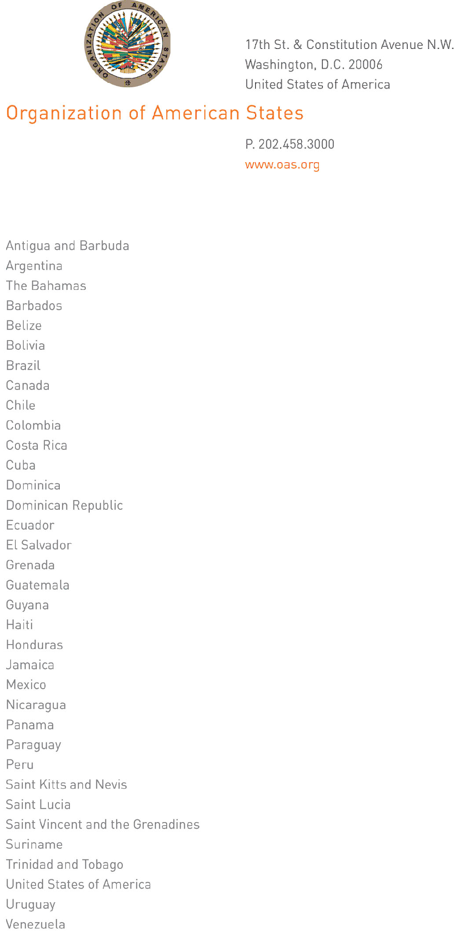
March 7, 2011

Her Excellency Carmen Lomellin
Ambassador, Permanent Representative of the
United States to the Organization of American States
Chair of the Permanent Council of the OAS
Washington, D.C.

Excellency:

I have the honor to address Your Excellency, in my capacity as Chair of the Committee on Juridical and Political Affairs of the Organization of American States (OAS) Permanent Council, to request to be allowed to advise the Permanent Council of the outcome of the Technical Meeting of Donors to Strengthen the Inter-American Human Rights System, held in Ottawa, Canada, from March 1-2, 2011.
input.doc

I am therefore requesting that you include the item “Report of the Chair of the CAJP on the Technical Meeting of Donors to Strengthen the Inter-American Human Rights System, held in Ottawa, Canada, from March 1-2, 2011” on the order of business for the next meeting of the Permanent Council.

Accept, Excellency, the renewed assurances of my highest consideration.

Hugo De Zela
Ambassador, Permanent Representative of Peru
to the Organization of American States
Chair, Committee on Juridical and Political Affairs

