OEA/Ser.G
CP/INF.6267/11
12 July 2011
Original: Spanish

PRESENTATION OF CREDENTIALS BY
AMBASSADOR JORGE RAMÓN HERNÁNDEZ ALCERRO,
PERMANENT REPRESENTATIVE OF HONDURAS TO THE
ORGANIZATION OF AMERICAN STATES
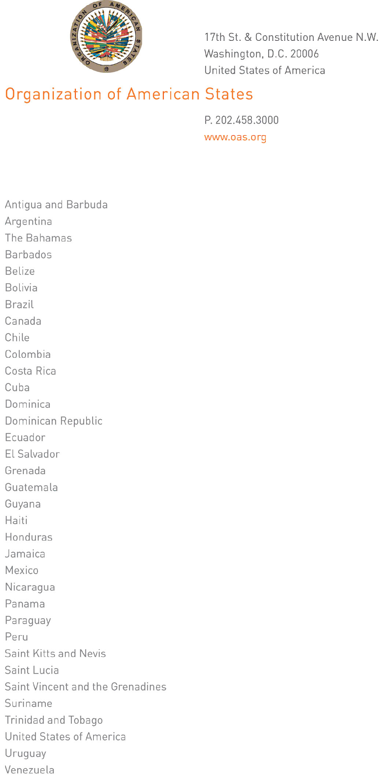
July 6, 2011

His Excellency
Jorge Skinner-Klee
Ambassador, Permanent Representative of Guatemala
to the Organization of American States
Washington, D.C.

Excellency:

I have the honor to address Your Excellency to inform you that on June 1, 2011, Ambassador Jorge Ramón Hernández Alcerro presented credentials as Permanent Representative of Honduras to the Organization of American States.
input.doc

Accept, Excellency, renewed assurances of my highest consideration.

José Miguel Insulza
Secretary General

