OEA/Ser.G
CP/INF.6297/11
7 September 2011
Original: Spanish

PRESENTATION OF CREDENTIALS BY
AMBASSADOR ROBERTO BERNARDO SALADÍN SELÍN,
PERMANENT REPRESENTATIVE OF THE DOMINICAN REPUBLIC TO THE
ORGANIZATION OF AMERICAN STATES
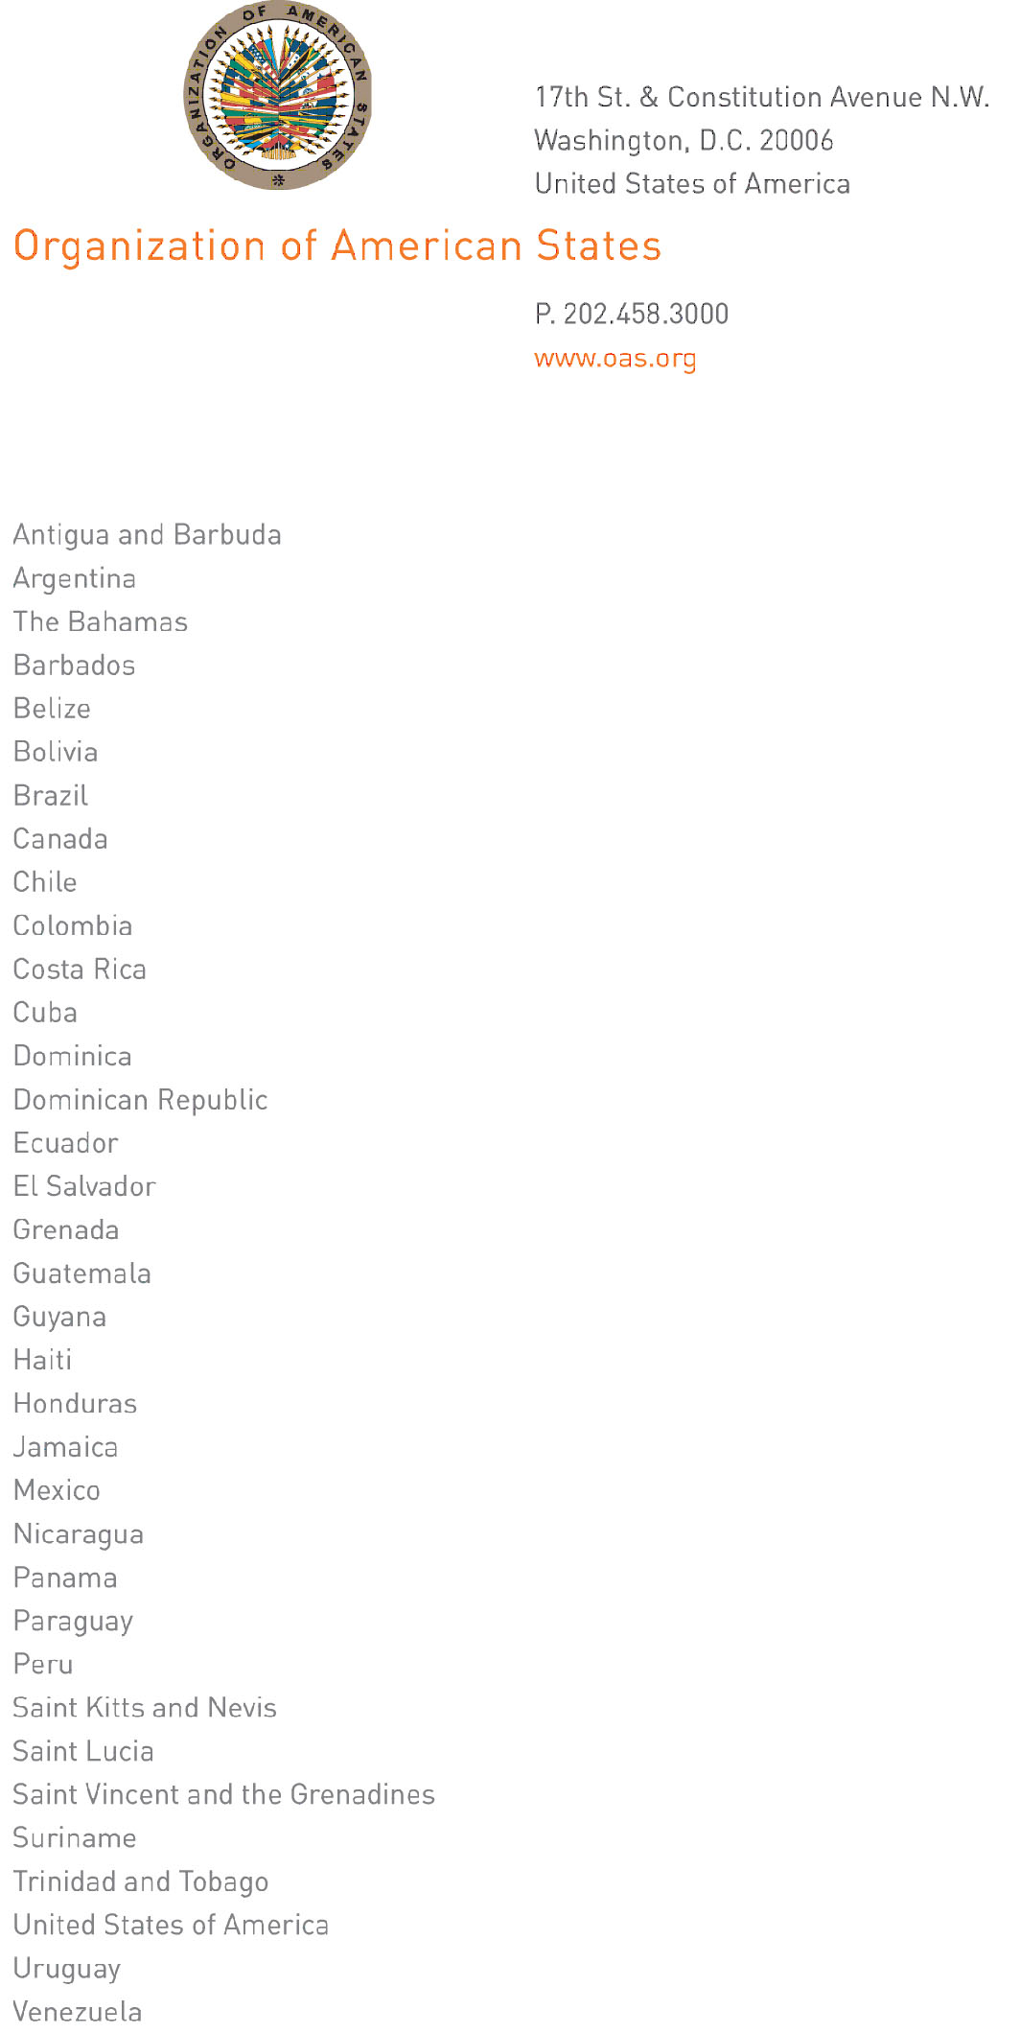
September 7, 2011

His Excellency
Jorge Skinner-Klee
Ambassador, Permanent Representative of Guatemala
to the Organization of American States
Washington, D.C.

Excellency:

I have the honor to address Your Excellency to inform you that this past September 1, Ambassador Roberto Bernardo Saladín Selín presented credentials as Permanent Representative of the Dominican Republic to the Organization of American States.
CP27034E04

Accept, Excellency, renewed assurances of my highest consideration.

José Miguel Insulza
Secretary General

