OEA/Ser.G
CP/INF.6301/11
14 September 2011
Original: Spanish

PRESENTATION OF CREDENTIALS BY
AMBASSADOR JOEL ANTONIO HERNÁNDEZ GARCÍA,
PERMANENT REPRESENTATIVE OF MEXICO TO THE
ORGANIZATION OF AMERICAN STATES
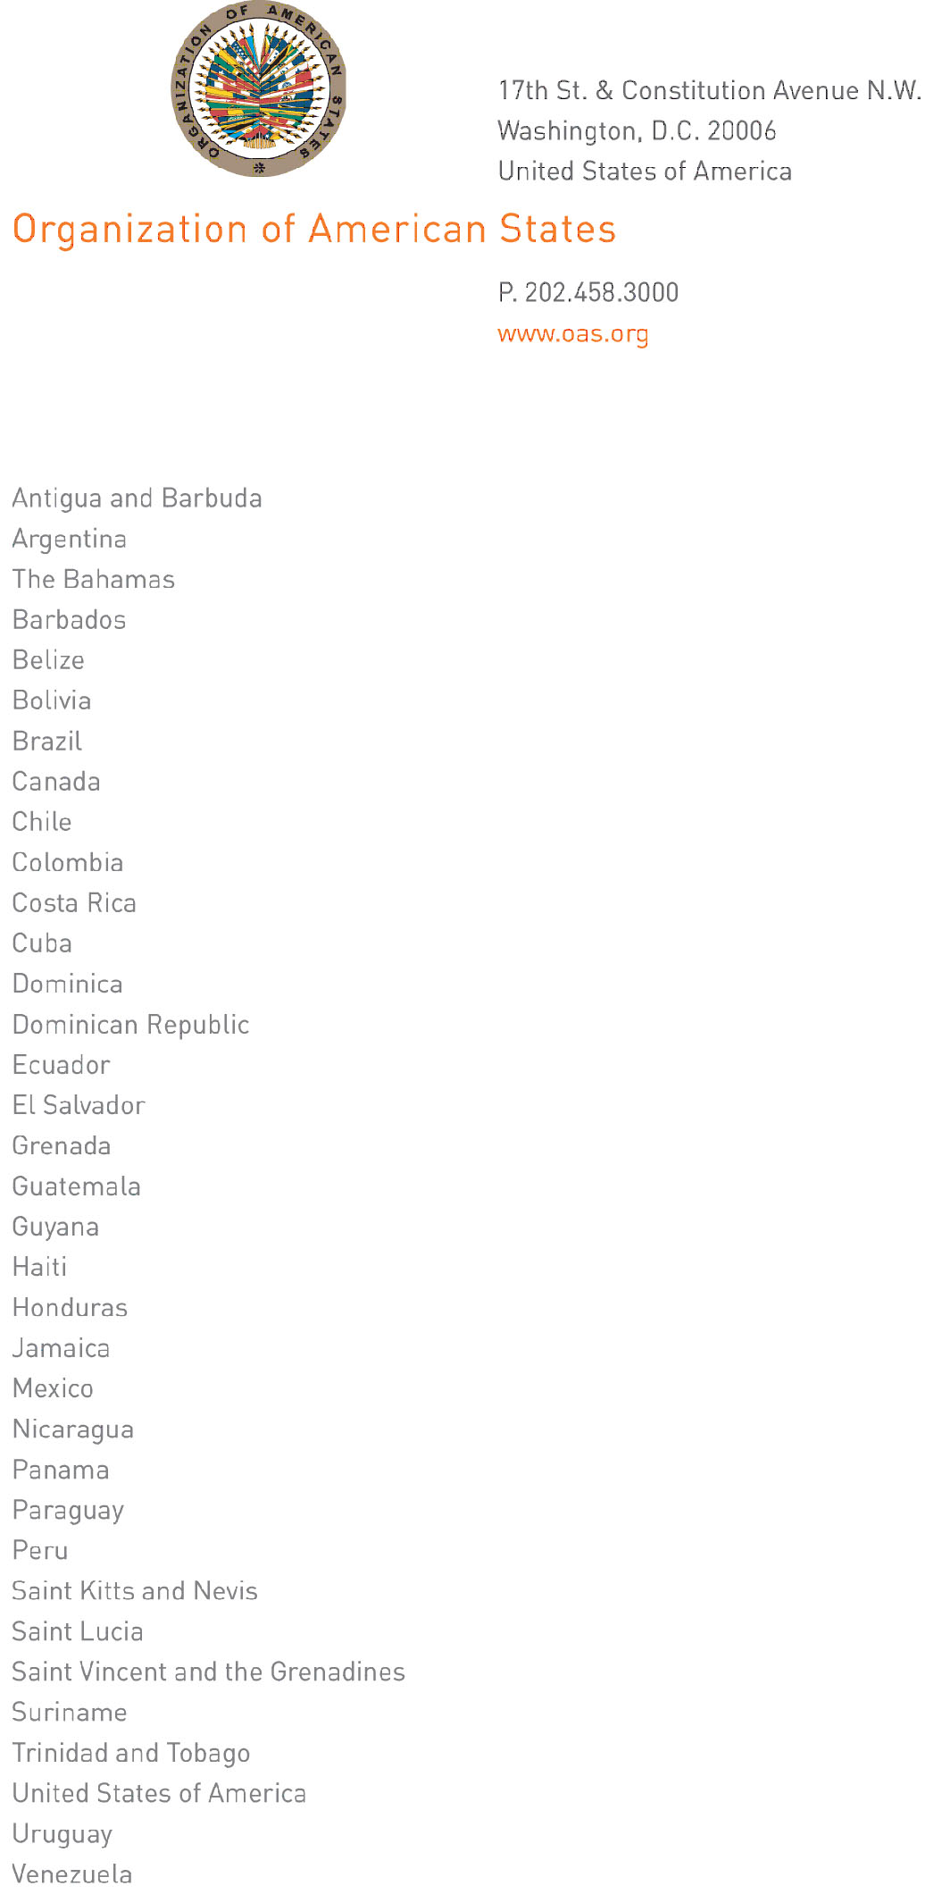

September 9, 2011

His Excellency
Jorge Skinner-Klee
Ambassador, Permanent Representative of Guatemala
to the Organization of American States
Chair of the Permanent Council
Washington, D.C.

Excellency:
input.doc
I have the honor to address Your Excellency to inform you that this past August 29, Ambassador Joel Antonio Hernández García presented credentials as Permanent Representative of Mexico to the Organization of American States.

Accept, Excellency, renewed assurances of my highest consideration.

José Miguel Insulza
Secretary General

