OEA/Ser.G
CP/INF.6321/11
12 October 2011
Original: Spanish

NOTE FROM THE CHAIRS OF THE COMMITTEE ON JURIDICAL AND POLITICAL AFFAIRS (CAJP) AND OF THE SPECIAL WORKING GROUP TO REFLECT ON THE WORKINGS OF THE IACHR WITH A VIEW TO STRENGTHENING THE IAHRS, REQUESTING THAT AN ITEM DEALING WITH THE TOPIC OF INCREASED FUNDING FOR THE AGENCIES OF THE INTER-AMERICAN HUMAN RIGHTS SYSTEM BE INCLUDED ON THE ORDER OF BUSINESS OF THE REGULAR MEETING OF THE PERMANENT COUNCIL TO BE HELD ON OCTOBER 19, 2011

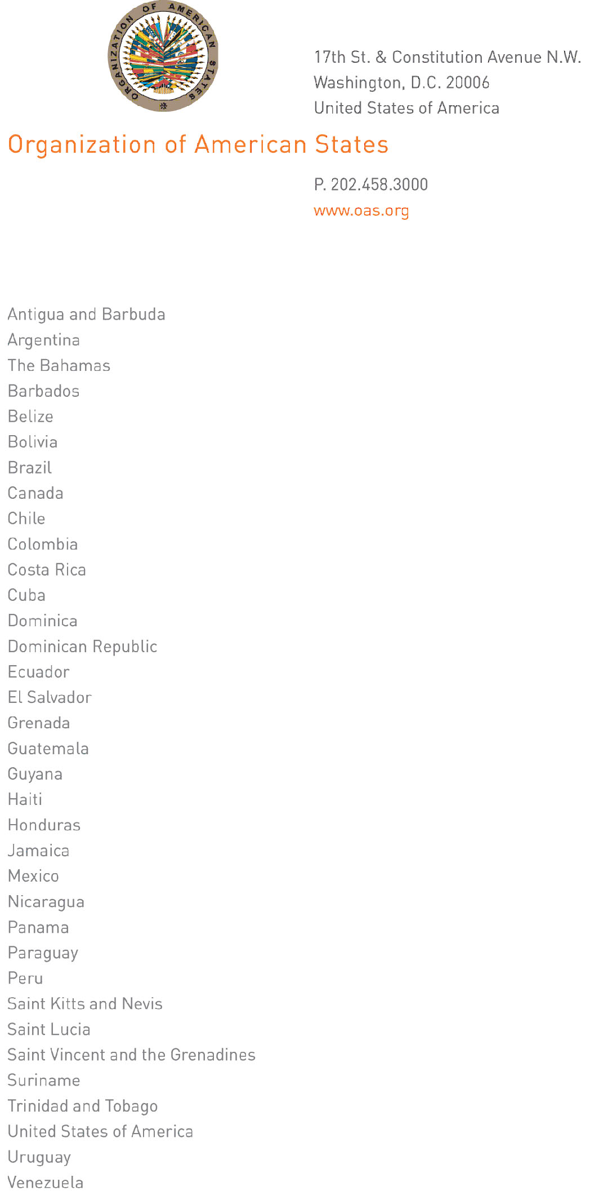
Washington, D.C., October 5, 2011

Excellency:

We have the pleasure of addressing you in your capacity as Chair of the Permanent Council of the Organization of American States, and of requesting that you give consideration to the inclusion, on the order of business of the Permanent Council’s Regular Meeting programmed for Wednesday, October 19, 2011, of an item dealing with the topic of increased funding for the agencies of the inter-American human rights system, in pursuit of the mandates contained in resolutions AG/RES 2675 (XLI-O/11), “Strengthening of the Inter-American Human Rights System pursuant to the Mandates Arising from the Summits of the Americas,” AG/RES. 2672 (XLI-O/11), “Observations and Recommendations on the Annual Report of the Inter-American Commission on Human Rights,” and AG/RES. 2652 (XLI-O/11), “Observations and Recommendations on the Annual Report of the Inter-American Court of Human Rights.”
Mr. Chair: bearing in mind that the Permanent Council has entrusted the CAJP with following up on the above mandates and that, in addition, at its regular meeting of June 29, 2011, the Permanent Council established a Working Group of the Permanent Council to “deepen the process of reflection on the workings of the Inter-American Commission on Human Rights (IACHR) in the framework of the American Convention on Human Rights and the Statute of the IACHR, with the aim of strengthening the inter-American human rights system, and to present its recommendations to the member states as soon as possible,” it is important and necessary that this topic be dealt with in a coordinated fashion, at the highest political level, and on an urgent basis in the forum that you chair, in preparation for the forty-second special session of the General Assembly of the OAS, at which the 2012 program-budget of the Organization is to be approved.

His Excellency

Ambassador Bayney R. Karran
Permanent Representative of Guyana to the OAS
Chair, Permanent Council of the OAS

We therefore propose that the aforesaid meeting of the Permanent Council also offer an opportunity for the IACHR to present its 2011-2015 Strategic Plan; for the Inter-American Court of Human Rights to give a presentation on its budgetary needs; and for the General Secretariat, through its Secretariat for Administration and Finance, to report on the work it is carrying out to draw up and present a proposal for bringing about an effective increase in the funding of the agencies of the inter-American human rights system in the Organization’s program-budget, in pursuit of the mandates contained in the resolutions referred to above.
We thank you in advance for the consideration given to this matter, and we avail ourselves of this opportunity to reassure you of our highest and most distinguished consideration.

María Isabel Salvador Hugo de Zela
Ambassador, Ambassador,
input.doc
Permanent Representative of Ecuador Permanent Representative of Peru
to the OAS to the OAS
Chair, Chair,
Committee on Juridical and Political Affairs Special Working Group to Reflect
on the Workings of the IACHR with a view
to Strengthening the IAHRS

C.C. José Miguel Insulza, Secretary General of the OAS
Ambassador Albert Ramdin, Assistant Secretary General of the OAS
Ambassador John Beale, Permanent Representative of Barbados and Chair of the CAAP
Dr. Diego García-Sayán, President, Inter-American Court of Human Rights
Dr. Dinah Shelton, President, Inter-American Commission on Human Rights
Gerald C. Anderson, Secretary for Administration and Finance

