OEA/Ser.G
CP/INF.6431/12
1 May 2012
Original: Spanish

NOTE FROM THE CHAIR OF THE LEO S. ROWE PAN AMERICAN FUND COMMITTEE
REQUESTING INCLUSION OF THE TOPIC “ELECTION OF A MEMBER TO THE
LEO S. ROWE PAN AMERICAN FUND COMMITTEE” ON THE ORDER OF BUSINESS
FOR THE NEXT REGULAR MEETING OF THE PERMANENT COUNCIL
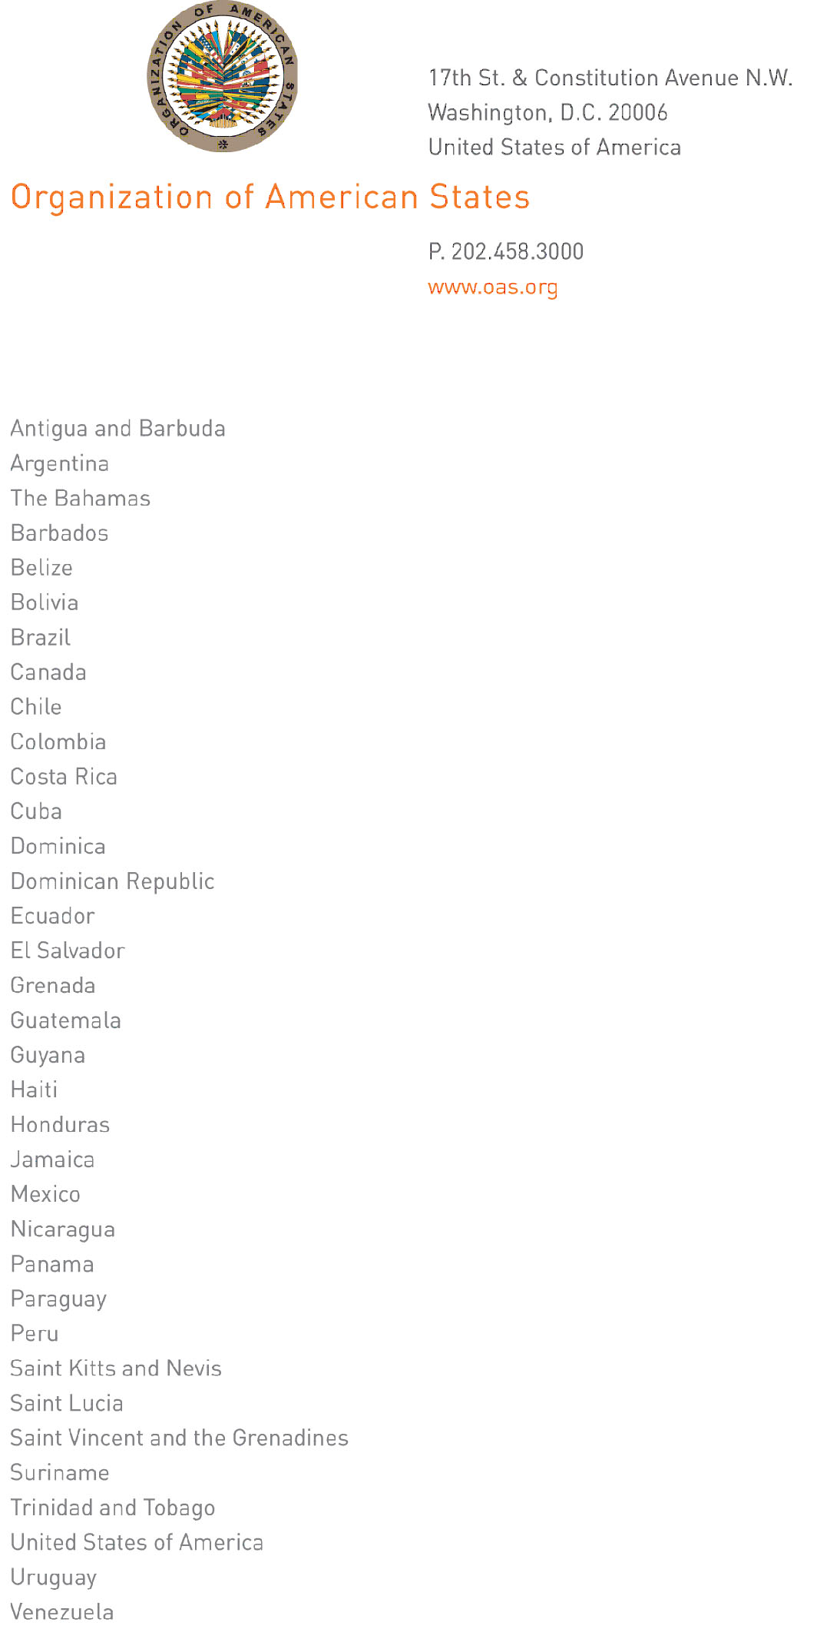
Washington, D.C.
April 27, 2012

His Excellency Leonidas Rosa Bautista
Ambassador, Permanent Representative of Honduras
to the OAS
Chair, Permanent Council
Washington, D.C.

Dear Ambassador Rosa Bautista,
input.doc
I am pleasured to write you, on behalf of Ambassador Deborah-Mae Lovell, to request that in your capacity as Chair of the Permanent Council you include on the order of business for the next meeting of that body the following topic:

- Election of a member to the Leo S. Rowe Pan American Fund Committee

This is in keeping with Article 3 of the Statutes of the Fund, owing to the expiry of term of Panama, one of the four member countries on the Committee.

Sincerely yours,

Lina M. Sevillano
Technical Secretary to the Leo S. Rowe Fund Committee
Department of Human Development
Education and Culture

