OEA/Ser.G
CP/INF. 6496/12
27 August 2012
Original: English

NOTE OF THE EXECUTIVE SECRETARY OF THE INTER-AMERICAN
COMMISSION OF WOMEN (CIM), CARMEN MORENO ENCLOSING THE DRAFT AGENDA FOR THE THIRTY-SIXTH ASSEMBLY OF DELEGATES OF THE CIM

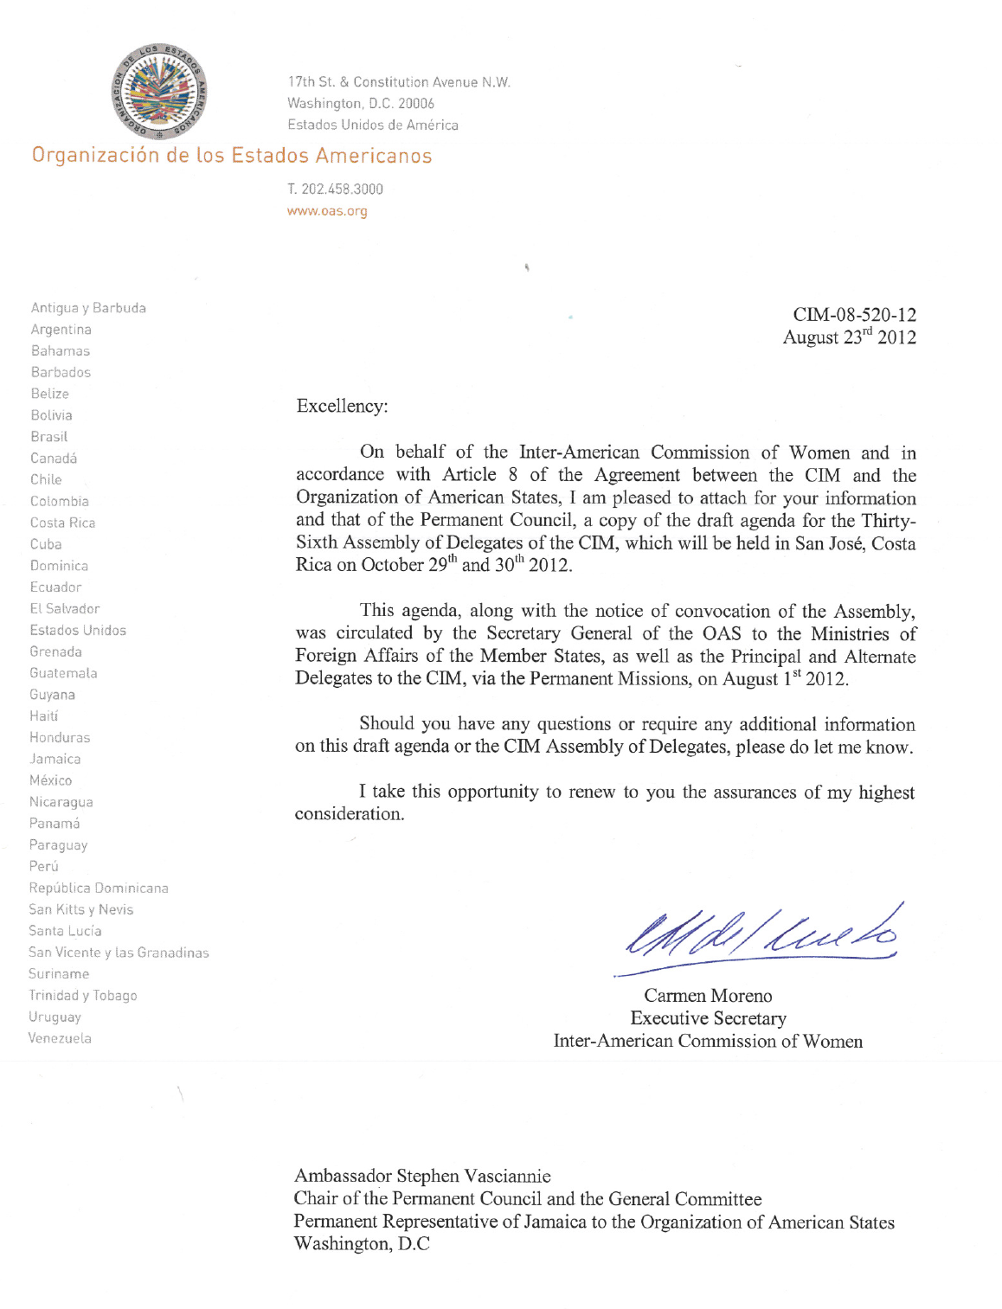



INTER-AMERICAN COMMISSION OF WOMEN

THIRTY-SIXTH ASSEMBLY OF DELEGATES OEA/Ser.L/II.2.36
October 29th to 30th 2012 CIM/doc.2/12 rev. 1
San José, Costa Rica May 1st 2012
Original: Spanish

DRAFT AGENDA OF THE
THIRTY-SIXTH ASSEMBLY OF DELEGATES OF THE CIM

input.doc
- Election of authorities of the XXXVI Assembly of Delegates of the CIM

- Adoption of the Draft Agenda and Organization of Work

- Modification of the CIM Legal Instruments

- Consideration of Reports:
- Report of the President, the Executive Committee and the Executive Secretariat
- Report of the Technical Secretariat of the Follow-up Mechanism to the Belém do Pará Convention (MESECVI)
- National reports on the thematic axes of the XXXVI Assembly of Delegates of the CIM

- Panels on the thematic axes of the Assembly:
- Violence against women and citizen security
- The social return on investment in care infrastructure
- Power and political participation

- Election of authorities of the Commission:
- Consideration of the Report of the Committee on Credentials
- Election of the President
- Election of the Vice-Presidents
- Election of the members of the Executive Committee
- Place and date of the XXXVII Assembly of Delegates of the CIM

- Program of work of the CIM: programmatic orientations

- Adoption of the Costa Rica Declaration and the Draft Resolutions

- Other matters

