OEA/Ser.G
CP/INF.6519/12
1 October 2012
Original: Spanish

SUMMARY OF THE PRESENTATION BY DR. RAÚL CUERO,
SCIENTIST-INVENTOR, PRESIDENT OF THE
INTERNATIONAL CREATIVITY PARK FOR YOUNG INVENTORS
Dialogue “Creativity, Innovation, and Intellectual Property: Imperative Challenge
for the Economic Development of Latin America and the Caribbean”

July 31, 2012

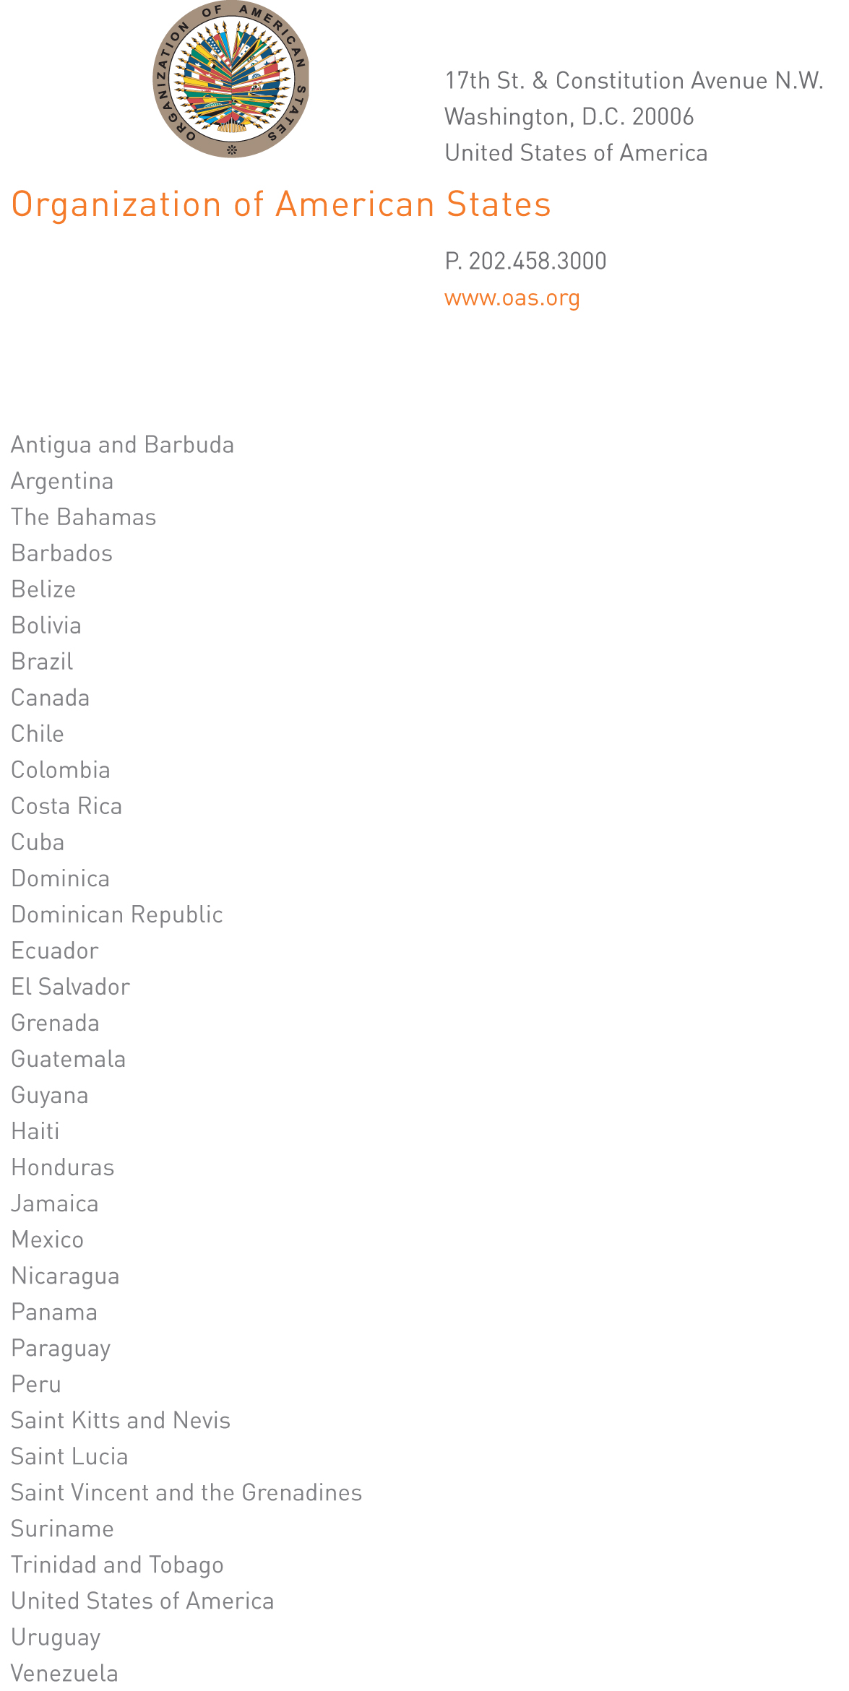
Permanent Mission of Colombia
to the Organization of American States

SUMMARY OF THE PRESENTATION BY DR. RAÚL CUERO, SCIENTIST-INVENTOR, PRESIDENT OF THE INTERNATIONAL CREATIVITY PARK FOR YOUNG INVENTORS

Dialogue “Creativity, Innovation, and Intellectual Property: Imperative Challenge for the Economic Development of Latin America and the Caribbean”

July 31, 2012

Introduction

On July 31, the Assistant Secretary General of the OAS, Ambassador Albert Ramdin, and the Ambassador of Colombia to the OAS, His Excellency Andrés González Díaz, organized a dialogue at the OAS entitled “Creativity, Innovation, and Intellectual Property: Imperative Challenge for the Economic Development of Latin America and the Caribbean” to present new models for scientific and technological development in Latin America and the Caribbean based on the experiences of the renowned scientist and inventor, Dr. Raúl Cuero, as well as young Colombian inventors.

Dr. Raúl Cuero, a NASA Technology Award laureate, founded the International Creativity Parks Program in Colombia and other parts of the world with the aim of training young inventors and promoting a culture of creativity and scientific and technological development to advance socioeconomic growth in the region. Dr. Cuero was accompanied by young inventors from the Park, who presented their inventions and patents, an experience now shared by young people in developed and developing countries alike.

Ambassador Andrés González extolled Dr. Cuero’s life as a source of pride for Colombia and the Americas. He added that models such as the Creativity Parks and partnerships with the private sector and business were showing the way and that Latin America had to make up lost ground in the area of patents, given that of the 873,667 granted in 2011 by the WIPO, the region had accounted for a mere 0.25%, or 2,210. The Ambassador added that Colombia would allocate at least 10% of its oil industry royalties to science and technology projects.
Assistant Secretary General Ramdin said that the countries of Latin America and the Caribbean needed to rethink their development approach, putting human capital, creativity, and scientific and technological development at the forefront of their strategies for carving out a more prosperous economic future. He noted that Colombia’s International Creativity Parks model highlighted the value of human capital, a very real asset that was driving economic growth, productivity, job creation, and social well-being, especially in the new information economy.

Ambassador Ramdin drew attention to the importance of stimulating investment in science and technology in the region and mentioned that, on average, the countries of Latin America and the Caribbean invested only 0.66% of GDP in research and development, compared with an investment level of 2.47% of GDP in OECD countries. He added that whereas 90% of investment in research in developed countries came from the private sector, in our region the private sector accounted for just 10% of total R&D investment. Ambassador Ramdin called on countries to implement long-term policies to foster innovation with public-private-academic sector participation that would generate economic benefits and reduce poverty and inequality.

The dialogue was attended by representatives of the permanent missions; the Executive Secretary for Integral Development, Jorge Saggiante; and directors and staff of the Executive Secretariat for Integral Development.

Presentation by Dr. Cuero

Dr. Cuero commented on the situation in Latin America and the Caribbean in terms of development, innovation, science and technology, and, based on his own life experience, presented the International Creativity Park as a means to economic development in which young people were regarded as a core asset.

He said that the technology lag and the lack of progress in the region could be due to the “education for service” mentality that has become widespread in Latin American societies. Dr. Cuero recognized the motivation of youth in their own countries and abroad; however, he considered that young people did not meet their goals as best they might. Therefore, he believed that it was necessary to foster the development of freethinking, universal, and inventive minds from an early age in order to take advantage as soon as possible of the conditions of diversity that we have in our countries for inventing.

To accomplish the foregoing and achieve progress, Dr. Cuero presented an equation where conception time over implementation time, plus knowhow, plus natural resources and marketing, equal prosperity. According to the scientist, that is what the region’s countries need to do. However, achieving that equation required the formation of creative individuals from an early age. It was fundamental to instill a culture of creativity in our countries in order to put knowledge at the service of the economy and thereby ensure development.

One example of the above was the initiative that Dr. Cuero had been pursuing in Colombia and other countries to create the International Creativity Park. The purpose of the Creativity Park was to train inventors like Dr. Cuero from an early age, so that they might come up with inventions that would foment economic development in the countries of Latin America and the Caribbean. Implementing this initiative did not require vast amounts of capital, but financing was needed from both the public and private sectors.

Presentation by young inventors and members of the International Creativity Park (Mariana Sánchez and John Trujillo)

Both gave a presentation on their experience and the projects on which they had worked (development of glass and carbon fiber, a more effective DNA expansion method, an oil detection sensor) highlighting the great intellectual and financial benefits of creating and marketing their inventions at an early age and the impact of this on the country’s development. Providing the country with technological capabilities established mechanisms for development, enterprise creation, and international business opportunities.

Conclusion by Dr. Cuero

Dr. Cuero concluded his presentation with some personal observations, saying, “we must never allow expectations to become the reason for achieving an end. We must focus on the process, not the reason.” “The process is what leads one to discover the unknown; that is what Cuero has done.” He also said that it was necessary to adopt an irreverent attitude to extant knowledge; while it should be respected, there was no need to treat it with awe. “That is what I have done to move forward.”
A summary biography of Dr. Cuero

Dr. Raúl Cuero was born in Buenaventura, Colombia, on January 30, 1948.

The extreme poverty in which he grew up made him realize at an early age the importance of creativity for survival. A Ph.D. in Microbiology research fellow and eminent professor, Dr. Cuero has won the NASA Technology Award among other accolades. With 19 inventions—most of them patented—and a range of tributes to his name in the countries of which he is a citizen (Colombia, United States, United Kingdom), Dr. Raúl Cuero established the International Creativity Parks Program with the aim of training young inventors and promoting a culture of creativity and scientific and technological development to advance socioeconomic growth in the region. By the end of its first four years of operation, the Park in Colombia had developed 10 inventions, six of which have patents pending. Enterprises have also already been set up on the strength of those inventions.
input.doc
In Dr. Cuero’s own words: “Many people, myself included, want to surpass their intellectual capacity to survive the pain of being ignorant.” He also said that only creativity had enabled him to achieve a genuine sense of belonging and absolute freedom. For more information, go to http://www.raulcuerobiotech.com

